Table of contents

UNITED STATES

SECURITIES AND EXCHANGE COMMISSION

WASHINGTON, D.C. 20549
____________________________________________

FORM 10-Q

____________________________________________

(Mark One)

- QUARTERLY REPORT PURSUANT TO SECTION 13 OR 15(d) OF THE SECURITIES EXCHANGE ACT OF 1934

For the quarterly period ended June 30, 2025

or

- TRANSITION REPORT PURSUANT TO SECTION 13 OR 15(d) OF THE SECURITIES EXCHANGE ACT OF 1934

For the transition period from ___________________ to ___________________

Commission File Number: 001-39100

____________________________________________

Progyny, Inc.

(Exact name of registrant as specified in its charter)
____________________________________________

Delaware

(State or other jurisdiction of

incorporation or organization)

1359 Broadway

New York, New York

27-2220139

(I.R.S. Employer

Identification No.)

10018

(Address of principal executive offices) (Zip Code)

(212) 888-3124

(Registrant’s telephone number, including area code)

N/A

(Former name, former address and former fiscal year, if changed since last report)

____________________________________________

Securities registered pursuant to Section 12(b) of the Act:

Title of each class | Trading Symbol(s) | Name of each exchange on which registered
Common Stock, | PGNY | The Nasdaq Global Select Market
$0.0001 par value per share

Indicate by check mark whether the registrant: (1) has filed all reports required to be filed by Section 13 or 15(d) of the Securities Exchange Act of 1934 during the preceding 12 months (or for such shorter period that the registrant was required to file such reports), and (2) has been subject to such filing requirements for the past 90 days. Yes x No o

Indicate by check mark whether the registrant has submitted electronically every Interactive Data File required to be submitted pursuant to Rule 405 of Regulation S-T (§ 232.405 of this chapter) during the preceding 12 months (or for such shorter period that the registrant was required to submit such files). Yes x No o

Indicate by check mark whether the registrant is a large accelerated filer, an accelerated filer, a non-accelerated filer, a smaller reporting company, or an emerging growth company. See the definitions of “large accelerated filer,” “accelerated filer,” “smaller reporting company,” and “emerging growth company” in Rule 12b-2 of the Exchange Act.

Large accelerated filer | x | Accelerated filer | o
Non-accelerated filer | o | Smaller reporting company | o
 |  | Emerging growth company | o

If an emerging growth company, indicate by check mark if the registrant has elected not to use the extended transition period for complying with any new or revised financial accounting standards provided pursuant to Section 13(a) of the Exchange Act. o

Indicate by check mark whether the registrant is a shell company (as defined in Rule 12b-2 of the Exchange Act). Yes o No x As of July 31, 2025, the registrant had 85,982,409 shares of common stock, $0.0001 par value per share, outstanding.

Table of contents

Table of Contents

 |  |  |  |  |  |  |  |  |  |  |  |  |  |  |  |  |  |  |  |  |  |  |  |  |  |  | Page
 | PART I. |  |  |  |  | FINANCIAL INFORMATION
 | Item 1. |  |  |  |  | Financial Statements (Unaudited)
 |  |  |  |  |  |  | Consolidated Balance Sheets as of June 30, 2025 and December 31, 2024 |  |  |  |  |  |  |  |  |  |  |  |  |  |  |  |  |  |  |  | 6
 |  |  |  |  |  |  | Consolidated Statements of Operations for the Three and Six Months Ended June 30,2025 and 2024 |  |  |  |  |  |  |  |  |  |  |  |  |  |  |  |  |  |  |  | 7
 |  |  |  |  |  |  | Consolidated Statements of Comprehensive Income for the Three and Six Months Ended June 30, 2025 and 2024 |  |  |  |  |  |  |  |  |  |  |  |  |  |  |  |  |  |  |  | 8
 |  |  |  |  |  |  | Consolidated Statements of Changes in Stockholders’ Equity for the Three and Six Months Ended June 30, 2025 and 2024 |  |  |  |  |  |  |  |  |  |  |  |  |  |  |  |  |  |  |  | 9
 |  |  |  |  |  |  | Consolidated Statements of Cash Flows for the Six Months Ended June 30, 2025 and 2024 |  |  |  |  |  |  |  |  |  |  |  |  |  |  |  |  |  |  |  | 10
 |  |  |  |  |  |  | Notes to Consolidated Financial Statements |  |  |  |  |  |  |  |  |  |  |  |  |  |  |  |  |  |  |  |  | 11
 | Item 2. |  |  |  |  | Management’s Discussion and Analysis of Financial Condition and Results of Operations |  |  |  |  |  |  |  |  |  |  |  |  |  |  |  |  |  |  |  |  |  | 24
 | Item 3. |  |  |  |  | Quantitative and Qualitative Disclosures About Market Risk |  |  |  |  |  |  |  |  |  |  |  |  |  |  |  |  |  |  |  |  |  | 39
 | Item 4. |  |  |  |  | Controls and Procedures |  |  |  |  |  |  |  |  |  |  |  |  |  |  |  |  |  |  |  |  |  | 40
 | PART II. |  |  |  |  | OTHER INFORMATION
 | Item 1. |  |  |  |  | Legal Proceedings |  |  |  |  |  |  |  |  |  |  |  |  |  |  |  |  |  |  |  |  |  | 41
 | Item 1A. |  |  |  |  | Risk Factors |  |  |  |  |  |  |  |  |  |  |  |  |  |  |  |  |  |  |  |  | 41
 | Item 2. |  |  |  |  | Unregistered Sales of Equity Securities and Use of Proceeds |  |  |  |  |  |  |  |  |  |  |  |  |  |  |  |  |  |  |  |  |  | 66
 | Item 3. |  |  |  |  | Defaults Upon Senior Securities |  |  |  |  |  |  |  |  |  |  |  |  |  |  |  |  |  |  |  |  | 67
 | Item 4. |  |  |  |  | Mine Safety Disclosures |  |  |  |  |  |  |  |  |  |  |  |  |  |  |  |  |  |  |  |  | 67
 | Item 5. |  |  |  |  | Other Information |  |  |  |  |  |  |  |  |  |  |  |  |  |  |  |  |  |  |  |  |  | 67
 | Item 6. |  |  |  |  | Exhibits |  |  |  |  |  |  |  |  |  |  |  |  |  |  |  |  |  |  |  |  |  | 68
 |  |  |  |  |  | Signatures |  |  |  |  |  |  |  |  |  |  |  |  |  |  |  |  |  |  |  |  |  | 69
 |  |  |  |  |  | 2

Table of contents

CAUTIONARY NOTE REGARDING FORWARD-LOOKING STATEMENTS

This Quarterly Report on Form 10-Q contains forward-looking statements within the meaning of the Private Securities Litigation Reform Act of 1995. We intend such forward-looking statements to be covered by the safe harbor provisions for forward-looking statements contained in Section 27A of the Securities Act of 1933, as amended, or the Securities Act, and Section 21E of the Securities Exchange Act of 1934, as amended, or the Exchange Act. All statements other than statements of historical fact contained in this Quarterly Report on Form 10-Q are forward-looking statements, including, without limitation, statements regarding our future results of operations and financial position; our ability to acquire or invest in complementary businesses, products, and technologies; our ability to achieve profitability on an annual basis and sustain such profitability; the sufficiency of our cash and cash equivalents and anticipated sources and uses of cash; our business strategies, plans, objectives and goals; our ability to acquire new clients and successfully engage new and existing clients; our ability to effectively manage our growth; our ability to compete effectively with existing competitors and new market entrants; the impact of recently adopted accounting pronouncements; our ability to attract and retain qualified employees and key personnel; the plans and objectives of management for future operations and capital expenditures; general economic and market trends; the impact of public health emergencies on our business, operations, and the markets and communities in which we and our clients, members and providers operate; and the potential impact of evolving laws and regulations, including any laws and regulations restricting reproductive rights. These statements are neither promises nor guarantees, but involve known and unknown risks, uncertainties and other important factors that may cause our actual results, performance or achievements to be materially different from any future results, performance or achievements expressed or implied by the forward-looking statements.

In some cases, you can identify forward-looking statements by terms such as “may,” “will,” “should,” “expect,” “plan,” “anticipate,” “could,” “intend,” “target,” “project,” “contemplate,” “believe,” “estimate,” “predict,” “potential,” “seek,” “assume,” “future,” “continue” or “aim” or the negative of these terms or other similar expressions. The forward-looking statements in this Quarterly Report on Form 10-Q are only predictions. We have based these forward-looking statements largely on our current expectations and projections about future events and financial trends that we believe may affect our business, financial condition and results of operations. These forward-looking statements speak only as of the date of this Quarterly Report on Form 10-Q and are subject to a number of important factors that could cause actual results to differ materially from those in the forward-looking statements, including the factors described under Part II, Item 1A. “Risk Factors” and Part I, Item 2. “Management’s Discussion and Analysis of Financial Condition and Results of Operations” of this Quarterly Report on Form 10-Q.

In addition, statements such as “we believe” and similar statements reflect our beliefs and opinions on the relevant subject. These statements are based upon information available to us as of the filing date of this Quarterly Report on Form 10-Q, and while we believe such information forms a reasonable basis for such statements, such information may be limited or incomplete, and our statements should not be read to indicate that we have conducted an exhaustive inquiry into, or review of, all potentially available relevant information. These statements are inherently uncertain, and investors are cautioned not to unduly rely upon these statements.

You should read this Quarterly Report on Form 10-Q and the documents that we reference in this Quarterly Report on Form 10-Q completely and with the understanding that our actual future results may be materially different from what we expect. We qualify all of our forward-looking statements by these cautionary statements. Except as required by applicable law, we do not plan to publicly update or revise any forward-looking statements contained herein, whether as a result of any new information, future events, changed circumstances or otherwise.

3

Table of contents

SUMMARY OF RISKS AFFECTING OUR BUSINESS

Below is a summary of the principal factors that make an investment in our common stock speculative or risky. This summary does not address all of the risks and uncertainties that we face. Additional discussion of the risks summarized in this risk factor summary, and other risks and uncertainties that we face, can be found under the heading “Risk Factors” in Part II, Item 1A. of this Quarterly Report on Form 10-Q and should be carefully considered, together with other information in this Quarterly Report on Form 10-Q and our other filings with the U.S. Securities and Exchange Commission, or the SEC, before making an investment decision regarding our common stock.

- We may fail to meet our publicly announced guidance or other expectations about our business and future results of operations, which would cause our stock price to decline.

- The market in which we operate is highly competitive, and, if we do not continue to compete effectively, our business, financial condition and results of operations could be harmed.

- Unfavorable conditions in the global economy or our industry could limit our ability to grow our business and negatively affect our results of operations.

- Our business depends on our ability to retain our existing clients and increase the adoption of our services within our client base. Any failure to do so would harm our business, financial condition and results of operations.

- Our largest clients account for a significant portion of our revenue, and a significant number of our clients are in the technology industry. The loss of one or more of these clients, changes to pricing terms with these clients or changes within the technology industry could negatively impact our business, financial condition and results of operations.

- If we are unable to attract new clients, our business, financial condition and results of operations would be adversely affected.

- A significant change in the utilization of our fertility solutions, including the consumption rate or the mix of utilization, could have an adverse effect on our business, financial condition and results of operations.

- Acquisitions, strategic investments, or partnerships could be difficult to identify, pose integration challenges, divert the attention of management, disrupt our business, dilute stockholder value, and adversely affect our business, financial condition and results of operations.

- We have a limited operating history with our current platform of solutions, which makes it difficult to predict our future results of operations.

- The health benefits industry may be subject to negative publicity, which could adversely affect our business, financial condition and results of operations.

- If our information technology systems, or those of the third parties with whom we do business, including our provider clinics, specialty pharmacies or other vendors, lag, fail or suffer cybersecurity breaches, we may experience a material disruption of our services or suffer a loss or inappropriate disclosure of confidential information, which could materially impact our business and results of operations.

- Our business depends on our ability to maintain our Center of Excellence network of high-quality fertility specialists and other healthcare providers. If we are unable to do so, our future growth would be limited and our business, financial condition and results of operations would be harmed.

- Our growth depends in part on the success of our strategic relationships with, and monitoring of, third parties, including channel partners and vendors as well as insurance carriers.

- If we fail to maintain an efficient pharmacy distribution network or if there is a disruption to our network of specialty pharmacies or their supply chains, our business, financial condition and results of operations could suffer.

- We operate in a highly regulated industry and must comply with a significant number of new and evolving legal and regulatory requirements, as well as complex judicial mandates.

4

Table of contents

- We are part of the broader healthcare industry and subject to increasing scrutiny and regulation within our business, including with respect to Progyny Rx’s PBM operations, which may adversely affect our business, financial condition and results of operations.

GENERAL

Unless the context otherwise indicates, references in this Quarterly Report on Form 10-Q to the terms “Progyny,” “the Company,” “we,” “our” and “us” refer to Progyny, Inc. and its wholly owned subsidiaries.

“Progyny®” and our other registered and common law trade names, trademarks and service marks are the property of Progyny, Inc. Other trade names, trademarks and service marks used in this Quarterly Report on Form 10-Q are the property of their respective owners. Solely for convenience, the trademarks and trade names in this Quarterly Report on Form 10-Q may be referred to without the ® and ™ symbols, but such references should not be construed as any indicator that their respective owners will not assert their rights thereto.

We announce material information to the public through filings with the SEC, our investor relations website at investors.progyny.com, press releases, public conference calls, and webcasts to achieve broad, non-exclusionary distribution of information. We therefore encourage investors and others interested in Progyny to review the information disclosed through such channels. Any updates to the list of disclosure channels through which we will announce information will be posted on the investor relations page on our website.

5

Table of contents

PART I – FINANCIAL INFORMATION

ITEM 1. FINANCIAL STATEMENTS

PROGYNY, INC.

Consolidated Balance Sheets

(Unaudited)

(in thousands, except share and per share amounts)

 |  | June 30, |  |  | December 31,
 |  | 2025 |  |  | 2024
ASSETS
Current assets:
Cash and cash equivalents | $ | 132,506 |  | $ | 162,314
Marketable securities |  | 172,586 |  |  | 65,640
Accounts receivable, net of $54,452 and $56,355 of allowance at June 30, 2025 and December 31, 2024, respectively |  | 271,853 |  |  | 235,324
Prepaid expenses and other current assets |  | 17,457 |  |  | 9,443
Total current assets |  | 594,402 |  |  | 472,721
Property and equipment, net |  | 19,943 |  |  | 12,383
Operating lease right-of-use assets |  | 26,423 |  |  | 17,251
Goodwill |  | 19,963 |  |  | 15,534
Intangible assets, net |  | 6,644 |  |  | 1,303
Deferred tax assets |  | 84,942 |  |  | 84,933
Other noncurrent assets |  | 8,633 |  |  | 2,977
Total assets | $ | 760,950 |  | $ | 607,102
LIABILITIES AND STOCKHOLDERS’ EQUITY
Current liabilities:
Accounts payable | $ | 140,517 |  | $ | 95,097
Accrued expenses and other current liabilities |  | 79,906 |  |  | 73,530
Total current liabilities |  | 220,423 |  |  | 168,627
Operating lease noncurrent liabilities |  | 25,505 |  |  | 16,413
Total liabilities |  | 245,928 |  |  | 185,040
Commitments and Contingencies (Note 6)
STOCKHOLDERS' EQUITY
Common stock, $0.0001 par value; 1,000,000,000 shares authorized; at June 30, 2025 and December 31, 2024, respectively; 98,309,704 and |  | 9 |  |  | 9
97,692,891 shares issued; 85,927,511 and 85,310,698 outstanding at June 30, 2025 and December 31, 2024, respectively |  | 9 |  |  | 9
Additional paid-in capital |  | 642,206 |  |  | 581,596
Treasury stock, at cost, $0.0001 par value; 12,998,173 and 12,998,173 shares at June 30, 2025 and December 31, 2024, respectively |  | (303,889) |  |  | (303,889)
Accumulated earnings |  | 176,478 |  |  | 144,307
Accumulated other comprehensive income |  | 218 |  |  | 39
Total stockholders’ equity |  | 515,022 |  |  | 422,062
Total liabilities and stockholders’ equity | $ | 760,950 |  | $ | 607,102

The accompanying notes are an integral part of these unaudited consolidated financial statements.

6

Table of contents

PROGYNY, INC.

Consolidated Statements of Operations

(Unaudited)

(in thousands, except share and per share amounts)

 |  | Three Months Ended |  |  |  |  |  | Six Months Ended
 |  | June 30, |  |  |  |  |  | June 30,
 | 2025 |  |  |  | 2024 |  |  | 2025 |  |  | 2024
Revenue | $ | 332,874 |  | $ | 304,087 |  | $ | 656,912 |  | $ | 582,165
Cost of services |  | 253,901 |  |  | 235,806 |  |  | 502,144 |  |  | 451,478
Gross profit |  | 78,973 |  |  | 68,281 |  |  | 154,768 |  |  | 130,687
Operating expenses:
Sales and marketing |  | 18,405 |  |  | 16,421 |  |  | 36,191 |  |  | 31,875
General and administrative |  | 36,210 |  |  | 31,173 |  |  | 70,049 |  |  | 59,602
Total operating expenses |  | 54,615 |  |  | 47,594 |  |  | 106,240 |  |  | 91,477
Income from operations |  | 24,358 |  |  | 20,687 |  |  | 48,528 |  |  | 39,210
Interest and other income, net |  | 2,719 |  |  | 4,380 |  |  | 5,086 |  |  | 8,372
Income before income taxes |  | 27,077 |  |  | 25,067 |  |  | 53,614 |  |  | 47,582
Provision for income taxes |  | 9,965 |  |  | 8,582 |  |  | 21,443 |  |  | 14,199
Net income | $ | 17,112 |  | $ | 16,485 |  | $ | 32,171 |  | $ | 33,383
Net income per share:
Basic | $ | 0.20 |  | $ | 0.18 |  | $ | 0.38 |  | $ | 0.35
Diluted | $ | 0.19 |  | $ | 0.17 |  | $ | 0.36 |  | $ | 0.34
Weighted-average shares used in computing net income per share:
Basic |  | 85,766,254 |  |  | 93,868,409 |  |  | 85,644,091 |  |  | 95,160,085
Diluted |  | 89,638,677 |  |  | 97,839,576 |  |  | 89,507,906 |  |  | 99,456,335

The accompanying notes are an integral part of these unaudited consolidated financial statements.

7

Table of contents

PROGYNY, INC.

Consolidated Statement of Comprehensive Income

(Unaudited)

(in thousands)

 |  | Three Months Ended |  |  |  |  |  | Six Months Ended
 |  | June 30, |  |  |  |  |  | June 30,
 | 2025 |  |  |  | 2024 |  |  | 2025 |  |  | 2024
Net income | $ | 17,112 |  | $ | 16,485 |  | $ | 32,171 |  | $ | 33,383
Other comprehensive income (loss), net of tax
Unrealized (loss) gain on marketable securities before reclassifications |  | (17) |  |  | 1,915 |  |  | (67) |  |  | 4,313
Reclassification of gains on the sale of marketable securities into net income |  | — |  |  | (2,630) |  |  | — |  |  | (5,118)
Net change on unrealized gains on marketable securities |  | (17) |  |  | (715) |  |  | (67) |  |  | (805)
Foreign currency translation gain (loss) |  | 125 |  |  | (10) |  |  | 246 |  |  | 11
Total other comprehensive income (loss), net of tax |  | 108 |  |  | (725) |  |  | 179 |  |  | (794)
Total comprehensive income | $ | 17,220 |  | $ | 15,760 |  | $ | 32,350 |  | $ | 32,589

The accompanying notes are an integral part of these unaudited consolidated financial statements.

8

Table of contents

PROGYNY, INC.

Consolidated Statements of Changes in Stockholders’ Equity

(Unaudited)

(in thousands, except share amounts)

 | Common Stock |  |  |  |  |  |  |  |  | Additional |  |  |  |  |  | Accumulated Other
 |  |  |  |  |  |  | Treasury |  |  | Paid in |  |  | Accumulated |  |  | Comprehensive
 | Shares |  | Amount |  |  |  | Stock |  |  | Capital |  |  | Earnings |  |  | Income |  |  | Total
For the three months ended June 30, 2025:
Balance at March 31, 2025 | 85,669,824 |  | $ | 9 |  | $ | (303,889) |  | $ | 611,563 |  | $ | 159,366 |  | $ | 110 |  | $ | 467,159
Issuance of employee equity awards, net of shares withheld | 257,687 |  |  | 0 |  |  | — |  |  | (2,430) |  |  | — |  |  | — |  |  | (2,430)
Stock-based compensation | — |  |  | — |  |  | — |  |  | 33,073 |  |  | — |  |  | — |  |  | 33,073
Other comprehensive income, net of tax | — |  |  | — |  |  | — |  |  | — |  |  | — |  |  | 108 |  |  | 108
Net income | — |  |  | — |  |  | — |  |  | — |  |  | 17,112 |  |  | — |  |  | 17,112
Balance at June 30, 2025 | 85,927,511 |  | $ | 9 |  | $ | (303,889) |  | $ | 642,206 |  | $ | 176,478 |  | $ | 218 |  | $ | 515,022
For the three months ended June 30, 2024:
Balance at March 31, 2024 | 96,115,816 |  | $ | 9 |  | $ | (27,367) |  | $ | 489,343 |  | $ | 106,869 |  | $ | 2,750 |  | $ | 571,604
Issuance of employee equity awards, net of shares withheld | 188,725 |  |  | 0 |  |  | — |  |  | (2,992) |  |  | — |  |  | — |  |  | (2,992)
Stock-based compensation | — |  |  | — |  |  | — |  |  | 33,319 |  |  | — |  |  | — |  |  | 33,319
Repurchase of common stock | (5,593,128) |  |  | — |  |  | (161,498) |  |  | — |  |  | — |  |  | — |  |  | (161,498)
Other comprehensive loss, net of tax | — |  |  | — |  |  | — |  |  | — |  |  | — |  |  | (725) |  |  | (725)
Net income | — |  |  | — |  |  | — |  |  | — |  |  | 16,485 |  |  | — |  |  | 16,485
Balance at June 30, 2024 | 90,711,413 |  | $ | 9 |  | $ | (188,865) |  | $ | 519,670 |  | $ | 123,354 |  | $ | 2,025 |  | $ | 456,193
For the six months ended June 30, 2025:
Balance at December 31, 2024 | 85,310,698 |  | $ | 9 |  | $ | (303,889) |  | $ | 581,596 |  | $ | 144,307 |  | $ | 39 |  | $ | 422,062
Issuance of employee equity awards, net of shares withheld | 616,813 |  |  | 0 |  |  | — |  |  | (5,475) |  |  | — |  |  | — |  |  | (5,475)
Stock-based compensation | — |  |  | — |  |  | — |  |  | 66,085 |  |  | — |  |  | — |  |  | 66,085
Other comprehensive income, net of tax | — |  |  | — |  |  | — |  |  | — |  |  | — |  |  | 179 |  |  | 179
Net income | — |  |  | — |  |  | — |  |  | — |  |  | 32,171 |  |  | — |  |  | 32,171
Balance at June 30, 2025 | 85,927,511 |  | $ | 9 |  | $ | (303,889) |  | $ | 642,206 |  | $ | 176,478 |  | $ | 218 |  | $ | 515,022
For the six months ended June 30, 2024:
Balance at December 31, 2023 | 96,348,522 |  | $ | 9 |  | $ | (1,009) |  | $ | 461,639 |  | $ | 89,971 |  | $ | 2,819 |  | $ | 553,429
Issuance of employee equity awards, net of shares withheld | 679,596 |  |  | 0 |  |  | — |  |  | (6,494) |  |  | — |  |  | — |  |  | (6,494)
Stock-based compensation | — |  |  | — |  |  | — |  |  | 64,525 |  |  | — |  |  | — |  |  | 64,525
Repurchase of common stock | (6,316,705) |  |  | — |  |  | (187,856) |  |  | — |  |  | — |  |  | — |  |  | (187,856)
Other comprehensive loss, net of tax | — |  |  | — |  |  | — |  |  | — |  |  | — |  |  | (794) |  |  | (794)
Net income | — |  |  | — |  |  | — |  |  | — |  |  | 33,383 |  |  | — |  |  | 33,383
Balance at June 30, 2024 | 90,711,413 |  | $ | 9 |  | $ | (188,865) |  | $ | 519,670 |  | $ | 123,354 |  | $ | 2,025 |  | $ | 456,193

The accompanying notes are an integral part of these unaudited consolidated financial statements.

9

Table of contents

PROGYNY, INC.

Consolidated Statements of Cash Flows

(Unaudited)

(in thousands)

Six Months Ended

June 30,

 | 2025 |  |  |  | 2024
OPERATING ACTIVITIES
Net income | $ | 32,171 |  | $ | 33,383
Adjustments to reconcile net income to net cash provided by operating activities:
Deferred tax expense |  | 23 |  |  | 5,522
Non-cash interest income |  | — |  |  | (77)
Depreciation and amortization |  | 2,313 |  |  | 1,470
Loss on disposal of property and equipment |  | 79 |  |  | —
Stock-based compensation expense |  | 64,895 |  |  | 64,088
Bad debt expense |  | 11,017 |  |  | 9,572
Net accretion of discounts on marketable securities |  | 27 |  |  | (6,987)
Foreign currency exchange rate loss |  | — |  |  | 30
Changes in operating assets and liabilities:
Accounts receivable |  | (47,166) |  |  | (61,496)
Prepaid expenses and other current assets |  | (7,946) |  |  | 1,279
Accounts payable |  | 45,207 |  |  | 26,396
Accrued expenses and other current liabilities |  | 5,852 |  |  | 8,860
Other noncurrent assets and liabilities |  | (1,154) |  |  | 386
Net cash provided by operating activities |  | 105,318 |  |  | 82,426
INVESTING ACTIVITIES
Purchase of property and equipment, net |  | (8,112) |  |  | (1,716)
Purchase of marketable securities |  | (200,088) |  |  | (158,639)
Sale of marketable securities |  | 93,015 |  |  | 271,099
Acquisition of business, net of cash acquired |  | (9,340) |  |  | (5,304)
Net cash (used in) provided by investing activities |  | (124,525) |  |  | 105,440
FINANCING ACTIVITIES
Repurchase of common stock |  | — |  |  | (183,723)
Proceeds from exercise of stock options |  | 18 |  |  | 988
Payment of employee taxes related to equity awards |  | (6,195) |  |  | (8,172)
Proceeds from contributions to employee stock purchase plan |  | 560 |  |  | 707
Net cash used in financing activities |  | (5,617) |  |  | (190,200)
Effect of exchange rate changes on cash, cash equivalents, and restricted cash |  | 52 |  |  | (2)
Net decrease in cash, cash equivalents, and restricted cash |  | (24,772) |  |  | (2,336)
Cash, cash equivalents, and restricted cash, beginning of period |  | 162,314 |  |  | 97,296
Cash, cash equivalents, and restricted cash, end of period | $ | 137,542 |  | $ | 94,960
Cash and cash equivalents | $ | 132,506 |  | $ | 94,960
Restricted cash included within noncurrent assets |  | 5,036 |  |  | —
Total cash, cash equivalents, and restricted cash | $ | 137,542 |  | $ | 94,960
SUPPLEMENTAL DISCLOSURE OF CASH FLOW INFORMATION
Cash paid for income taxes, net of refunds received | $ | 24,342 |  | $ | 17,317
SUPPLEMENTAL DISCLOSURE OF NON-CASH INVESTING AND FINANCING ACTIVITIES
Additions of property and equipment, net included in accounts payable and accrued expenses | $ | 468 |  | $ | 158

The accompanying notes are an integral part of these unaudited consolidated financial statements.

10

Table of contents

PROGYNY, INC.

NOTES TO CONSOLIDATED FINANCIAL STATEMENTS

(Unaudited)

- Business and Basis of Presentation

Description of Business

Progyny, Inc. (together with its subsidiaries referred to as “Progyny” or the “Company”) was incorporated in the state of Delaware on April 3, 2008, and maintains its corporate headquarters in New York, NY.

Progyny is a benefits management company specializing in fertility, family building and women's health benefits solutions and operates and manages in one operating segment. The fertility benefits solution consists of a significant service that integrates: (1) the treatment services (“Smart Cycles”) that the Company has designed, (2) access to the Progyny network of high-quality fertility specialists that perform the Smart Cycle treatments and (3) active management of the selective network of high-quality provider clinics, real-time member eligibility and treatment authorization, member-facing digital tools and detailed quarterly reporting supported by the Company’s dedicated client success teams, and end-to-end comprehensive concierge member support provided by Progyny’s in-house staff of Progyny Care Advocates (“PCAs”) (collectively, the “care management services”).

The Company enhanced its benefits solution offerings with the launch of its pharmacy benefits solution, Progyny Rx, effective January 1, 2018. Progyny Rx provides the Company's members with access to the medications needed during their fertility treatment. As part of this solution, the Company provides care management services, which include formulary plan design, simplified authorization, assistance with prescription fulfillment, and timely delivery of the medications by the Company’s network of specialty pharmacies, as well as medication administration training, pharmacy support services, and continuing PCA support. As a pharmacy benefits solution provider, Progyny manages the dispensing of pharmaceuticals through the Company’s specialty pharmacy contracts. Progyny Rx is only available as an add-on service to the fertility benefits solution.

Basis of Presentation

The accompanying interim unaudited consolidated financial statements include the accounts of Progyny, Inc. and its wholly owned subsidiaries. The interim unaudited consolidated financial statements have been prepared in accordance with accounting principles generally accepted in the United States of America (“U.S. GAAP”) and pursuant to the rules and regulations of the Securities and Exchange Commission (“SEC”) applicable to interim financial reporting. These interim consolidated financial statements have been prepared on a basis consistent with the annual consolidated financial statements and, in the opinion of management, include all adjustments necessary to fairly state the Company's financial position as of June 30, 2025, the results of the Company's operations for the three and six months ended June 30, 2025 and 2024 and the results of the Company's cash flows for the six months ended June 30, 2025 and 2024. Therefore, these unaudited consolidated financial statements should be read in conjunction with the audited consolidated financial statements and related footnotes included in the Company’s Annual Report on Form 10-K for the fiscal year ended December 31, 2024, filed with the SEC on March 3, 2025 (the “Annual Report on Form 10-K”).

The results for the three and six months ended June 30, 2025 are not necessarily indicative of the operating results expected for the year ending December 31, 2025 or any other future period. The Company will continue to assess these potential impacts to its business and will make adjustments to its operations as necessary.

Use of Estimates

The preparation of consolidated financial statements in conformity with U.S. GAAP generally requires management to make estimates and assumptions that affect the reported amount of certain assets, liabilities, revenue, and expenses, and the related disclosure of contingent assets and liabilities. Such estimates include, but are not limited to, the determination of accrued receivables related to revenue recognition, accrued claims payable, allowance for doubtful accounts, stock-based compensation expense, lease liabilities, and accounting for income taxes. Management bases its estimates on historical experience and on various other assumptions that are believed to be reasonable under the circumstances, the results of which form the basis for making judgments about the carrying value of assets and liabilities that are not readily apparent from other sources. Actual results may differ from these estimates under different assumptions or conditions.

11

Table of contents

- Significant Accounting Policies

There have been no material changes in the Company’s significant accounting policies as compared to the significant accounting policies described in Note 2 of the Company’s Annual Report on Form 10-K.

Revenue Recognition

Revenue is recognized when control of the promised goods or services is transferred to clients in an amount that reflects the consideration the Company expects to be entitled to in exchange for those goods or services.

The Company applies the following five-step model to recognize revenue from contracts with clients:

- Identification of the contract, or contracts, with a client;

- Identification of the performance obligations in the contract;

- Determination of the transaction price;

- Allocation of the transaction price to the performance obligations in the contract; and

- Recognition of revenue when, or as, a performance obligation is satisfied.

Progyny’s contracts typically have a stated term of three years and include contractual termination options after the first year, allowing the client to terminate the contract with 30 to 90 days’

notice.

Fertility Benefits Solution Revenue

Progyny primarily generates revenue through its fertility benefits solution, in which Progyny provides self-insured enterprise entities (“clients”) and their employees and partners (together, “members”) with fertility benefits. As part of the fertility benefits solution, Progyny provides access to effective and cost-efficient fertility treatments, referred to as Smart Cycles, as well as other related services. Smart Cycles are proprietary treatment bundles that include certain medical services available to members through Progyny’s proprietary, credentialed network of provider clinics. In addition to access to Progyny’s Smart Cycle treatment bundles and access to Progyny’s network of provider clinics, the fertility benefits solution includes other comprehensive services, which Progyny refers to as care management services, such as active management of the provider clinic network, real-time member eligibility and treatment authorization, member-facing digital tools throughout the Smart Cycle and detailed quarterly reporting all supported by client facing account management and end-to-end comprehensive member support provided by Progyny’s in house staff of PCAs.

The promises within Progyny’s fertility benefits contract with a client represent a single performance obligation because Progyny provides a significant service of integrating the Progyny designed Smart Cycles and access to the fertility treatment services provided by provider clinics with the other comprehensive services into the combined fertility benefits solution that the client contracted to receive. Progyny’s fertility benefits solution is a stand-ready obligation that is satisfied over the contract term.

Progyny’s contracts include the following sources of consideration, which are all variable: a per employee per month (“PEPM”) administration fee (in most, but not all contracts), and a fixed rate per Smart Cycle. The PEPM administration fee is estimated using the expected value method and is allocated between the fertility benefits solution and the pharmacy benefits solution based on standalone selling price, estimated using an expected cost-plus margin method. The fixed rate per Smart Cycle meets the variable consideration allocation exception as the usage-based fees relate specifically to the Company’s efforts to satisfy the performance obligation to provide services and is allocated to the distinct period during which the related services were performed and represents the consideration the Company is entitled to for the fertility benefits services provided. As a result, the fixed rate per Smart Cycle is included in the transaction price for the fertility benefits solution.

12

Table of contents

Progyny’s contracts also include potential service level agreement refunds related to outcome-based service metrics. These service level refunds, which are determined based on results of a full plan year, if met, are based on a percentage of the PEPM fee paid by clients. The Company estimates the variable consideration related to the total PEPM administration fee, less estimated refunds related to service level agreements using the expected value method and recognizes the amounts allocated to the fertility benefits solution ratably over the contract term. Progyny’s estimates of service level agreement refunds have not historically resulted in significant adjustments to the transaction price. There is no constraint on variable consideration within Progyny’s fertility benefits contracts.

The Company recognizes revenue for its fertility benefit solution in the period in which the Smart Cycle services are provided to the member. The services provided in a reporting period are based on actual claims received from the provider clinic and an estimate of services provided but for which a claim has not been received at the end of the reporting period, which we refer to as accrued receivables, and is discussed in further detail below.

Clients are typically invoiced on a monthly basis for the PEPM administration fee. Progyny invoices its clients and members for their respective portions of the fixed rate per Smart Cycle bundle when all treatment services within a Smart Cycle are completed by the provider clinic. Once an invoice is issued, payment terms are typically between 30 to 60 days.

The Company assesses whether it is the principal or the agent for each arrangement with a client, since fertility treatment services are provided by a third party—the provider clinics. The Company is the principal in its arrangements with clients and therefore presents revenue gross of the amounts paid to the provider clinics because Progyny controls the specified service (the fertility benefits solution) before it is transferred to the client. Progyny integrates the fertility treatment services provided by the provider clinics into the overall fertility benefits solution that the client contracted to receive. In addition, Progyny defines the scope of the potential services to be performed by the provider clinics and monitors the performance of the provider clinics. Furthermore, Progyny is primarily responsible for fulfilling the promise to the client and has discretion in setting the pricing, as Progyny separately negotiates agreements with the provider clinics, which establish pricing for each treatment service. Pricing of services from provider clinics is independent from the fees charged to clients.

Pharmacy Benefits Solution Revenue

For clients that have the fertility benefits solution, Progyny offers, as an add-on, its pharmacy benefits solution, which is a separate, fully integrated pharmacy benefit. As part of the pharmacy benefits solution, Progyny provides care management services, which include Progyny’s formulary plan design, prescription fulfillment, simplified authorization and timely delivery of the medications used during treatment through Progyny’s network of specialty pharmacies, and clinical services consisting of member assessments, UnPack It calls, telephone support, online education, medication administration training, pharmacy support services and continuing PCA support.

The pharmacy-related promises represent a single performance obligation because Progyny provides a significant service of integrating the formulary plan design, prescription fulfillment, clinical services and PCA support into the combined pharmacy benefits solution that the client contracted to receive. The pharmacy benefits solution is a stand-ready obligation that is satisfied over the contract term.

Progyny’s contracts include the following sources of consideration, all of which are variable: a PEPM administration fee (in most, but not all contracts) and a fixed fee per fertility drug. As described above, the PEPM administration fee, less estimated refunds related to service level agreements, is allocated to the pharmacy benefits solution and recognized ratably over the contract term. The fixed fee per fertility drug meets the variable consideration allocation exception as the usage-based fees relate specifically to the Company’s efforts to satisfy the performance obligation to provide services and is allocated to the distinct period during which the related services were performed and represents the consideration the Company is entitled to for the pharmacy benefits services provided. As a result, the fixed fee per fertility drug is included in the transaction price and recognized in the period in which the Company is entitled to consideration from a client, which is when a prescription is filled and delivered to the members. There is no constraint on variable consideration within Progyny’s pharmacy benefits contracts.

As stated above, clients are invoiced on a monthly basis for the PEPM administration fee. Progyny invoices the client and the member for their respective portions of the fixed fee per fertility drug, when the prescription services are completed by the specialty pharmacies. Once an invoice is issued, payment terms are typically between 30 to 60 days.

13

Table of contents

The Company assesses whether it is the principal or the agent for each arrangement with a client, as prescription fulfillment and clinical services are provided by a third party—the specialty pharmacies. The Company is the principal in its arrangements with clients, and therefore presents revenue gross of the amounts paid to the specialty pharmacies. Progyny controls the specified service (the pharmacy benefits solution) before it is transferred to the client. Progyny integrates the prescription fulfillment and clinical services provided by the pharmacies and PCAs into the overall pharmacy benefits solution that the client contracted to receive. In addition, Progyny defines the scope of the potential services to be performed by the specialty pharmacies and monitors the performance of the specialty pharmacies. Furthermore, Progyny is primarily responsible for fulfilling the promise to the client and has discretion in setting the pricing, as Progyny separately negotiates agreements with pharmacies, which establish pricing for each drug. Pricing of fertility drugs is independent from the fees charged to clients.

The Company does not disclose the transaction price allocated to remaining performance obligations because all of the transaction price is variable and is allocated to the distinct periods to which the services relate, as discussed above. The remaining contract term is typically less than one year, due to the client’s contractual termination options. There were no material contract asset or contract liability balances as of June 30, 2025 and December 31, 2024.

Accrued Receivables and Accrued Claims Payable

Accrued receivables are estimated based on historical experience for those fertility benefits services provided but for which a claim has not been received from the provider clinic at the end of the reporting period, which includes assumptions regarding the lag between authorization date and service date as well as estimates for changes and cancellations of services. At the same time, cost of services and accrued claims payables are estimated based on the amount to be paid to the provider clinic and expected gross margin on fertility benefits services. Estimates are adjusted to actual at the time of billing. Adjustments to original estimates have not been material.

As of June 30, 2025 and December 31, 2024, accrued receivables were $61.0 million and $45.6 million, respectively. Accrued receivables are included within accounts receivable in the consolidated balance sheet.

Accrued claims payable of $38.1 million and $32.1 million as of June 30, 2025 and December 31, 2024, respectively, are included within accrued expenses and other current liabilities in the consolidated balance sheet. Claims payable are generally paid within 30 days based on contractual terms.

As of June 30, 2025 and December 31, 2024, unbilled receivables, which represent claims received and approved but unbilled at the end of the reporting period, were $49.2 million and $47.0 million, respectively. Unbilled receivables are typically billed to clients within 30 days of the approved claim based on the contractual billing schedule agreed upon with the client. Unbilled receivables are included in accounts receivable in the consolidated balance sheet.

Accounts Receivable and Allowance for Doubtful Accounts

The accounts receivable balance primarily includes amounts due from clients and members. The Company estimates the allowance for doubtful accounts based on the lifetime expected credit losses for the client and member receivable pools, respectively. Under this current expected credit losses model, the Company determines the allowance for doubtful accounts based on factors such as the age of the receivable balance, historical experience of losses, current economic conditions, and reasonable and supportable forecasts of future economic conditions in order to develop loss rates for each of its receivable pools. An allowance for credit losses is applied at the time the asset is recognized, including to current or not yet due amounts, based on the Company’s estimated loss rates which consider the migration of receivables from current to aged and collection rates associated with receivables that are delinquent. Expected credit losses are recorded as general and administrative expenses on the consolidated statements of operations. The Company records write-offs, as a deduction from the allowance for doubtful accounts, in the period in which its receivables are deemed uncollectible, which is when all efforts of collection have been exhausted or it is no longer pursuing collection of the receivable, and can take up to several years from the initial billing based on the nature of the Company’s receivables, which consist of a high volume of low dollar balances, particularly on the member receivable pool. The following table provides a summary of the activity in this allowance (in thousands):

 |  |  | Balance at |  |  | Charged |  |  |  |  |  | Balance
 |  |  | Beginning |  |  | to Costs |  |  |  |  |  | at End
Six Months Ended June 30, 2025 |  |  | of Period |  |  | and Expenses |  |  | Write-offs |  |  | of Period
Allowance for doubtful accounts |  | $ | 56,355 |  | $ | 11,017 |  | $ | (12,920) |  | $ | 54,452

14

Table of contents

Cost of Services

Fertility Benefits Services

Fertility benefits services costs include: (1) fees paid to provider clinics within the Company’s network, labs and anesthesiologists; (2) costs incurred (including salaries, bonuses, benefits, stock-based compensation expense, other related costs, and an allocation of the Company's general overhead, depreciation and amortization) for those employees associated with care management service functions: Provider Account Management, PCA, Provider Relations and Claims Processing teams; and (3) related information technology support costs. Contracts with provider clinics are typically for a term of one to two years.

Pharmacy Benefits Services

Pharmacy benefits services costs include: (1) the fees for prescription drugs dispensed and clinical services provided during the reporting period by specialty pharmacy partners; (2) costs incurred (including salaries, bonuses, benefits, stock-based compensation expense, other related costs, and an allocation of the Company's general overhead, depreciation and amortization) for those employees associated with care management service functions: PCA, Provider Relations and Claims Processing teams; and (3) related information technology support costs. Contracts with the specialty pharmacies are typically for a term of one year.

In the specialty pharmacy contracts, the contractual fees of prescription drugs sold includes the cost of the prescription drugs purchased and shipped to members by the Company’s specialty mail service dispensing pharmacies, net of any volume-related or other discounts.

Vendor Rebates

The Company receives a rebate on formulations purchased and dispensed by the Company’s specialty pharmacies. The Company’s contractual arrangements with pharmacy program partners provide for the Company to receive a discount (or rebate) from established list prices paid subsequent to dispensing when products are purchased indirectly from a pharmacy program partner (such as through a specialty pharmacy). These rebates are recognized as a reduction of cost of services when prescriptions are dispensed and are generally estimated and billed to manufacturers within 20 days after the end of each month. Vendor rebates are included within accounts receivable in the consolidated balance sheet. The effect of adjustments resulting from the reconciliation of rebates recognized to the amounts billed and collected has not been material to the Company’s results of operations.

Recently Adopted Accounting Pronouncements

In November 2023, the FASB issued ASU No. 2023-07, Segment Reporting (Topic 280): Improvements to Reportable Segment Disclosures. The standard is intended to provide a better understanding of an entity's overall performance and business activities through improved disclosure about an entity's reportable segments, including more detailed information about reportable segment expenses. The Company adopted this standard in the annual period beginning January 1, 2024 and applied the disclosure requirements retrospectively to all prior periods presented in the financial statements. The adoption of this standard did not have a material impact on the Company's consolidated financial statements.

Accounting Pronouncements Issued but Not Yet Adopted

In December 2023, the FASB issued ASU No. 2023-09, Income Taxes (Topic 740): Improvements to Income Tax Disclosures. The standard is intended to enhance the transparency and decision usefulness of income tax disclosures primarily through changes to the rate reconciliation and income taxes paid information. The new standard will be effective for the Company for the fiscal year beginning January 1, 2025. While the new standard does require further disaggregation of the income tax footnote, the Company currently does not expect the adoption of the new standard to have a material effect on its consolidated financial statements.

15

Table of contents

In November 2024, the FASB issued ASU 2024-03, Income Statement - Reporting Comprehensive Income - Expense Disaggregation Disclosures (Subtopic 220-40): Disaggregation of Income Statement Expenses. The standard is intended to provide enhanced transparency into the nature of expenses and requires more detailed information on specific expense categories (purchases of inventory, employee compensation, depreciation, and intangible asset amortization) included in certain expense captions presented on the face of the income statement. The new standard will be effective for the Company for the fiscal year beginning January 1, 2027, and for interim periods within the fiscal year beginning January 1, 2028. Early adoption is permitted. The amendments may be applied either 1) prospectively to financial statements issued for reporting periods after the effective date of this ASU or 2) retrospectively to all periods presented in the financial statements. The Company is currently evaluating the impact of the new standard including the impact on its disclosures.

In July 2025, the FASB issued ASU 2025-05, Financial Instruments - Credit Losses (Topic 326) - Measurement of Credit Losses for Accounts Receivable and Contract Assets. The amendment in ASU 2025-05 provides entities with a practical expedient to simplify the estimation of expected credit losses by assuming that the current conditions as of the balance sheet date will not change for the remaining life of the asset. The new standard will be effective for the Company for the fiscal year, including interim periods, beginning January 1, 2026. Early adoption is permitted and this amendment is applied prospectively. The Company is currently evaluating the impact of the new standard on its consolidated financial statements.

3. | Revenue
Disaggregated revenue
 | The following table disaggregates revenue by service (in thousands):
 |  |  |  | Three Months Ended |  |  |  |  |  | Six Months Ended
 |  |  |  | June 30, |  |  |  |  |  | June 30,
 |  |  |  | 2025 |  |  | 2024 |  |  | 2025 |  |  | 2024
Fertility benefits services revenue |  | $ |  | 213,943 |  | $ | 193,563 |  | $ | 420,348 |  | $ | 363,332
Pharmacy benefits services revenue |  |  |  | 118,931 |  |  | 110,524 |  |  | 236,564 |  |  | 218,833
 | Total revenue | $ |  | 332,874 |  | $ | 304,087 |  | $ | 656,912 |  | $ | 582,165
 |  | 16

Table of contents

- Fair Value of Financial Instruments

The fair value of financial instruments is determined based on assumptions that market participants would use when pricing an asset or liability at the balance sheet date. Certain assets are categorized based on the following fair value hierarchy of market participant assumptions:

Level 1 — Unadjusted quoted prices in active markets that are accessible at the measurement date for identical assets or liabilities.

Level 2 — Inputs, other than quoted prices in active markets, that are observable either directly or indirectly.

Level 3 — Prices or valuation techniques that require inputs that are both significant to the fair value of the asset or liability and supported by little or no market activity.

The Company uses observable market data when available, and minimizes the use of unobservable inputs when determining fair value.

As of June 30, 2025 and December 31, 2024, the Company had $135.8 million and $167.7 million, respectively, in financial assets held in money market accounts and $172.6 million and $65.6 million, respectively, held in marketable securities, including U.S. treasury bills. All were classified as Level 1 in the fair value hierarchy. The Company measured these assets at fair value. The

Company classified these assets as Level 1 because the values of these assets are determined using unadjusted quoted prices in active markets for identical assets. For the three months ended June 30, 2025 and 2024, interest income on cash, cash equivalents, restricted cash, and marketable securities, including the accretion of discounts on investments, was $2.4 million and $0.8 million, respectively. For the six months ended June 30, 2025 and 2024, interest income on cash, cash equivalents, restricted cash, and marketable securities, including the accretion of discounts on investments, was $4.7 million and $1.4 million, respectively.

As of June 30, 2025 and December 31, 2024, the Company did not maintain any assets or liabilities classified as Level 2 or Level 3 in the fair value hierarchy.

- Leases

In September 2019, the Company’s sublease agreement for the 25,212 square foot office in its corporate headquarters commenced in New York, NY and is scheduled to expire in May 2029. Pursuant to the sublease, the Company is obligated to pay the base rent of approximately $1.3 million per annum through the end of the fifth lease year and approximately $1.4 million per annum thereafter through the expiration date.

In February 2023, the Company's lease agreement for the additional 24,099 square foot office in its corporate offices (entered into in February 2022) commenced in New York, NY and expires in April 2036. Pursuant to the lease, the Company is obligated to pay the base rent of approximately $1.4 million per annum through the end of the fifth lease year and approximately $1.5 million per annum thereafter through the expiration date.

In March 2025, the Company's lease agreement for the additional 21,262 square foot office in its corporate offices (entered into in February 2022) commenced in New York, NY and expires in April 2036. In accordance with ASC 842, the Company recorded a right-of-use asset and a lease liability of $10.1 million and $10.0 million, respectively. Pursuant to the lease, the Company is

obligated to pay the base rent of approximately $1.3 million per annum through the end of the fifth lease year and approximately $1.4 million per annum thereafter through the expiration date.

The Company recognizes lease expense on a straight-line basis over the lease term. Lease expense for the three months ended June 30, 2025 and 2024 was $1.0 million and $0.7 million, respectively. For the six months ended June 30, 2025 and 2024, lease expense was $1.8 million and $1.3 million, respectively.

Cash outflows from operating activities attributable to the operating leases for the six months ended June 30, 2025 and 2024 was $1.5 million and $0.9 million, respectively.

17

Table of contents

Information related to the Company's leases is as follows (in thousands):

 | Balance Sheet Location |  | June 30, 2025 |  | December 31, 2024
Operating Leases

Right-of-use asset | Operating lease right-of-use assets | $ | 26,423 | $ | 17,251
Short-term lease liabilities | Accrued expenses and other current liabilities | $ | 3,124 | $ | 2,859
Long-term lease liabilities | Operating lease noncurrent liabilities | $ | 25,505 | $ | 16,413
Other Information
Weighted-average remaining lease term, operating lease |  |  | 9.4 years |  | 8.9 years
Weighted-average discount rate, operating lease |  |  | 4.87% |  | 4.61%
Future minimum facility lease payments related to the Company's operating lease liabilities as of June 30, 2025 were as follows (in thousands):
Year Ending December 31: |  |  | Operating Lease Payments as of June 30, 2025
2025 |  | $ |  |  | 1,526
2026 |  |  |  |  | 3,935
2027 |  |  |  |  | 4,379
2028 |  |  |  |  | 4,358
2029 |  |  |  |  | 3,565
Thereafter |  |  |  |  | 18,430
Total undiscounted lease payments |  | $ |  |  | 36,193
Less: imputed interest |  |  |  |  | 7,564
Present value of lease liabilities |  | $ |  |  | 28,629
Less: current portion of operating lease liabilities |  |  |  |  | 3,124
Operating lease noncurrent liabilities |  | $ |  |  | 25,505

February 2022 Lease Agreement

As noted above, the Company commenced its leases for the additional 24,099 square foot and 21,262 square foot offices in its corporate offices in New York, NY in February 2023 and March 2025, respectively, pursuant to a lease agreement entered into by the Company in February 2022. The lease agreement also provides for continued occupancy of the 25,212 square foot office after the expiration of the current sublease. For the current 25,212 square foot office, the Company is obligated to pay the base rent of approximately $1.6 million per year beginning in June 2029, which is the lease commencement, through April 2036, the expiration date.

- Commitments and Contingencies

The Company records accruals for loss contingencies when it is probable that a liability will be incurred and the amount of the loss can be reasonably estimated. If the Company determines that a loss is reasonably possible, the Company discloses the matter, and the amount or range of the possible loss, if estimable, in the notes to the consolidated financial statements.

From time to time, the Company is involved in certain claims and litigation arising in the normal course of business. The Company is not aware of any legal proceedings or claims, that the Company believes will have, individually or in the aggregate, a material adverse effect on the Company’s financial position or results of operations.

18

Table of contents

- Stockholders’ Equity Share Repurchase Program

In February 2024, the Company’s Board of Directors authorized a share repurchase program of up to $100 million in shares of common stock (the “February Share Repurchase Program”). In May 2024, the Company's Board of Directors authorized an additional share repurchase program of up to $100 million in shares of common stock (the “May Share Repurchase Program”). In August 2024, the Company's Board of Directors authorized an additional share repurchase program of up to $100 million in shares of common stock (the “August Share Repurchase Program,” and together with the February Share Repurchase Program and the May Share Repurchase Program, the ("2024 Share Repurchase Programs"). During the six months ended June 30, 2024, the Company repurchased a total of 6,316,705 shares of common stock under the 2024 Share Repurchase Programs for a total cost of $187.9 million, inclusive of excise taxes and trading fees, for an average price per share of $29.45. For the year ended December 31, 2024, the Company repurchased a total of 12,382,193 shares of common stock under the 2024 Share Repurchase Programs.

As of the year ended December 31, 2024, the 2024 Share Repurchase Programs were completed, and no amounts remained available for repurchase under the programs.

Stock-based Compensation Expense

The following table summarizes stock-based compensation expense, which was included in the statements of operations as follows (in thousands):

 |  | Three Months Ended |  |  |  |  |  | Six Months Ended
 |  | June 30, |  |  |  |  |  | June 30,
 | 2025 |  |  | 2024 |  |  |  | 2025 |  |  | 2024
Cost of services | $ | 9,542 |  | $ | 9,448 |  | $ | 18,940 |  | $ | 18,481
Sales and marketing |  | 8,184 |  |  | 7,911 |  |  | 16,059 |  |  | 15,414
General and administrative |  | 14,657 |  |  | 15,677 |  |  | 29,896 |  |  | 30,193
Total stock-based compensation expense | $ | 32,383 |  | $ | 33,036 |  | $ | 64,895 |  | $ | 64,088

19

Table of contents

Accumulated Other Comprehensive Income

Accumulated other comprehensive income consisted of the following (in thousands):

 |  |  | Three Months Ended June 30, 2025 |  |  |  |  |  |  |  |  |  |  | Three Months Ended June 30, 2024
 |  | Unrealized gains on |  |  |  | Foreign currency |  |  |  |  |  |  |  | Unrealized gains on |  |  | Foreign currency
 |  |  |  |  |  | translation |  |  | Total |  |  |  |  |  |  |  | translation |  |  | Total
 | marketable securities |  |  |  |  | adjustments |  |  |  |  |  | marketable securities |  |  |  |  | adjustments |  |  | Total
Balance at beginning of period | $ | (32) |  |  | $ | 142 |  | $ | 110 |  |  | $ |  | 2,739 |  | $ | 11 |  | $ | 2,750
Other comprehensive (loss) income before reclassifications, net of
_{tax}(1) |  | (17) |  |  |  | 125 |  |  | 108 |  |  |  |  | 1,915 |  |  | (10) |  |  | 1,905
Amounts reclassified from accumulated other comprehensive |  |  | — |  |  | — |  |  | — |  |  |  |  | (2,630) |  |  | — |  |  | (2,630)
income, net of tax⁽³⁾ |  |  |  |  |  |  |  |  |  |  |  |  |  | (2,630) |  |  |  |  |  | (2,630)
Net current period other comprehensive (loss) income |  | (17) |  |  |  | 125 |  |  | 108 |  |  |  |  | (715) |  |  | (10) |  |  | (725)
Balance at end of period | $ | (49) |  |  | $ | 267 |  | $ | 218 |  |  | $ |  | 2,024 |  | $ | 1 |  | $ | 2,025
 |  |  | Six Months Ended June 30, 2025 |  |  |  |  |  |  |  |  |  |  | Six Months Ended June 30, 2024
 |  |  | Unrealized gains on |  |  | Foreign currency |  |  |  |  |  |  |  | Unrealized gains on |  |  | Foreign currency
 |  |  |  |  |  | translation |  |  | Total |  |  |  |  |  |  |  | translation |  |  | Total
 |  |  | marketable securities |  |  | adjustments |  |  |  |  |  |  |  | marketable securities |  |  | adjustments |  |  | Total

Balance at beginning of period $

Other comprehensive income before reclassifications, net of tax⁽²⁾
Amounts reclassified from accumulated other comprehensive income, net of tax⁽³⁾

18 | $ | 21 |  | $ | 39 |  | $ | 2,829 |  | $ | (10) |  | $ | 2,819
(67) |  | 246 |  |  | 179 |  |  | 4,313 |  |  | 11 |  |  | 4,324
— |  | — |  |  | — |  |  | (5,118) |  |  | — |  |  | (5,118)

Net current period other comprehensive (loss) income |  | (67) |  |  | 246 |  |  | 179 |  |  | (805) |  |  | 11 |  |  | (794)
Balance at end of period | $ | (49) |  | $ | 267 |  | $ | 218 |  | $ | 2,024 |  | $ | 1 |  | $ | 2,025

________________________________

- Represents unrealized losses of $0.0 million, net of tax benefit of $0, for the three months ended June 30, 2025 and unrealized gains of $2.6 million, net of tax expense of $0.7 million, for the three months ended June 30, 2024.
- Represents unrealized losses of $0.1 million, net of tax benefit of $0, for the six months ended June 30, 2025 and unrealized gains of $5.9 million, net of tax expense of $1.6 million, for the six months ended June 30, 2024.
- The effects on net income of amounts reclassified from accumulated other comprehensive income were as follows (in thousands):

Details about Accumulated Other Comprehensive Income |  |  | Three Months Ended June 30, |  |  |  |  | Six Months Ended June 30,
Component |  |  | 2025 |  | 2024 |  |  | 2025 |  |  | 2024 |  |  | Affected Line Item in Statement of Operations
Gains on marketable securities |  | $ | — |  | $ | 3,593 |  | $ | — |  | $ | 6,988 |  | Interest and other income, net
 |  |  | — |  |  | 3,593 |  |  | — |  |  | 6,988 |  | Income before income taxes
 |  |  | — |  |  | 963 |  |  | — |  |  | 1,870 |  | Provision for income taxes
 |  | $ | — |  | $ | 2,630 |  | $ | — |  | $ | 5,118 |  | Net income

- Income Taxes

For the six months ended June 30, 2025 and 2024, the Company calculated its year-to-date provision for income taxes by applying the estimated annual effective tax rate to the year-to-date profit from operations before income taxes and adjusts the provision for income taxes for discrete tax items recorded in the period. The Company updates its estimate of its annual effective tax rate at the end of each quarterly period. The estimate takes into account annual forecasted income before income taxes and any significant permanent tax items. During the six months ended June 30, 2025, the Company recorded a provision for income taxes of $21.4 million, primarily driven by the Company's operating profit and equity compensation activity that occurred during the period. During the

six months ended June 30, 2024, the Company recorded a provision for income taxes of $14.2 million, primarily driven by the Company's operating profit, partially offset by equity compensation activity that occurred during the period.

20

Table of contents

On July 4, 2025, the One Big Beautiful Bill Act (the “OBBBA”) was signed into law. The OBBBA includes various changes to U.S. federal income tax law, including extensions of several expiring provisions from the Tax Cuts and Jobs Act of 2017. The OBBBA has multiple effective dates, with certain provisions effective in 2025. The Company is currently evaluating the impact the new law will have on its consolidated financial statements and will recognize any income tax effects beginning in the third quarter of 2025, which is the period the OBBBA was signed into law.

- Acquisitions

On January 8, 2025, the Company completed its acquisition of Benefit Bump LLC, a comprehensive parental leave benefits navigation program for new and growing families. The acquisition enhances the Company's existing offerings, extending its ability to further serve the needs of families on their journey from pregnancy to early childhood and beyond. The transaction was for a purchase price of $10.5 million, including $2.5 million held in escrow for standard indemnifications and the satisfaction of certain conditions. The transaction was accounted for using the acquisition method resulting in tangible and intangible assets acquired and liabilities assumed, recorded at their estimated fair values as of the acquisition date. Any excess consideration over the fair value of the assets and liabilities assumed was recognized as goodwill and is subject to revision as the purchase price allocation is completed during the measurement period (up to one year from acquisition date). This acquisition did not have a material impact on the Company’s consolidated financial statements.

On June 17, 2024, the Company completed its acquisition of Apryl GmbH, a Berlin-based fertility benefits platform, to expand its global offering. The transaction was for a purchase price of €5.1 million, or $5.5 million based on the exchange rate on the acquisition closing date, and was accounted for using the acquisition method. As a result, tangible and intangible assets acquired and liabilities assumed were recorded at their estimated fair values as of the acquisition date. Any excess consideration over the fair value of the assets and liabilities assumed was recognized as goodwill and is subject to revision as the purchase price allocation is completed during the measurement period (up to one year from acquisition date). This acquisition did not have a material impact on the Company’s consolidated financial statements.

- Net Income Per Share

Basic net income per share is calculated by dividing the net income by the weighted-average number of shares of common stock outstanding for the period.

Diluted net income per share is computed by dividing the diluted net income by the weighted-average number of common shares outstanding for the period, including potential dilutive common shares assuming dilutive effect of outstanding common stock options, restricted stock units, common stock warrants, and shares issuable under the employee stock purchase plan. In periods when the Company has incurred a net loss, diluted net loss per share is the same as basic net loss per share because dilutive common shares are not assumed to have been issued if their effect is anti-dilutive.

21

Table of contents

A reconciliation of net income and the number of shares in the calculation of basic and diluted net income per share is as follows (in thousands, except share and per share amounts):

 |  | Three Months Ended |  |  |  |  |  | Six Months Ended
 |  | June 30 |  |  |  |  |  | June 30,
 |  | 2025 |  |  | 2024 |  |  | 2025 |  |  | 2024
Basic net income per common share:
Numerator:
Net income | $ | 17,112 |  | $ | 16,485 |  | $ | 32,171 |  | $ | 33,383
Denominator:
Weighted-average shares used in computing basic net income per share |  | 85,766,254 |  |  | 93,868,409 |  |  | 85,644,091 |  |  | 95,160,085
Basic net income per share | $ | 0.20 |  | $ | 0.18 |  | $ | 0.38 |  | $ | 0.35
Diluted net income per common share:
Numerator:
Net income | $ | 17,112 |  | $ | 16,485 |  | $ | 32,171 |  | $ | 33,383
Denominator:
Weighted-average shares used in computing basic net income per share |  | 85,766,254 |  |  | 93,868,409 |  |  | 85,644,091 |  |  | 95,160,085
Effect of dilutive securities
Options to purchase common stock |  | 3,174,843 |  |  | 3,558,853 |  |  | 3,173,687 |  |  | 3,748,342
Shares issuable under ESPP |  | 1,384 |  |  | 3,040 |  |  | — |  |  | 4,523
Warrants to purchase common stock |  | — |  |  | 288,081 |  |  | — |  |  | 290,035
Restricted stock units |  | 696,196 |  |  | 121,193 |  |  | 690,128 |  |  | 253,350
Total effect of dilutive securities |  | 3,872,423 |  |  | 3,971,167 |  |  | 3,863,815 |  |  | 4,296,250
Weighted-average shares used in computing diluted net income per share |  | 89,638,677 |  |  | 97,839,576 |  |  | 89,507,906 |  |  | 99,456,335
Diluted net income per share | $ | 0.19 |  | $ | 0.17 |  | $ | 0.36 |  | $ | 0.34

The following weighted-average outstanding shares of potentially dilutive securities were excluded from the computation of diluted income per share for the period presented because including them would have been antidilutive:

 | Three Months Ended |  |  |  |  | Six Months Ended
 | June 30, |  |  |  |  | June 30,
 | 2025 |  |  | 2024 |  | 2025 |  |  | 2024
Options to purchase common stock | 15,199,884 |  |  | 13,667,019 |  | 15,207,450 |  |  | 13,111,238
Shares issuable under ESPP | — |  |  | — |  | 933 |  |  | —
Restricted stock units | 1,759,928 |  |  | 2,442,920 |  | 1,810,438 |  |  | 1,558,562
Total | 16,959,812 |  |  | 16,109,939 |  | 17,018,821 |  |  | 14,669,800
 | 22

Table of contents

- Segments

Progyny is a benefits management company specializing in fertility, family building and women's health benefits solutions. Substantially, all of the Company's revenues and assets are attributable to the United States.

The chief operating decision maker (“CODM”) is the Chief Executive Officer. The Company determined it has one operating segment and one reportable segment, as the CODM manages the business and evaluates performance at the consolidated level.

The CODM uses net income to allocate resources (including personnel, technology, and capital resources) for the single segment to make decisions regarding the annual budget, ongoing operations, and strategic investments to drive the Company's strategy and mission.
 |  |  |  | Three Months Ended |  |  |  |  |  | Six Months Ended
 |  |  |  | June 30, |  |  |  |  |  | June 30,
 |  |  | 2025 |  |  |  | 2024 |  |  | 2025 |  |  | 2024
 | Revenue⁽¹⁾ |  | $ | 332,874 |  | $ | 304,087 |  | $ | 656,912 |  | $ | 582,165
 | Less:
 | Cost of services |  |  | 253,901 |  |  | 235,806 |  |  | 502,144 |  |  | 451,478
 | Sales and marketing |  |  | 18,405 |  |  | 16,421 |  |  | 36,191 |  |  | 31,875
 | General and administrative |  |  | 36,210 |  |  | 31,173 |  |  | 70,049 |  |  | 59,602
 | Interest and other income, net |  |  | (2,719) |  |  | (4,380) |  |  | (5,086) |  |  | (8,372)
 | Provision for income taxes |  |  | 9,965 |  |  | 8,582 |  |  | 21,443 |  |  | 14,199
 | Net income |  | $ | 17,112 |  | $ | 16,485 |  | $ | 32,171 |  | $ | 33,383

(1) Refer to footnote 3, for disaggregated revenue by service.

 | June 30, 2025 |  |  |  | December 31, 2024
Total Assets | $ | 760,950 |  | $ | 607,102

- Subsequent Events

On July 1, 2025, the Company entered into a revolving credit facility (the “Facility”) pursuant to a Credit Agreement (the “Credit Agreement”) with the lenders and issuing banks, party thereto and JPMorgan Chase Bank, N.A., as administrative agent, collateral agent, and swingline lender. The Credit Agreement makes available to the Company a maximum aggregate amount of $200 million, subject to customary borrowing conditions, until maturity on July 1, 2030. Interest on the borrowings under the Credit Agreement accrues, at a variable rate, based on, at the Company’s option (i) adjusted Secured Overnight Financing Rate (“SOFR”), or (ii) the alternate base rate, plus, in each case, an applicable margin. The applicable margin is determined by reference to the Company’s total leverage ratio, as specified in the Credit Agreement. Interest is payable on each Interest Payment Date, as specified in the Credit Agreement. Borrowings under the Credit Agreement may be repaid or reborrowed at any time.

The Credit Agreement contains customary events of default, representations and warranties and covenants, including, among other things, covenants that restrict or limit the ability of the Company to incur certain additional indebtedness; create liens; engage in mergers or consolidations; make certain payments or distributions in respect of junior and unsecured indebtedness, dividends or equity interest; make certain investments; dispose of certain assets; engage in sale and lease-back transactions; engage in certain affiliate transactions; make certain modifications to the terms of junior and unsecured indebtedness, as well as negative pledge provisions, subject to customary exceptions, and customary financial covenants, including a total leverage ratio covenant and an interest coverage ratio covenant.

As of the date of this filing, no amounts were drawn under the Facility.

23

Table of contents

ITEM 2. MANAGEMENT’S DISCUSSION AND ANALYSIS OF FINANCIAL CONDITION AND RESULTS OF OPERATIONS

The following discussion and analysis of our financial condition and results of operations should be read in conjunction with our consolidated financial statements and the related notes and other financial information included elsewhere in this Quarterly Report on Form 10-Q and our Annual Report on Form 10-K for the fiscal year ended December 31, 2024, filed with the SEC on March 3, 2025. In addition to historical financial information, the following discussion contains forward-looking statements that reflect our plans, estimates, and beliefs. Our actual results could differ materially from those expressed or implied by such forward-looking statements. Important factors that could cause or contribute to these differences include, but are not limited to, those identified below and those discussed in the section titled “Risk Factors” under Part II, Item 1A. of this Quarterly Report on Form 10-Q.

Overview

We envision a world where everyone can realize their dreams of family and ideal health. Our mission is to empower healthier, supported journeys through transformative fertility, family building and women's health benefits. Through our differentiated approach to benefits plan design, member education and support and active network management, our clients’ employees are able to pursue the most effective treatment across life's milestones from the best providers and achieve optimal outcomes.

Progyny is a leading benefits management company specializing in fertility, family building and women's health benefits solutions in the United States. Our clients include many of the nation’s most prominent employers across a broad array of industries. We launched our fertility benefits solution in 2016 with our first five employer clients, and we have grown our current base of clients to over 540 with at least 1,000 covered lives. We currently have contracts to provide coverage to approximately 6.8 million employees and their covered dependents (known in our industry as covered lives, and to whom we refer to as our members). We have achieved this growth by demonstrating that our purpose-built, data-driven and disruptive platform consistently delivers superior clinical outcomes in a cost-efficient manner while driving exceptional client and member satisfaction. We have retained substantially all of our clients since we launched our fertility benefits solution, and our member satisfaction is evidenced by our most recent industry-leading Net Promoter Score, or NPS, of +79 for our fertility benefits solution and +84 for Progyny Rx, our integrated pharmacy benefits solution, as of December 31, 2024. Our members experience healthier pregnancies and superior rates of pregnancy and live births, as well as reduced rates of miscarriages and multiple births, saving valuable time and money and limiting personal and professional disruption.

Progyny In-Network Provider Clinic

National Averages for All Provider Averages

Outcome Clinics for All Patients

Progyny In-Network Provider Clinic

Averages

for Progyny Members Only(3)

Live birth rate per attempted retrieval(2) |  | 34.9 % |  | 36.8 % |  | 46.7 %
Single embryo transfer rate(1) |  | 78.9 % |  | 80.8 % |  | 96.6 %
Pregnancy rate per IVF transfer(1) |  | 54.3 % |  | 55.6 % |  | 60.8 %
Miscarriage rate(1) |  | 18.2 % |  | 17.9 % |  | 14.4 %
Live birth rate per transfer(2) |  | 42.2 % |  | 43.2 % |  | 52.1 %
IVF multiples rate(2) |  | 5.5 % |  | 4.9 % |  | 2.1 %
________________________________

- Calculated based on the Society for Assisted Reproductive Technology, or SART, 2021 National Summary Report, finalized in 2024.

- Calculated based on CDC, 2022 National Summary and Clinic Data Sets, published in 2024.

- Calculated based on the 12-month period ended December 31, 2023.

24

Table of contents

Revenue Model

Fertility Benefits Solution. Our fertility benefits solution includes providing members with access to effective and cost-efficient fertility treatments through our Smart Cycle plan design. Smart Cycles are proprietary treatment bundles designed by us to include those medical services available to our members through our selective network of high-quality fertility specialists. Medical services under our Smart Cycles include everything needed for a comprehensive fertility treatment cycle, including all necessary diagnostic testing and access to the latest technology (such as, in the case of in vitro fertilization, or IVF, preimplantation genetic testing). We currently offer 20 different Smart Cycle treatment bundles, which may be used in various combinations depending on the member’s need. Each Smart Cycle treatment bundle has a separate unit value (i.e., some have fractional values and some have whole values). Our clients contract to purchase a cumulative Smart Cycle unit value per eligible member. These can range from one to an unlimited unit value. Members, in consultation with their Progyny Care Advocates, or PCAs, can choose their preferred provider clinics within our network and utilize the specific Smart Cycle treatment bundles necessary for the treatment pathway they determine throughout their fertility journey.

In addition, we provide care management services as part of our fertility benefits solution, which include active management of our selective network of high-quality fertility specialists, real-time member eligibility and treatment authorization, member-facing digital solutions, detailed quarterly reporting for our clients supported by our dedicated client success teams and end-to-end comprehensive concierge member support provided by our in-house staff of PCAs. Clients can also add adoption and surrogacy reimbursement programs as part of this solution.

Pharmacy Benefits Solution. Progyny Rx can only be purchased by clients that purchase our fertility benefits solution. Progyny Rx provides our members with access to the medications needed during their fertility treatment. As part of this solution, we provide care management services, which include our formulary plan design, simplified authorization, assistance with prescription fulfillment and timely delivery of the medications by our network of specialty pharmacies, as well as medication administration training, pharmacy support services and continuing PCA support.

Our Clients. We currently serve over 540 employers with at least 1,000 covered lives in the United States across more than 40 industries. Our current clients, who are industry leaders across both high-growth and mature industries and who range in size from approximately 1,000 to 600,000 employees, represent approximately 6.8 million covered lives.

Our clients primarily contract with us to provide our fertility benefits solution and, where added on by our clients, our Progyny Rx solution. Our revenue has both a utilization-based component and a population-based component, as follows:

- Utilization Component. Clients pay us for the fertility benefits and Progyny Rx solutions utilized by their employees. With respect to the fertility benefits solution, we bill clients for Smart Cycles in accordance with our bundled case rates, which vary by the type of fertility service rendered and clinic location. Case rates include all third-party fertility specialists, anesthesiology and laboratory services, as well as all of our care management services. With respect to Progyny Rx, we bill the client for the fertility medication dispensed to their employees in connection with the authorized fertility treatments. Medication fees also include our formulary management, drug utilization review and cost containment services and other care management services.

- Population-Based Component. Clients who purchase our fertility benefits solution also typically pay us a per employee per month fee, or PEPM fee, which is population-based. This allows us to provide access to our PCAs for fertility and family building education and guidance and other digital tools to all of our members, regardless of whether they ultimately pursue fertility treatment. PEPM fees represented 1% of our total revenue for the six months ended June 30, 2025 and 2024.

Our revenue in a given year is determined by the utilization, including rate of consumption and mix, of our fertility benefits and Progyny Rx solutions by our members as well as the number of members enrolled in our clients’ benefits plans. Each year, we contract with new clients for our fertility benefits solution and, where added by the client, our Progyny Rx solution. Given that the majority of our clients contract with us for a January 1st benefits plan start date, our sales cycle follows the conventional healthcare benefits cycle, which largely concludes by the end of October of the prior year to allow for benefits education and annual open enrollment to occur in November. For some clients that are considering a start date later in the year, the sales cycle can extend through the next year. Similarly, for existing clients, any changes in plan designs are typically elected by the end of October so that clients can inform their employees of the benefits during the open enrollment period ahead of a January 1st plan year start.

25

Table of contents

Key Operational and Business Metrics

In addition to the measures presented in our consolidated financial statements, we use the following key operational and business metrics to evaluate our business, measure our performance, develop financial forecasts, and make strategic decisions.

Member and Client Base. Our addressable market is primarily large self-insured employers, as well as labor populations under the Labor Management Relations Act of 1947 (also known as the Taft-Hartley Act) and federal government populations. There are approximately 8,000 employers in the United States who have a minimum of 1,000 employees, who together with Taft-Hartley labor populations and federal government populations, represent approximately 106 million potential covered lives in total. Our current member base of approximately 6.8 million covered lives under contract represents a mid-single digit percent of our total market opportunity. We intend to continue to drive new client acquisition by investing significantly in sales and marketing to engage, educate and drive awareness of the unmet need around fertility solutions among benefits executives. We also increase brand awareness and adoption with employers by leveraging our strong relationships with benefits consultants. In particular, we are focused on expanding the number of clients with more than 2,500 covered lives. As of June 30, 2025 and December 31, 2024, we served 542 and 473 clients, representing 6,754,000 and 6,472,000 members, respectively.

Importantly, as we have continued to grow, we have meaningfully diversified our client base across more than 40 different industries currently from just two industries when we launched our fertility benefits solution in 2016. We are expanding our client base within each industry and have an industry-specific strategy that enables us to most effectively target our addressable market. Because our clients within an industry compete with each other for employees, we believe our solutions are increasingly viewed as an important way for them to differentiate from, or remain competitive with, one another. Additionally, we believe that our expanding presence has resulted in a heightened awareness of the need to offer fertility benefits and has informed the market of the value we provide to our clients and our members, which we believe also helps facilitate growth. In addition, we are continuously utilizing our established client relationships to evaluate other potential fertility solutions that could benefit our members and simultaneously drive growth. Our ability to attract new clients will depend on a number of factors, including the effectiveness and pricing of our solutions, offerings of our competitors, the effectiveness of our marketing efforts to drive awareness and the demand for fertility benefits solutions overall. We define a client as an organization for which we have an active contract in the period indicated. We count each organization we contract with as a single client, including divisions, segments or subsidiaries of larger organizations to the extent we contract separately with them.

Benefits Utilization. A key driver of our revenue is the number of members we serve and the rate at which they utilize their fertility benefits. As our client base has grown, our membership has grown from approximately 0.1 million members in 2016 when we launched our fertility benefits solution to approximately 6.8 million members as of June 30, 2025.

The following table highlights the number of assisted reproductive treatment, or ART, cycles performed for Progyny members and the member utilization rates for each of the periods presented:

 |  | Three Months Ended |  |  |  |  | Six Months Ended
 |  | June 30, |  |  |  |  | June 30,
 | 2025 |  |  | 2024 |  |  | 2025 |  |  | 2024
Assisted Reproductive Treatment (ART) Cycles⁽¹⁾ |  | 16,938 |  |  | 15,562 |  | 33,098 |  |  | 30,364
Utilization - All Members⁽²⁾ |  | 0.55% |  |  | 0.55% |  | 0.82% |  |  | 0.84%
Utilization - Female Only⁽²⁾ |  | 0.48% |  |  | 0.47% |  | 0.69% |  |  | 0.71%
Average Members ⁽³⁾ |  | 6,743,000 |  |  | 6,409,000 |  | 6,723,000 |  |  | 6,347,000

________________________________

- Represents the number of ART cycles performed, including IVF with a fresh embryo transfer, IVF freeze all cycles/embryo banking, frozen embryo transfers, and egg freezing. Includes ART cycles performed in 2025 under the extended transition of care agreement with the large client who did not renew its services agreement.

26

Table of contents

- Represents the member utilization rate for all fertility and family building services, including, but not limited to, ART cycles, initial consultations, IUIs, and genetic testing. The utilization rate for all members includes all unique members (female and male) who utilize the benefit during that period, while the utilization rate for female only includes only unique females who utilize the benefit during that period. For purposes of calculating utilization rates in any given period, the results reflect the number of unique members utilizing the benefit for that period. Individual periods cannot be combined as member treatments may span multiple periods. Utilization for 2025 excludes activity under the extended transition of care agreement with the large client who did not renew its services agreement, as only members meeting certain criteria were eligible to use the benefit.

- Includes approximately 300,000 members from a single client who are not reflected in utilization as a result of the client's chosen benefit design. 2025 excludes the limited number of members who were eligible to use the benefit under the extended transition of care agreement with the large client who did not renew its services agreement.

Components of Results of Operations

Revenue

Revenue includes fertility benefits solution revenue, pharmacy benefits solution revenue and PEPM fees.

Fertility Benefits Solution Revenue

Fertility benefits solution revenue primarily represents utilization of our fertility benefits solution. Our client contracts are typically for a three-year term and pricing for this solution is established for each Smart Cycle treatment bundle, based in part on when the client first became a client and the number of members covered under the solution. Fertility benefits solution revenue includes amounts we receive directly from members, including deductibles, co-insurance and co-payments associated with the treatments under the fertility benefits solution. Revenue is recognized based on the negotiated price with our clients and includes the portion to be paid directly by the member. Revenue is recognized when Smart Cycle services are completed for a member. Revenue is also accrued for authorized Smart Cycle services rendered based on member appointments scheduled with a fertility specialist in our network but for which no claim has yet been reported, net of expected changes and cancellations of services.

Pharmacy Benefits Solution Revenue

Pharmacy benefits solution revenue primarily represents utilization of Progyny Rx. For clients who contract for the fertility benefits solution, we offer an add-on, separate, fully integrated pharmacy benefits solution designed by us. Progyny Rx provides our members with access to our formulary plan design, simplified authorization, prescription fulfillment and timely delivery of the medications used during treatment through our network of specialty pharmacies, as well as provides our members with medication administration training and other pharmacy support services. Prescription drugs are dispensed by our contracted mail order specialty pharmacies. Revenue related to the dispensing of prescription drugs by the specialty pharmacies in our network includes the prescription fees negotiated with our clients, including the portion that we collect directly from members (deductibles, co-insurance and co-payments). The contractual fees agreed to with our clients are inclusive of the cost of the prescription drug from our specialty providers, less any applicable discounts (or rebates), as well as the related clinical and care management services. Revenue from these arrangements is recognized when the drugs are dispensed. This solution was introduced in the marketplace in the third quarter of 2017 and went live with a select number of clients on January 1, 2018.

Per Employee Per Month (PEPM) Fee

Clients who purchase our fertility benefits solution also pay us a population based PEPM fee which provides access to our PCAs for fertility and family building education and guidance and other digital tools for all of our covered members, regardless of whether or not they ultimately pursue fertility treatment. We earn a PEPM fee for the majority of our clients. Revenue from the PEPM fee is billed and recognized monthly based upon the contractual fee and the number of employees at that specific client for that month.

Cost of Services

Our cost of services has three primary components: (1) fertility benefits services; (2) pharmacy benefits services; and (3) vendor rebates.

27

Table of contents

Fertility Benefits Services

Fertility benefits services costs include: (1) fees paid to provider clinics within our network, labs and anesthesiologists; (2) costs incurred (including salaries, bonuses, benefits, stock-based compensation expense, other related costs, and an allocation of our general overhead, depreciation and amortization) for those employees associated with our care management service functions: Provider Account Management, PCA, Provider Relations and Claims Processing teams; and (3) related information technology support costs. Our contracts with provider clinics are typically for a term of one to two years.

Pharmacy Benefits Services

Pharmacy benefits services costs include: (1) the fees for prescription drugs dispensed and clinical services provided during the reporting period by our specialty pharmacy partners; (2) costs incurred (including salaries, bonuses, benefits, stock-based compensation expense, other related costs, and an allocation of our general overhead, depreciation and amortization) for those employees associated with our care management service functions: PCA, Provider Relations and Claims Processing teams; and (3) related information technology support costs. Contracts with the specialty pharmacies are typically for a term of one year.

Vendor Rebates

We receive a rebate on certain medications purchased by our specialty pharmacies. Our contractual arrangements with pharmacy program partners provide for us to receive a rebate from established list prices, which is paid subsequent to dispensing. These rebates are recorded as a reduction to cost of services when prescriptions are dispensed.

Gross Profit and Gross Margin

Gross profit is total revenue less total cost of services. Gross margin is gross profit expressed as a percentage of total revenue. We expect that gross profit and gross margin will continue to be affected by various factors, including the geographic location where treatments are performed, as well as pricing with each of our clients, provider clinics, labs, specialty pharmacies and pharmaceutical companies, all of which are negotiated separately, have different contracting start and end dates and durations, which are not coterminous with each other. Additionally, staffing levels and the related personnel costs, including stock-based compensation expense, and other costs necessary to deliver our care management services will continue to grow as we continue to add clients and their associated members.

Operating Expenses

Our operating expenses consist of sales and marketing and general and administrative expenses.

Sales and Marketing Expense

Sales and marketing expense consists primarily of employee related costs, including salaries, bonuses, commissions, benefits, stock-based compensation expense, other related costs, and an allocation of our general overhead, depreciation and amortization for those employees associated with sales and marketing. These expenses also include third-party consulting services, advertising, marketing, promotional events, and brand awareness activities. We expect sales and marketing expense to continue to increase in absolute dollars as we continue to invest and grow our business.

General and Administrative Expense

General and administrative expense consists primarily of employee related costs, including salaries, bonuses, benefits, stock-based compensation expense, other related costs, and an allocation of our general overhead, depreciation and amortization for those employees associated with general and administrative services such as executive, legal, human resources, information technology, accounting, and finance. These expenses also include third-party consulting services and facilities costs. We anticipate that we will incur additional general and administrative expenses on an ongoing basis to support the growth of our business.

28

Table of contents

Interest and Other Income, Net

Interest and other income, net primarily includes interest income and expense as well as investment income and losses.

Provision for Income Taxes

We are subject to income taxes in the United States and in certain foreign jurisdictions. Income tax expense consists of taxes currently payable and changes in deferred tax assets and liabilities calculated according to local tax rules. Deferred income taxes are recorded for the expected tax consequences of temporary differences between the tax basis of assets and liabilities for financial reporting purposes and amounts recognized for income tax purposes. As of each reporting date, management considers new evidence, both positive and negative, that could affect its view of the future realization of deferred tax assets. We believe there is sufficient positive evidence to conclude that it is more likely than not that substantially all the net deferred tax assets are realizable.

Results of Operations

The following tables set forth our results of operations for the periods presented and as a percentage of revenue for those periods:

 |  |  |  |  | Three Months Ended |  |  |  |  |  | Six Months Ended
 |  |  |  |  | June 30, |  |  |  |  |  | June 30,
 |  |  |  | 2025 |  |  |  | 2024 |  |  | 2025 |  |  | 2024
 |  |  |  |  | (in thousands) |  |  |  |  |  | (in thousands)
Consolidated Statements of Operations Data:
Revenue |  |  |  | $ | 332,874 |  | $ | 304,087 |  | $ | 656,912 |  | $ | 582,165
Cost of services⁽¹⁾ |  |  |  |  | 253,901 |  |  | 235,806 |  |  | 502,144 |  |  | 451,478
Gross profit |  |  |  |  | 78,973 |  |  | 68,281 |  |  | 154,768 |  |  | 130,687
Operating expenses:
 | Sales and marketing | (1) |  |  | 18,405 |  |  | 16,421 |  |  | 36,191 |  |  | 31,875
 | General and administrative⁽¹⁾ |  |  |  | 36,210 |  |  | 31,173 |  |  | 70,049 |  |  | 59,602
 | Total operating expenses |  |  |  | 54,615 |  |  | 47,594 |  |  | 106,240 |  |  | 91,477
Income from operations |  |  |  |  | 24,358 |  |  | 20,687 |  |  | 48,528 |  |  | 39,210
Interest and other income, net |  |  |  |  | 2,719 |  |  | 4,380 |  |  | 5,086 |  |  | 8,372
Income before income taxes |  |  |  |  | 27,077 |  |  | 25,067 |  |  | 53,614 |  |  | 47,582
Provision for income taxes |  |  |  |  | 9,965 |  |  | 8,582 |  |  | 21,443 |  |  | 14,199
Net income |  |  |  | $ | 17,112 |  | $ | 16,485 |  | $ | 32,171 |  | $ | 33,383
Adjusted EBITDA⁽²⁾ |  |  |  | $ | 57,946 |  | $ | 54,477 |  | $ | 115,736 |  | $ | 104,768
_______________________________
(1) Includes stock-based compensation expense as follows:
 |  |  |  |  | Three Months Ended |  |  |  |  |  | Six Months Ended
 |  |  |  |  | June 30, |  |  |  |  |  | June 30,
 |  |  |  | 2025 |  |  |  | 2024 |  |  | 2025 |  |  | 2024
Cost of services |  |  |  | $ | 9,542 |  | $ | 9,448 |  | $ | 18,940 |  | $ | 18,481
Sales and marketing |  |  |  |  | 8,184 |  |  | 7,911 |  |  | 16,059 |  |  | 15,414
General and administrative |  |  |  |  | 14,657 |  |  | 15,677 |  |  | 29,896 |  |  | 30,193
Total stock‑based compensation expense |  |  |  | $ | 32,383 |  | $ | 33,036 |  | $ | 64,895 |  | $ | 64,088
 |  |  |  | 29

Table of contents

- Adjusted EBITDA is a non-GAAP financial measure that we define as net income, adjusted to exclude depreciation and amortization, stock-based compensation expense, interest and other income, net, and provision for income taxes. See “Management’s Discussion and Analysis of Financial Condition and Result of Operations – Non-GAAP Financial Measure – Adjusted EBITDA" below for a reconciliation of Adjusted EBITDA to net income, the most directly comparable measure calculated in accordance with U.S. GAAP.

 |  | Three Months Ended |  |  |  |  | Six Months Ended
 |  | June 30, |  |  |  |  | June 30,
2025 |  |  |  |  | 2024 |  | 2025 |  |  | 2024
Consolidated Statements of Operations Data, as a percentage of revenue:
Revenue |  | 100.0% |  |  | 100.0% |  | 100.0% |  |  | 100.0%
Cost of services |  | 76.3 |  |  | 77.5 |  | 76.4 |  |  | 77.6
Gross profit |  | 23.7 |  |  | 22.5 |  | 23.6 |  |  | 22.4
Operating expenses:
Sales and marketing |  | 5.5 |  |  | 5.4 |  | 5.5 |  |  | 5.5
General and administrative |  | 10.9 |  |  | 10.3 |  | 10.7 |  |  | 10.2
Total operating expenses |  | 16.4 |  |  | 15.7 |  | 16.2 |  |  | 15.7
Income from operations |  | 7.3 |  |  | 6.8 |  | 7.4 |  |  | 6.7
Interest and other income, net |  | 0.8 |  |  | 1.4 |  | 0.8 |  |  | 1.4
Income before income taxes |  | 8.1 |  |  | 8.2 |  | 8.2 |  |  | 8.2
Provision for income taxes |  | 3.0 |  |  | 2.8 |  | 3.3 |  |  | 2.4
Net income |  | 5.1% |  |  | 5.4% |  | 4.9% |  |  | 5.7%

Note: percentages shown in the table may not foot due to rounding.

Non-GAAP Financial Measure – Adjusted EBITDA

Adjusted EBITDA is a supplemental financial measure that is not required by, or presented in accordance with U.S. GAAP. We believe that Adjusted EBITDA, when taken together with our U.S. GAAP financial results, provides meaningful supplemental information regarding our operating performance and facilitates internal comparisons of our historical operating performance on a more consistent basis by excluding certain items that may not be indicative of our business, results of operations or outlook. In particular, we believe that the use of Adjusted EBITDA is helpful to our investors as it is a measure used by management in assessing the health of our business, determining incentive compensation, evaluating our operating performance, and for internal planning and forecasting purposes.

Adjusted EBITDA is presented for supplemental informational purposes only, has limitations as an analytical tool and should not be considered in isolation or as a substitute for financial information presented in accordance with U.S. GAAP. Some of the limitations of Adjusted EBITDA include: (1) it does not properly reflect capital commitments to be paid in the future; (2) although depreciation and amortization are non-cash charges, the underlying assets may need to be replaced and Adjusted EBITDA does not reflect these capital expenditures; (3) it does not consider the impact of stock-based compensation expense; (4) it does not reflect other non-operating income and expenses, including interest and other income, net; and (5) it does not reflect tax payments that may represent a reduction in cash available to us. In addition, our Adjusted EBITDA may not be comparable to similarly titled measures of other companies because they may not calculate Adjusted EBITDA in the same manner as we calculate the measure, limiting its usefulness as a comparative measure. Because of these limitations, when evaluating our performance, you should consider Adjusted EBITDA alongside other financial performance measures, including our net income, gross margin, and other U.S. GAAP results.

We calculate Adjusted EBITDA as net income, adjusted to exclude depreciation and amortization, stock-based compensation expense, interest and other income, net, and provision for income taxes. The following table presents a reconciliation of Adjusted EBITDA to net income, the most directly comparable financial measure stated in accordance with U.S. GAAP, for each of the periods indicated:

30

Table of contents

 |  | Three Months Ended |  |  |  |  |  | Six Months Ended
 |  | June 30, |  |  |  |  |  | June 30,
 | 2025 |  |  |  | 2024 |  |  | 2025 |  |  | 2024
 |  | (in thousands) |  |  |  |  |  | (in thousands)
Net income | $ | 17,112 |  | $ | 16,485 |  | $ | 32,171 |  | $ | 33,383
Add:
Depreciation and amortization |  | 1,205 |  |  | 754 |  |  | 2,313 |  |  | 1,470
Stock‑based compensation expense |  | 32,383 |  |  | 33,036 |  |  | 64,895 |  |  | 64,088
Interest and other income, net |  | (2,719) |  |  | (4,380) |  |  | (5,086) |  |  | (8,372)
Provision for income taxes |  | 9,965 |  |  | 8,582 |  |  | 21,443 |  |  | 14,199
Adjusted EBITDA | $ | 57,946 |  | $ | 54,477 |  | $ | 115,736 |  | $ | 104,768

Comparison of Three Months Ended June 30, 2025 and 2024

Revenue

 |  | Three Months Ended
 |  | June 30,
 | 2025 |  |  |  | 2024 |  | % Change
 |  | (dollars in thousands)
Revenue |  | $332,874 |  |  | $304,087 |  | 9%

Revenue increased by $28.8 million, or 9%, for the three months ended June 30, 2025 compared to the three months ended June 30, 2024. This increase is primarily due to a $20.4 million, or 11%, increase in revenue from our fertility benefits solution and a $8.4 million, or 8%, increase in revenue from our Progyny Rx solution. The increase in revenue from our fertility benefits solution and our Progyny Rx solution were primarily due to the increase in the number of clients and covered lives.

Cost of Services

 |  | Three Months Ended
 |  | June 30,
 | 2025 |  |  |  | 2024 |  | % Change
 |  | (dollars in thousands)
Cost of services |  | $253,901 |  |  | $235,806 |  | 8%

Cost of services increased by $18.1 million, or 8%, for the three months ended June 30, 2025 compared to the three months ended June 30, 2024, primarily due to an increase in medical treatment and pharmacy prescription costs associated with fertility treatment delivered. This increase in cost of services was also attributable to an increase in personnel-related costs primarily due to incremental head count which included an increase in stock-based compensation expense of $0.1 million.

Gross Profit and Gross Margin

 |  | Three Months Ended
 |  | June 30,
 | 2025 |  |  | 2024 |  |  | % Change
 |  | (dollars in thousands)
Gross profit |  | $78,973 |  |  | $68,281 |  | 16%
Gross margin |  | 23.7% |  |  | 22.5%

Gross profit increased by $10.7 million, or 16%, for the three months ended June 30, 2025 compared to the three months ended June 30, 2024.

31

Table of contents

Gross margin increased 120 basis points for the three months ended June 30, 2025 compared to the three months ended June 30, 2024, primarily due to ongoing efficiencies realized in the delivery of our care management services.

Operating Expenses

Sales and Marketing Expense

 |  | Three Months Ended
 |  | June 30,
 | 2025 |  |  |  | 2024 |  | % Change
 |  | (dollars in thousands)
Sales and marketing |  | $18,405 |  |  | $16,421 |  | 12%

Sales and marketing expense increased by $2.0 million, or 12%, for the three months ended June 30, 2025 compared to the three months ended June 30, 2024. This increase was primarily due to a $1.5 million increase in personnel-related costs attributable to incremental head count which included an increase in stock-based compensation expense of $0.2 million, and a $0.5 million increase in other related sales and marketing expenses.

General and Administrative Expense

 |  | Three Months Ended
 |  | June 30,
 | 2025 |  |  |  | 2024 |  | % Change
 |  | (dollars in thousands)
General and administrative |  | $36,210 |  |  | $31,173 |  | 16%

General and administrative expense increased by $5.0 million, or 16%, for the three months ended June 30, 2025 compared to the three months ended June 30, 2024. This increase was primarily due to a $1.6 million increase in personnel-related costs as higher costs attributable to incremental head count were partially offset by a $1.0 million decrease in stock-based compensation expense, an increase of $0.6 million in bad debt expense driven by our revenue growth, and a $2.8 million increase in other related general and administrative expenses.

Interest and Other Income, Net

 |  | Three Months Ended
 |  | June 30,
 | 2025 |  |  |  | 2024 |  | % Change
 |  | (dollars in thousands)
Interest and other income, net |  | $2,719 |  |  | $4,380 |  | (38%)

Interest and other income, net decreased by $1.7 million for the three months ended June 30, 2025 compared to the three months ended June 30, 2024, primarily due to a decrease in investment income, partially offset by an increase in interest income.

Provision for Income Taxes

 |  | Three Months Ended
 |  | June 30,
 | 2025 |  |  |  | 2024 |  | % Change
 |  | (dollars in thousands)
Provision for income taxes |  | $9,965 |  |  | $8,582 |  | 16%

For the three months ended June 30, 2025, we recorded a provision for income taxes of $10.0 million, as compared to a provision for income taxes of $8.6 million for the three months ended June 30, 2024, primarily due to higher operating profit as well as a decrease in tax benefits for equity compensation, including discrete tax benefits, in the current year period.

32

Table of contents

Comparison of Six Months Ended June 30, 2025 and 2024

Revenue

 |  | Six Months Ended
 |  | June 30,
 | 2025 |  |  |  | 2024 |  | % Change
 |  | (dollars in thousands)
Revenue |  | $656,912 |  |  | $582,165 |  | 13%

Revenue increased by $74.7 million, or 13%, for the six months ended June 30, 2025 compared to the six months ended June 30, 2024. This increase is primarily due to a $57.0 million, or 16%, increase in revenue from our fertility benefits solution and a $17.7 million, or 8%, increase in revenue from our Progyny Rx solution. The increases in revenue from our fertility benefits solution and our Progyny Rx solution were primarily due to the increase in the number of clients and covered lives.

Cost of Services

 |  | Six Months Ended
 |  | June 30,
 | 2025 |  |  |  | 2024 |  | % Change
 |  | (dollars in thousands)
Cost of services |  | $502,144 |  |  | $451,478 |  | 11%

Cost of services increased by $50.7 million, or 11%, for the six months ended June 30, 2025 compared to the six months ended June 30, 2024, primarily due to an increase in medical treatment and pharmacy prescription costs associated with fertility treatment delivered. This increase in cost of services was also attributable to an increase in personnel-related costs primarily due to incremental head count which included an increase in stock-based compensation expense of $0.5 million.

33

Table of contents

Gross Profit and Gross Margin

 | Six Months Ended
 | June 30,
 | 2025 | 2024 |  | % Change
 | (dollars in thousands)
Gross profit | $154,768 | $130,687 |  | 18%
Gross margin | 23.6% | 22.4%

Gross profit increased by $24.1 million, or 18%, for the six months ended June 30, 2025 compared to the six months ended June 30, 2024.

Gross margin increased 120 basis points for the six months ended June 30, 2025 compared to the six months ended June 30, 2024, primarily due to ongoing efficiencies realized in the delivery of our care management services.

Operating Expenses

Sales and Marketing Expense

 |  | Six Months Ended
 |  | June 30,
 | 2025 |  |  |  | 2024 |  | % Change
 |  | (dollars in thousands)
Sales and marketing |  | $36,191 |  |  | $31,875 |  | 14%

Sales and marketing expense increased by $4.3 million, or 14%, for the six months ended June 30, 2025 compared to the six months ended June 30, 2024. This increase was primarily due to a $3.3 million increase in personnel-related costs attributable to incremental head count which included an increase in stock-based compensation expense of $0.6 million, and a $1.0 million increase in other related sales and marketing expenses.

General and Administrative Expense

 |  | Six Months Ended
 |  | June 30,
 | 2025 |  |  |  | 2024 |  | % Change
 |  | (dollars in thousands)
General and administrative |  | $70,049 |  |  | $59,602 |  | 18%

General and administrative expense increased by $10.4 million, or 18%, for the six months ended June 30, 2025 compared to the six months ended June 30, 2024. This increase was primarily due to a $4.2 million increase in personnel-related costs as higher costs attributable to incremental head count were partially offset by a $0.3 million decrease in stock-based compensation expense, an increase of $1.4 million in bad debt expense driven by our revenue growth, and a $4.8 million increase in other related general and administrative expenses.

34

Table of contents

Interest and Other Income, Net

 |  | Six Months Ended
 |  | June 30,
 | 2025 |  |  |  | 2024 |  | % Change
 |  | (dollars in thousands)
Interest and other income, net |  | $5,086 |  |  | $8,372 |  | (39%)

Interest and other income, net decreased by $3.3 million for the six months ended June 30, 2025 compared to the six months ended June 30, 2024, primarily due to a decrease in investment income, partially offset by an increase in interest income.

Provision for Income Taxes

 |  | Six Months Ended
 |  | June 30,
 | 2025 |  |  |  | 2024 |  | % Change
 |  | (dollars in thousands)
Provision for income taxes |  | $21,443 |  |  | $14,199 |  | 51%

For the six months ended June 30, 2025, we recorded a provision for income taxes of $21.4 million, as compared to a provision for income taxes of $14.2 million for the six months ended June 30, 2024, primarily due to higher operating profit as well as a decrease in tax benefits for equity compensation, including discrete tax benefits, in the current year period.

Liquidity and Capital Resources

As of June 30, 2025, we had $132.5 million of cash and cash equivalents and $172.6 million of marketable securities. We have financed our operations primarily through sales of our solutions and the net proceeds we have received from sales of equity securities. Our cash and cash equivalents and working capital are affected by the timing of payments to third party providers and collections from clients and have increased as our revenue has increased. In particular, during the ramp up and onboarding of new clients who typically begin their benefits plan year as of January 1st, our accounts receivable has historically increased more than our accounts payable, accrued expenses and other current liabilities in the early part of each calendar year. Historically, these timing impacts have reversed throughout the remainder of the fiscal year. Accordingly, our working capital, and its impact on cash flow from operations, can fluctuate materially from period to period.

On July 1, 2025, we entered into a revolving credit facility (the “Facility”) pursuant to a Credit Agreement (the “Credit Agreement”) with the lenders and issuing banks, party thereto and JPMorgan Chase Bank, N.A., as administrative agent, collateral agent, and swingline lender. The Credit Agreement makes available a maximum aggregate amount of $200 million, subject to customary borrowing conditions, until its maturity on July 1, 2030. As of the date of this filing, no amounts were drawn under the Facility. Refer to Note 12, to the Consolidated Financial Statements included in this Quarterly Report on Form 10-Q for additional information.

We believe that our existing cash and cash equivalents, including the proceeds from our marketable securities, cash flow from operations, and the availability of funds under our revolving credit facility will be sufficient to support working capital and capital expenditure requirements for at least the next 12 months. We also expect these sources of existing cash and cash equivalents will be sufficient to fund our long-term contractual obligations and capital needs. However, this is subject, to a certain extent, to general economic, financial, competitive, regulatory, and other factors that are beyond our control. Moreover, our future capital requirements will depend on many factors, including sales of our solutions and client renewals, the timing and the amount of cash received from clients, the amount of capital investment necessary to support our benefits offerings and growth strategy, the expansion of our sales and marketing activities and the continuing market adoption of our solutions. In addition, we may enter into arrangements to acquire or invest in complementary businesses, products, and technologies.

35

Table of contents

We may, in the future, be required to seek additional equity or debt financing. In the event that we require additional financing, we may not be able to raise such financing on terms acceptable to us or at all. If we are unable to raise additional capital or generate cash flows necessary to expand our operations and invest in continued innovation, we may not be able to compete successfully, which would harm our business, operations and financial condition.

The following table summarizes our cash flows from operations for the periods presented:

Six Months Ended
June 30,

 | 2025 |  |  |  | 2024
 |  | (in thousands)
Cash provided by operating activities | $ | 105,318 |  | $ | 82,426
Cash (used in) provided by investing activities |  | (124,525) |  |  | 105,440
Cash used in financing activities |  | (5,617) |  |  | (190,200)
Effect of exchange rate changes on cash, cash equivalents and restricted cash |  | 52 |  |  | (2)
Net decrease in cash, cash equivalents, and restricted cash | $ | (24,772) |  | $ | (2,336)

Operating Activities

Net cash provided by operating activities was $105.3 million for the six months ended June 30, 2025, primarily consisting of net income of $32.2 million adjusted for certain items, which includes $64.9 million of stock-based compensation expense, $11.0 million of bad debt expense, $2.3 million of depreciation and amortization, and $0.1 million of loss on disposal of property and equipment. Changes in operating assets and liabilities resulted in cash used in operating activities from increases in accounts receivable of $47.2 million, prepaid expenses and other current assets of $7.9 million, other noncurrent assets and liabilities of $1.2 million, partially offset by cash provided by operating activities from increases in accounts payable of $45.2 million and accrued expenses and other current liabilities of $5.9 million. These changes were a result of the impact of revenue growth and our operating results as well as the timing of cash collections and payments to third

parties, including $24.3 million of cash paid for income taxes, net of refunds received for the period ended June 30, 2025.

Net cash provided by operating activities was $82.4 million for the six months ended June 30, 2024, primarily consisting of net income of $33.4 million adjusted for certain items, which include $64.1 million of stock-based compensation expense, $9.6 million of bad debt expense, $7.0 million of net accretion of discounts on marketable securities, $5.5 million of deferred tax expense, and $1.5 million of depreciation and amortization. Changes in operating assets and liabilities resulted in cash used in operating activities from increases in accounts receivable of $61.5 million, partially offset by cash provided by operating activities from increases in accounts payable of $26.4 million, accrued expenses and other current liabilities of $8.9 million, and other noncurrent assets and liabilities of $0.4 million as well as a decrease in prepaid expenses and other current assets of $1.3 million. These changes were a result of the impact of revenue growth and our operating results as well as the timing of cash collections and payments to third parties, including $17.3 million of cash paid for income taxes, net of refunds received in the six months ended June 30, 2024.

Investing Activities

Net cash used in investing activities was $124.5 million for the six months ended June 30, 2025 which primarily consisted of net investments in marketable securities of $107.1 million and $9.3 million of cash used in a business acquisition, net of cash acquired. The remainder of the activity consisted of purchases of computers, software, including capitalized software development costs, leasehold improvements, and furniture and fixtures. For the six months ended June 30, 2024, net cash provided by investing activities was $105.4 million which primarily consisted of net investments from marketable securities of $112.5 million, partially offset by $5.3 million used for a business acquisition, net of cash acquired. The remainder of the activity consisted of purchases of computers, software, including capitalized software development costs, and leasehold improvements. Our capital investments, including investments in technology and the development of software, are expected to increase over the next 12 months as we continue to invest in our benefits offerings and growth strategy.

36

Table of contents

Financing Activities

Net cash used in financing activities was $5.6 million for the six months ended June 30, 2025, consisting of payments of $6.2 million for employee taxes related to equity awards, partially offset by $0.6 million in proceeds from contributions to our employee stock purchase plan.

Net cash used in financing activities was $190.2 million for the six months ended June 30, 2024, consisting of repurchases of $183.7 million of common stock under the February 2024 and May 2024 share repurchase programs and payments of $8.2 million for employee taxes related to equity awards, partially offset by $1.0 million in proceeds from stock option exercises and $0.7 million in proceeds from contributions to our employee stock purchase plan.

Share Repurchase Programs

In February 2024, our Board of Directors authorized a share repurchase program of up to $100 million in shares of common stock. In May 2024, our Board of Directors authorized an additional share repurchase program of up to $100 million in shares of common stock. In August 2024, our Board of Directors authorized an additional share repurchase program of up to $100 million in shares of common stock. As of the year ended December 31, 2024, the share repurchase programs were completed, and no amounts remained available for repurchase under the programs.

Operating Lease Commitments

In September 2019, we commenced a sublease agreement for our corporate offices in New York, New York. The sublease is for a 25,212 square foot office and will expire in May 2029. Pursuant to the sublease, we will pay the base rent of approximately $1.3 million per year through the end of the fifth lease year and approximately $1.4 million per year thereafter through the expiration date.

In February 2022, we entered into a lease agreement for leases commencing in February 2023 and March 2025 for additional space in our corporate offices in New York, New York, consisting of a 24,099 square foot office and a 21,262 square foot office, respectively. The lease agreement also provides for continued occupancy of the 25,212 square foot office after the expiration of the current sublease. For the 24,099 square foot office, we pay the base rent of approximately $1.4 million per year through the end of the fifth year and approximately $1.5 million per year thereafter through April 2036, the expiration date. For the 21,262 square foot office, we will pay the base rent of approximately $1.3 million per year starting in the April 2026 through the end of the fifth year and approximately $1.4 million per year thereafter through the April 2036, the expiration date. For our current 25,212 square foot office, we will pay the base rent of approximately $1.6 million per year beginning in June 2029 through the April 2036, the expiration date.

Critical Accounting Estimates

Our consolidated financial statements and accompanying notes have been prepared in accordance with U.S. GAAP. The preparation of these consolidated financial statements requires us to make estimates and assumptions that affect the reported amounts of assets, liabilities, revenue and expenses, and related disclosures. We base our estimates on historical experience and on various other assumptions that we believe are reasonable under the circumstances. We evaluate our estimates and assumptions on an ongoing basis. Actual results may differ from these estimates. To the extent that there are material differences between these estimates and our actual results, our future financial statements will be affected.

We believe that the assumptions and estimates associated with our accrued receivables related to revenue recognition, accrued claims payable, stock-based compensation expense, and accounting for income taxes have the greatest potential impact on our financial statements. Therefore, we consider these to be our critical accounting estimates.

For additional information about our critical accounting policies and estimates, see the disclosure included in our Annual Report on Form 10-K as well as "Financial Statements (Unaudited)

— Note 1 – Business and Basis of Presentation" and "Financial Statements (Unaudited) — Note 2 – Significant Accounting Policies" in the notes to the unaudited consolidated financial statements included in Part I, Item 1 of this Quarterly Report on Form 10-Q. There have been no material changes to the Company’s critical accounting policies and estimates since our Annual Report on Form 10-K.

37

Table of contents

Recently Adopted Accounting Pronouncements

For a full discussion of recently adopted accounting pronouncements, see "Financial Statements (Unaudited) — Note 2 – Significant Accounting Policies", to the consolidated financial statements included in Part I, Item 1 of this Quarterly Report on Form 10-Q.

38

Table of contents

ITEM 3. QUANTITATIVE AND QUALITATIVE DISCLOSURES ABOUT MARKET RISK

We are exposed to market risks in the ordinary course of our business. Market risk represents the risk of loss that may impact our financial position due to adverse changes in financial market prices and rates. Our market risk exposure is primarily the result of fluctuations in interest rates.

Interest Rate Risk

Interest rate risk is highly sensitive due to many factors, including U.S. monetary and tax policies, U.S. and international economic factors and other factors beyond our control.

At June 30, 2025, we had cash and cash equivalents of $132.5 million and marketable securities of $172.6 million. Interest-earning instruments carry a degree of interest rate risk. We do not enter into investments for trading or speculative purposes and have not used any derivative financial instruments to manage our interest rate risk exposure. Our investments are exposed to market risk due to a fluctuation in interest rates, which may affect our interest income and the fair market value of our investments. A hypothetical 1% change in interest rates would not result in a material impact on our consolidated financial statements.

Inflation Rate Risk

While it is difficult to accurately measure the impact of inflation on our results of operations and financial condition, we do not believe that inflation has had a material effect on our business, financial condition or results of operations. Nonetheless, if our costs were to become subject to significant inflationary pressures, we may not be able to fully offset such higher costs through price increases. Our inability or failure to do so could harm our business, financial condition, and results of operations.

39

Table of contents

ITEM 4. CONTROLS AND PROCEDURES

Limitations on Effectiveness of Controls and Procedures

The Company maintains disclosure controls and procedures (as that term is defined in Rules 13a-15(e) and 15d-15(e) under the Exchange Act) that are designed to ensure that information required to be disclosed in the Company’s reports under the Exchange Act is recorded, processed, summarized and reported within the time periods specified in the SEC’s rules and forms, and that such information is accumulated and communicated to the Company’s management, including its Chief Executive Officer and Chief Financial Officer, as appropriate, to allow timely decisions regarding required disclosures. In designing and evaluating our disclosure controls and procedures, management recognizes that any controls and procedures, no matter how well designed and operated, can provide only reasonable assurance of achieving the desired control objectives. In addition, the design of disclosure controls and procedures must reflect the fact that there are resource constraints, and that management is required to apply judgment in evaluating the benefits of possible controls and procedures relative to their costs.

Evaluation of Disclosure Controls and Procedures

Our management, with the participation of our principal executive officer and principal financial officer, has evaluated, as of the end of the period covered by this Quarterly Report on Form 10-Q, the effectiveness of our disclosure controls and procedures (as that term is defined in Rules 13a-15(e) and 15d-15(e) under the Exchange Act). Based on this evaluation, our principal executive officer and principal financial officer concluded that our disclosure controls and procedures were effective at the reasonable assurance level as of June 30, 2025.

Changes in Internal Control over Financial Reporting

There were no changes in our internal control over financial reporting (as that term is defined in Rules 13a-15(f) and 15d-15(f) under the Exchange Act) that occurred during the quarter ended June 30, 2025 that materially affected, or are reasonably likely to materially affect, our internal control over financial reporting.

40

Table of contents

PART II – OTHER INFORMATION

ITEM 1. LEGAL PROCEEDINGS

See Part I, Item 1 “Financial Statements (Unaudited) — Note 6 — Commitments and Contingencies.”

ITEM 1A. RISK FACTORS

Investing in our common stock involves a high degree of risk. You should carefully consider all of the information contained in this Quarterly Report on Form 10-Q, including the sections titled “Cautionary Note Regarding Forward-Looking Statements” and Part I, Item 2. “Management’s Discussion and Analysis of Financial Condition and Results of Operations” and our unaudited consolidated financial statements and the accompanying notes included elsewhere in this Quarterly Report on Form 10-Q. The risks and uncertainties described below are not the only ones we face. Any of the following risks could materially and adversely affect our business, financial condition and results of operations, the actual outcome of matters as to which forward-looking statements are made in this Quarterly Report on Form 10-Q and could cause the trading price of our common stock to decline, which would cause you to lose all or part of your investment. Our business, financial condition and results of operations could also be harmed by risks and uncertainties not currently known to us or that we currently do not believe are material.

Risks Related to Our Business and Industry

We may fail to meet our publicly announced guidance or other expectations about our business and future results of operations, which would cause our stock price to decline.

We have provided, and may continue to provide, guidance about our business and future results of operations. On August 7, 2025, we issued guidance for the third quarter of 2025 and full year 2025. Our guidance, which consists of forward-looking statements, is qualified by, and subject to, such assumptions, estimates and expectations as of the date such guidance is given and may be revised at a later time, solely in our discretion, as we learn more information. Such forward-looking statements involve known and unknown risks, uncertainties, and other important factors that may cause our actual results, performance or achievements to be materially different from any future results, performance, or achievements expressed or implied by the forward-looking statements. In developing guidance, our management must make certain assumptions and judgments about, among other things, our business strategy, plans, and goals; expectations concerning our market position and future operations; and other financial and operating information, as well as the impact of events beyond our control, such as macroeconomic conditions, shortages of fertility medications or trends in utilization or consumption, that are inherently difficult to predict. While the guidance may be presented with numerical specificity, it is necessarily speculative in nature. Accordingly, our guidance is only an estimate of what management believes is realizable as of the date of release of such guidance. Furthermore, analysts and investors may develop and publish their own projections of our business, which may form a consensus about our future performance. Our actual business results may vary significantly from such guidance or consensus due to a number of factors, many of which are outside of our control and which could adversely affect our business and future results of operations. In addition, if we make downward revisions of our previously announced guidance, or if our publicly announced guidance of our future results of operations fails to meet expectations of securities analysts, investors or other interested parties, the price of our common stock would decline.

The market in which we operate is highly competitive, and, if we do not continue to compete effectively, our business, financial condition and results of operations could be harmed.

We operate in a highly competitive market and compete on the basis of several factors, including: the value and comprehensiveness of our solutions and the Smart Cycle (our unique approach to benefits plan design that ensures that members always have coverage for a full treatment cycle as their access to treatment is not limited by a dollar maximum that could be exhausted mid-treatment), superior outcomes, access for all employee groups and covered dependents, equitable access to care across geographic areas, quality of the member experience and comprehensive member support, access to our selective Center of Excellence network of high-quality fertility specialists, data reporting and analysis and access to an integrated pharmacy solution. While we do not believe any single competitor offers similarly robust and integrated fertility and family building benefits solutions, there are alternative solutions in the market offered by health insurance companies, entities owned or sponsored by health insurance companies, and venture capital or private equity-backed companies that focus on maternity and reproductive health services more broadly or that provide fertility-specific benefits solutions.

41

Table of contents

As we market our solutions to potential clients that currently utilize other fertility benefits vendors, we may fail to convince their internal stakeholders that our offerings and our model are superior to their current solutions. Some of our competitors are more established, benefit from greater brand recognition and have substantially greater financial, technical and marketing resources. Our competitors may develop or integrate solutions and services that may be more efficient or appealing to our existing and potential clients. For example, fertility-focused PBMs could emerge that would compete with Progyny Rx. In addition, we believe one of our key competitive advantages is our purpose-built, data-driven platform. While we do not believe any competitors have developed a similarly robust data collection, sharing and reporting process at this time, current or future competitors may be successful in doing so in the future.

As the market in which we operate matures and more competitors enter the market and introduce differentiated solutions or services that compete with our solutions, our success depends on our ability to: compete effectively in our market, identify and effectively respond to changes in market dynamics and client and member preferences, maintain or increase our market share, and differentiate our offerings by innovating and delivering products and services that provide enhanced value to our clients and members. As we market our solutions to existing and potential clients, we must convince them that our solutions and our model are superior to our competitors. As a result of these and other factors, we may be unable to continue to compete successfully, which would have an adverse effect on our business, financial condition and results of operations. We also could be adversely affected if we fail to identify or effectively respond to changes in market dynamics. As a result of any of these factors, we may not be able to continue to compete successfully against our current or future competitors, and this competition could result in declining market share, which would harm our business, financial condition and results of operations.

In addition, many healthcare industry participants are consolidating to create larger and more integrated healthcare delivery systems with greater market power, and we expect regulatory and economic conditions to result in additional consolidation in the healthcare industry. Financial investors are acquiring fertility practices, and this may accelerate consolidation within the fertility industry. Although comprehensive, our solution is a standalone fertility benefit, and clients may prefer a single healthcare solution, which could adversely affect our ability to retain existing clients or grow our client base. We work with partner organizations to market our benefit to potential clients. As consolidation accelerates, the economies of scale of our partner organizations may grow. If a partner experiences sizable growth following consolidation, it may determine that it no longer needs to rely on us and may reduce demand for our services. Furthermore, as healthcare providers consolidate to create larger and more integrated healthcare delivery systems with greater market power, these providers may try to use their market power to negotiate fee increases for their services. Finally, consolidation may also result in the acquisition of our partners by competitors or development by our partners of products and services that compete with our products and services. Any of these potential results of consolidation could also have a material adverse effect on our business, financial condition and results of operations.

Unfavorable conditions in the global economy or our industry could limit our ability to grow our business and negatively affect our results of operations.

Market volatility and uncertainty related to general economic conditions remain widespread, making it very difficult for our clients and us to accurately forecast and plan future business activities. Negative conditions in the general economy in the United States and elsewhere, including conditions resulting from changes in gross domestic product growth, financial and credit market fluctuations, inflation, consumer confidence, international trade relations, tariffs, export controls and other trade barriers, global trade wars or domestic preferences, geopolitical conflict, political turmoil, natural catastrophes, epidemics, pandemics or outbreaks of contagious diseases, warfare and terrorist attacks, could cause a decrease in business investments, including spending on employee benefits, and negatively affect the growth of our business. In addition, economic conditions, including inflation, interest rate fluctuations, changes in capital market conditions, disruptions in the banking industry and other parts of the financial services sector, and regulatory changes, such as the taxability of medical benefits like ours, may affect our ability to obtain necessary financing on acceptable terms.

42

Table of contents

Unfavorable changes in our industry, including reductions in general healthcare spending, or in the United States and global economy could have a negative effect on our and our existing clients’ and potential clients’ results of operations. This could result in the delay or cancellation by certain clients, including if adoption of our solutions are perceived by existing clients and potential clients to be discretionary, if they experience a reduction in their employee headcount, whether due to reductions in force or turnover, or are unable to grow employee headcount or there are material defaults by members on past amounts due. An increase in the cost of obtaining fertility medication or general medical cost inflation could also negatively impact our results of operations. In addition, the increased pace of consolidation in the healthcare industry may result in competitors with greater market power, which may adversely affect our ability to retain existing clients and attract new clients. Many economists believe the global economy will likely experience a recessionary environment in the near future. The Federal Reserve’s efforts to tame inflation have led to, and may continue to lead to, increased interest rates. A significant escalation or expansion of economic disruption could have a material adverse effect on our results of operations. We cannot predict the timing, strength, or duration of any economic slowdown, instability, or recovery, generally or within any particular industry, nor its impact on us or our clients.

The global economy has also been impacted by geopolitical tensions. There is currently significant uncertainty about future trade relationships between the United States and various other countries. Further escalation of specific trade tensions, or more broadly in global trade conflicts, could materially and adversely affect the Company’s business and operations. The U.S. government and other governments may impose tariffs on certain pharmaceutical drugs and their components that may impact pharmaceutical imports into the United States, and we, our customers, suppliers, and our pharmacy program partners may then become subject to additional tariffs and adverse business impacts. If we are not successful in mitigating the impact of tariffs, trade barriers, and other geopolitical disruptions, our business revenue, gross margins, results of operations and financial condition may be adversely affected.

Our business depends on our ability to retain our existing clients and increase the adoption of our services within our client base. Any failure to do so would harm our business, financial condition and results of operations.

As part of our growth strategy, we are focused on retaining and expanding our services within our existing client base. Our clients can expand the benefits they offer their employees in a number of ways, including by adding egg freezing, increasing the number of Smart Cycle units, and adding our Progyny Rx solution or any of our other solutions and services. We went live with Progyny Rx in 2018 and 91% of our current clients have now launched this solution, including approximately 95% of the clients we signed in 2024.

Factors that may affect our ability to retain our existing clients and sell additional solutions to them include, but are not limited to, the following:

- the price, timeliness and outcomes of our solutions;

- the availability, price, timeliness, outcomes, performance and functionality of competing solutions;

- our ability to maintain and appropriately expand our Center of Excellence network of high-quality fertility specialists;

- our ability to continue to offer complementary solutions and services that will enhance our comprehensive fertility and family building offering;

- changes in healthcare laws and regulations, the enforcement of such laws and regulations, or healthcare trends;

- global economic conditions, including any material increase in unemployment rates, and the business environment of our clients and, in particular, slowing growth or reduction in our clients’ headcount or spending on employee benefits; and

- consolidation of our clients, resulting in a change to their benefits program or a shift to one of our competitors.

Any of the above factors, alone or together, could negatively affect our ability to retain existing clients and sell additional solutions to them, which would have an adverse effect on our business, revenue growth and results of operations.

43

Table of contents

Our largest clients account for a significant portion of our revenue and a significant number of our clients are in the technology industry. The loss of one or more of these clients, changes to pricing terms with these clients or changes within the technology industry could negatively impact our business, financial condition and results of operations.

We currently have contracts to serve over 540 employers with at least 1,000 covered lives in the United States across more than 40 industries. For the six months ended June 30, 2025, no client accounted for more than 10% of our total revenue. For the six months ended June 30, 2024, one of our clients accounted for 11% of our total revenue (the “Client”). In the third quarter of 2024, we were notified that the Client elected to exercise a 90-day option to terminate its services agreement, effective as of January 1, 2025.

Engagement with these clients is generally covered through contracts that are multi-year in duration. These clients may terminate early or decline to renew their existing contracts with us upon expiration, and any such termination or failure to renew could have a negative impact on our revenue and impact our long-term growth. Our clients could also renegotiate pricing terms at the time of renewal, which could have a negative impact on our revenue. In addition, we generate a significant portion of our revenue from clients in the technology industry. Any of a variety of changes in that industry, including reductions in workforce or heightened employee attrition, changes in economic conditions, mergers or consolidations, reduced spending on benefits programs and other factors, could adversely affect our business, financial condition and results of operations.

If we are unable to attract new clients, our business, financial condition and results of operations would be adversely affected.

To increase our revenue, we must continue to attract new clients. Our ability to do so depends in large part on the success of our sales and marketing efforts and our ability to attract industry leaders in diversified sectors, which could prompt others in the same sectors to follow suit in order to remain competitive. Potential clients may seek out other options; therefore, we must demonstrate that our solutions are valuable and superior to alternatives. If we fail to provide high-quality solutions and convince clients of the benefits of our model and value proposition, we may not be able to attract new clients. The market for our solutions could decline or grow more slowly than we expect, including due to general economic conditions, high unemployment rates, reductions in workforce or employee attrition, impacts related to epidemics, pandemics, and outbreaks of contagious diseases, a decrease in business investments, including spending on employee benefits, and other factors. If the market for our solutions declines or grows more slowly than we expect, or if the number of clients that contract with us for our solutions declines or fails to increase as we expect, our financial results could be adversely impacted. As the markets in which we participate mature, fertility solutions and services evolve and competitors begin to enter into the market and introduce differentiated solutions or services that are perceived to compete with our solutions, particularly if such competing solutions are adopted by an industry leader in a particular sector, our ability to sell our solutions could be impaired. As a result of these and other factors, we may be unable to attract new clients, which would have an adverse effect on our business, financial condition and results of operations.

A significant change in the utilization of our fertility solutions, including the consumption rate or the mix of utilization, could have an adverse effect on our business, financial condition and results of operations.

We cannot control or predict the consumption rate of our solutions or the mix of utilization of our solutions by our clients, in particular as it relates to newer clients. A significant reduction in the number of members using our solutions could adversely affect our business, financial condition and results of operations. Factors that have and could continue to contribute to a reduction in the use of our solutions include: reductions in workforce by existing clients; general economic downturns that result in business failures and high unemployment rates; impacts related to public health emergencies; employers no longer offering comprehensive health coverage or offering alternative solutions such as coverage on a voluntary, employee-funded basis; labor shortages at our provider clinics; changes to the taxability of medical benefits; failure to adapt and respond effectively to changes in the medical landscape, laws, regulations and government enforcement priorities, or client and member needs, requirements or preferences; premium increases and benefits changes; or negative publicity.

It is also difficult for us to control or predict the consumption rate or mix of utilization of our solutions at the member level. If the actual utilization of our solutions by members is significantly greater than budgeted, our clients may be responsible for costs that exceed their planned expenditure. If we cannot help our clients accurately predict rate of consumption by their

employees, our clients may turn to alternative solutions, and our business and profitability would be adversely impacted. In addition, higher clinical success rates and other factors could also impact timing and treatment paths, which may result in lower revenue per utilizing member.

44

Table of contents

Acquisitions, strategic investments, or partnerships could be difficult to identify, pose integration challenges, divert the attention of management, disrupt our business, dilute stockholder value, and adversely affect our business, financial condition and results of operations.

From time to time, we may acquire or invest in businesses, joint ventures, products and services, or technologies that we believe could complement or expand our solutions, enhance our technical capabilities, or otherwise offer growth opportunities. For example, we acquired Apryl GmbH, a Berlin-based fertility benefits platform, in June 2024 and Benefit Bump LLC, a comprehensive parental leave benefits navigation program for new and growing families in January 2025. We also expanded our offerings to include preconception, maternity and postpartum and menopause and midlife care solutions. We expect to make additional investments as we continue to introduce new solutions and services to enhance our comprehensive family building offering and our technology infrastructure, including systems architecture, scalability, availability, performance and security. Any such acquisition or investment may divert the attention of management and cause us to incur expenses in identifying, investigating and pursuing suitable opportunities, whether or not the transactions are completed, and may result in unforeseen operating difficulties and expenditures. In particular, we may encounter difficulties integrating the businesses, technologies, products and services, personnel or operations of any acquired companies, particularly if key personnel of an acquired company choose not to work for us, an acquired company is operationally difficult to integrate, or we have difficulty retaining the clients of any acquired business due to changes in ownership, management or otherwise. Any such transactions that we are able to complete may not result in any synergies or other benefits we had expected to achieve, which could result in impairment charges that could be substantial. In addition, certain transactions could also result in dilutive issuances of equity securities or the incurrence of debt, which could adversely affect our results of operations. If the resulting business from a transaction fails to meet our expectations, or we fail to successfully integrate such businesses into our own, our business, financial condition and results of operations may be adversely affected, or we may be exposed to unknown risks or liabilities.

We have a limited operating history with our current platform of solutions, which makes it difficult to predict our future results of operations.

We went live with our fertility benefits solution in 2016 and Progyny Rx in 2018. As a result of our limited operating history with our current platform of solutions, as well as a limited amount of time serving a majority of our client base, our ability to accurately forecast our future results of operations is limited and subject to a number of uncertainties, including our ability to plan for and model future growth. Our historical revenue growth should not be considered indicative of our future performance. Further, in future periods, our revenue growth could slow or decline for a number of reasons, including slowing demand for our solutions and fertility benefits in general, change in utilization trends by our members, general economic slowdown, an increase in unemployment rates, increased competition, changes in healthcare trends and regulations, changes to science relating to the fertility market, a decrease in the growth of the fertility market, or our failure to anticipate and adapt to changing market trends and to take advantage of growth opportunities. If our assumptions regarding these risks and uncertainties and our future revenue growth are incorrect or change, or if we do not address these risks effectively, our operating and financial results could differ materially from our expectations, and our business could suffer.

We have a history of operating losses and may not sustain profitability in the future.

We experienced net losses from 2015 to 2019. For example, our net loss was $8.6 million for the year ended December 31, 2019. While we have experienced significant revenue growth since 2016, achieved profitability starting in 2020 and currently project future profitability, we cannot guarantee that we will have sufficient sales to sustain our growth or maintain profitability in the future. We also expect our costs and expenses to increase in future periods, which could negatively affect our future results of operations if our revenue does not increase sufficiently to cover increased costs. In particular, we expect to continue to invest in our sales and client success teams to educate potential clients and drive new client adoption, as well as expand the scope of Progyny benefits within our existing client base. We also expect to incur additional costs as we continue to introduce new solutions and services to enhance our comprehensive family building offering and our technology infrastructure, including systems architecture, scalability, availability, performance and security. We will face increased compliance costs associated with our growth and the expansion of our client base. In addition, we incur significant legal, accounting and other expenses related to being a public company. Our efforts to grow our business may be costlier than we expect, and we may not be able to increase our revenue enough to offset our increased operating expenses. We may incur significant losses in the future for a number of reasons, including the other risks described herein, and unforeseen expenses, difficulties, complications and delays, and other unknown events. If we are unable to sustain profitability, the value of our business and common stock may significantly decrease.

45

Table of contents

The health benefits industry may be subject to negative publicity, which could adversely affect our business, financial condition and results of operations.

The health benefits industry may be subject to negative publicity, which can arise from, among other things, increases in premium rates, industry consolidation, cost of care initiatives, drug prices and the ongoing debate over the ACA. In addition, negative publicity may result in increased regulation and legislative review of industry practices, which may further increase our costs of doing business and adversely affect our profitability. For example, PBM programs and drug rebates have been criticized as leading to a lack of transparency about the true cost of a drug, and certain members of Congress as well as HHS’s Office of Inspector General, or OIG, have proposed regulatory changes that could potentially affect our business and operations. Negative public perception or publicity of the health benefits industry in general, the insurance carriers with whom we integrate our solutions, our self-insured employer clients, or us could adversely affect our business, financial condition and results of operations.

If our information technology systems, or those of third parties with whom we do business, including our provider clinics, specialty pharmacies or other vendors, lag, fail or suffer cybersecurity breaches, we may experience a material disruption of our services or suffer a loss or inappropriate disclosure of confidential information, which could materially impact our business and results of operations.

Our business is increasingly dependent on critical, complex and interdependent information technology systems, including cloud-based systems, to support business processes as well as internal and external communications. Therefore, our success is dependent in part on our ability to secure, integrate, develop, redesign and enhance our (or contract with vendors to provide) information technology systems that support our business strategy initiatives and processes in a compliant, secure, and cost and resource efficient manner. If we or the third parties with whom we do business, including our provider clinics, specialty pharmacies or other vendors, experience an issue with our or their information technology systems, it may result in a disruption to our operations or downstream disruption to our relationships with our clients or our provider clinics. Additionally, if we choose to in source any of the services currently handled by a third-party vendor, it may result in technological or operational disruptions.

In the current environment, there are numerous and evolving risks to cybersecurity and data privacy, including criminal hackers, hacktivists, denial-of-service, ransomware, state-sponsored intrusions, industrial espionage, employee malfeasance and human or technological errors. High-profile cybersecurity breaches at other companies and government agencies have increased in recent years. There is the possibility of targeted cyberattacks by foreign countries or entities that could impact United States government and private companies’ technological infrastructures, some of which we utilize to provide our services. The healthcare industry has seen a shift to an accelerated use of digital and technological platforms, particularly in response to the COVID-19 pandemic. As a result of such shift, there have been, and may continue to be, more targeted cyberattacks and threats on us, our vendors, provider clinics and specialty pharmacies. Despite the implementation of security measures, including steps designed to secure our technology infrastructure and sensitive data, we cannot provide assurance that our current information technology system or any updates or upgrades thereto, the current or future information technology systems of the third parties with whom we do business, including our provider clinics, specialty pharmacies or other vendors, are fully protected against malicious intrusion, malware, computer viruses, unauthorized access, natural disasters, terrorism, war, telecommunication and electrical failures, information or data theft or other similar risks. Furthermore, because the techniques used to obtain unauthorized access to, or to sabotage, systems change frequently and often are not recognized until launched against a target, we may be unable to anticipate these techniques or implement adequate preventative measures. We may also experience cybersecurity breaches that may remain undetected for an extended period. Even if identified, we may be unable to adequately investigate or remediate incidents or breaches due to attackers increasingly using tools and techniques that are designed to circumvent controls, to avoid detection, and to remove or obfuscate forensic evidence.

46

Table of contents

We have experienced in the past and expect to continue to experience actual and attempted cyberattacks of our information technology systems, such as through email phishing scams, spoofing attempts and malicious attachments. Although none of these actual or attempted cyberattacks has had a material adverse impact on our operations or financial condition, we cannot guarantee that such incidents will not have such an impact in the future. In addition, to the extent that any disruption or cybersecurity breach were to result in a loss or inappropriate disclosure of confidential or proprietary information, we could incur liability. We have access to sensitive information relating to members, our employees and our business partners in the ordinary course of our business. Any failure or perceived failure by us, or our third-party vendors on our behalf, to comply with U.S. and foreign data privacy and cybersecurity laws, rules and regulations, as well as contractual commitments in this respect, may result in governmental enforcement actions, fines, or litigation, which could have an adverse effect on our reputation and business. If a significant data breach occurred, our reputation could be materially and adversely affected, confidence among our clients and members may be diminished, or we may be subject to legal claims, any of which may contribute to the loss of clients and have a material adverse effect on us. We maintain cyber liability insurance, however, this insurance may not be sufficient to cover the financial, legal, business or reputational losses that may result from an interruption or breach of our systems, and we cannot be sure that such coverage will continue to be available on commercially reasonable terms or at all. To the extent such disruptions or uncertainties result in the theft, destruction, loss or misappropriation or release of our confidential data or our intellectual property, our business and results of operations could be materially and adversely affected. See “Risks Related to Legal and Regulatory Requirements—We operate in a highly regulated industry and must comply with a significant number of evolving legal and regulatory requirements, as well as complex judicial mandates, which could have an adverse impact on our business—Data Protection and Breaches.”

If we fail to offer high-quality support, our reputation could suffer.

Our clients rely on our client success personnel and our members rely on our PCAs to resolve issues and realize the full benefits that our solutions and services provide. High-quality support is also important for the renewal and expansion of our services to existing clients. The importance of our support functions will increase as we expand our business and pursue new clients. If we do not help our clients quickly resolve issues and provide effective ongoing support, our ability to maintain and expand our offerings to existing and new clients could suffer, and our reputation with existing or potential clients could suffer. Further, to the extent that we are unsuccessful in hiring, training and retaining adequate PCAs and client success personnel, our ability to provide adequate and timely support to our members and clients would be negatively impacted, and our members’ and clients’ satisfaction with our solutions and services would be adversely affected.

Failure to effectively develop and expand our marketing and sales capabilities could harm our ability to increase our client base and achieve broader market acceptance of the solutions we provide.

Our ability to increase our client base and achieve broader market acceptance of the solutions we provide will depend to a significant extent on our ability to expand our marketing and sales capabilities. We plan to continue expanding our direct sales force and to dedicate significant resources to sales and marketing programs, including direct sales, inside sales, targeted direct marketing, advertising, digital marketing, e-newsletter and conference sponsorships. All of these efforts will require us to invest significant financial and other resources. Our business and results of operations could be harmed if our sales and marketing efforts do not generate significant increases in revenue. We may not achieve anticipated revenue growth from expanding our sales and marketing efforts if we are unable to hire, develop, integrate and retain talented and effective sales personnel, if our new and existing sales personnel, on the whole, are unable to achieve desired productivity levels in a reasonable period of time, or if our sales and marketing programs are not effective.

Our future revenue may not grow at the rates they historically have, or at all.

We have experienced significant growth since the launch of our fertility benefits solution in 2016. Revenue and our client base may not grow at the same rates they historically have, or they may decline in the future. Our future growth will depend, in part, on our ability to:

- continue to attract new clients and maintain existing clients;

- price our solutions and services effectively so that we are able to attract new clients, expand sales to our existing clients and maintain profitability;

- provide our clients and members with client support that meets their needs, including through dedicated PCAs;

47

Table of contents

- maintain successful collection of member cost shares and other applicable receivable balances directly from members;

- retain and maintain relationships with high-quality and respected fertility specialists;

- attract and retain highly qualified personnel to support all clients and members;

- maintain satisfactory relationships with insurance carriers; and

- increase awareness of our brand and successfully compete with other companies.

We may not successfully accomplish all or any of these objectives, which may affect our future revenue, and which makes it difficult for us to forecast our future results of operations. In addition, if the assumptions that we use to plan our business are incorrect or change in reaction to changes in our market, it may be difficult for us to maintain profitability. You should not rely on our revenue for any prior quarterly or annual periods as any indication of our future revenue or revenue growth.

In addition, we expect to continue to expend substantial financial and other resources on:

- sales and marketing;

- our technology infrastructure, including systems architecture, scalability, availability, performance and security; and

- general administration, including increased legal and accounting expenses associated with being a public company.

These investments may not result in increased revenue growth in our business. If we are unable to increase our revenue at a rate sufficient to offset the expected increase in our costs, our business, financial position, and results of operations will be harmed, and we may not be able to maintain profitability over the long term. Additionally, we may encounter unforeseen operating expenses, difficulties, complications, delays and other unknown factors that may result in losses in future periods.

If our revenue growth does not meet our expectations in future periods, we may not maintain profitability in the future, and our business, financial position and results of operations may be

harmed.

If the estimates and assumptions we use to determine the size of the target markets for our services are inaccurate, our future growth rate may be impacted, and our business would be harmed.

Market opportunity estimates and growth forecasts, including those we have generated ourselves, are subject to significant uncertainty and are based on assumptions and estimates that may not prove to be accurate, including the risks described herein. Even if the market in which we operate achieves the forecasted growth, our business could fail to grow at similar rates, if at all.

Our estimates of the market opportunity for our services are based on the assumption that the purpose-built, data-driven and disruptive fertility benefits platform with the Smart Cycle plan design we offer will continue to be attractive to employers. Employers may pursue alternatives or may not see the value in providing enhanced fertility-related coverage and services to their employees. In addition, we believe we are helping to expand the size of the fertility market as we enhance demand and increase awareness for fertility benefits. If these assumptions prove inaccurate, or if the increase in awareness of fertility benefits attracts potential competitors to enter the market and results in greater competition, our business, financial condition and results of operations could be adversely affected.

48

Table of contents

Furthermore, the healthcare industry is rapidly evolving and the markets for fertility benefits management and the related fertility pharmacy benefits management are relatively immature. It is difficult to predict member utilization rates and demand for our solutions, the entry of competitive solutions or the future growth rate and size of the fertility market, and more specifically the fertility benefits management market and the pharmacy benefits management market. The expansion of the fertility market depends on a number of factors, including, but not limited to: the continued trend of individuals starting families later in life, increase in number of single mothers by choice, adoption of non-traditional paths to parenthood and continued de-stigmatization of infertility. Further, the expansion of the fertility benefits management market and the pharmacy benefits market both depend on a number of factors, including, but not limited to: the continued trends of a competitive workforce with employers competing for talent based on benefits that they provide and employers’ focus on benefits to attract and retain top talent.

Additionally, in June 2022 the U.S. Supreme Court in Dobbs v. Jackson Women's Health Organization reversed Roe v. Wade by holding that there is no constitutional right to abortion. Consequently, certain states have enacted or proposed restrictive abortion laws that may also implicate fertility procedures and travel reimbursement programs, which may decrease the demand for, or availability of, certain fertility services. Although President Biden issued executive orders and federal agencies have issued guidance intended to protect access to reproductive healthcare services, the enactment of certain state laws restricting abortion care and other changes in laws, or in interpretation of laws through court decisions, affecting fertility benefits may conflict with, and ultimately limit, the covered benefits offered by a company to its employees and the types of fertility treatment services available at provider clinics. We cannot predict the timing or impact of any future rule making, executive orders, court decisions or other changes in the law, or in how such laws, once enacted, would be interpreted and enforced.

If fertility benefits management or pharmacy benefits management do not continue to achieve market acceptance, or if there is a reduction in demand caused by a lack of client or member acceptance, a reduction in employers’ focus on enhancing benefits to employees, weakening economic conditions, data security or privacy concerns, governmental regulation, competing offerings or otherwise, the market for our solutions and services might not continue to develop or might develop more slowly than we expect, which would adversely affect our business, financial condition and results of operations. Any losses, costs or liabilities may not be covered by, or may exceed the coverage limits of, any or all applicable insurance policies.

We may not be able to successfully manage our growth, and if we are not able to grow efficiently, our business, financial condition and results of operations could be harmed.

As usage of our solutions grows, we will need to devote additional resources to improving and maintaining our infrastructure. In addition, we will need to appropriately scale our internal business systems and our client success and member services personnel to serve our growing client base. Any failure of or delay in these efforts could result in reduced client and member satisfaction, resulting in decreased sales to new clients and lower renewal and utilization rates by existing clients, which could hurt our revenue growth and our reputation. Even if we are successful in these efforts, they will require the dedication of management time and attention. We could also face inefficiencies or service disruptions as a result of our efforts to scale our internal infrastructure. We cannot be sure that the expansion and improvements to our internal infrastructure will be effectively implemented on a timely basis, and such failures could harm our business, financial condition and results of operations.

Our business experiences seasonality, which may cause fluctuations in our revenue and results of operations.

Our business experiences moderate seasonality in revenue with a slightly higher proportion of revenue during the second half of the year as compared to the first half. Given that the majority of our clients contract with us for a January 1st benefits plan start date and that the average cost of treatments earlier in the overall treatment process is somewhat lower than the average cost as treatment progresses, our revenue from treatment services tends to grow as the year continues, particularly for new clients. In addition, as with most medical benefits plans, members will typically seek to maximize the use of their benefits once they have reached their annual deductible and/or annual out-of-pocket maximums, thereby increasing treatments in the latter part of the year. We expect that this seasonality will continue to affect our revenue and results of operations in the future as we continue to target larger enterprise clients.

The seasonality of our business could create cash flow management risks if we do not adequately anticipate and plan for periods of comparatively decreased cash flow, which could negatively impact our ability to execute on our strategy, which in turn could harm our results of operations. Accordingly, our results for any particular quarter may vary for a number of reasons, and we caution investors to evaluate our quarterly results in light of these factors.

49

Table of contents

If our new solutions and services are not adopted by our clients or members, or if we fail to innovate and develop new offerings that are adopted by our clients, our revenue and results of operations may be adversely affected.

To date, we have derived a substantial majority of our revenue from sales of our fertility benefits and Progyny Rx solutions. As we operate in an evolving industry and new market, our long-term results of operations and continued growth will depend on our ability to successfully develop and market new solutions and services to our clients. If our existing clients and members do not value and/or are not willing to adopt such new solutions or services, it could adversely affect our business, financial condition and results of operations. If we are unable to accurately predict clients’ or members’ preferences, if the market in which we operate changes, including in response to government regulation, or if we are unable to modify our solutions and services on a timely basis, we may lose clients. Our results of operations would also suffer if our innovations are not responsive to the needs of our members, appropriately timed with market opportunity or effectively brought to market.

If we fail to adapt and respond effectively to the changing medical landscape, changing laws, regulations and government enforcement priorities, and changing client needs, requirements or preferences, our offerings may become less competitive.

The market in which we compete is subject to a changing medical landscape and changing laws, regulations and government enforcement priorities, as well as changing client needs, requirements and preferences. The success of our business will depend, in part, on our ability to adapt and respond effectively to these changes on a timely basis. Our business strategy may not effectively respond to these changes, and we may fail to recognize and position ourselves to capitalize on market opportunities. We may not have sufficient advance notice and resources to develop and effectively implement an alternative strategy. There may be scientific or clinical changes that require us to change our solutions or that make our solutions, including the Smart Cycles, less competitive in the marketplace. If there are sensitivities to our model or our existing competitors and new entrants create new disruptive business models and/or develop new solutions that clients and members prefer to our solutions, we may lose clients and members, and our results of operations, cash flows and/or prospects may be adversely affected. The future performance of our business will depend in large part on our ability to design and implement market appropriate strategic initiatives, some of which will occur over several years in a dynamic industry. If these initiatives do not achieve their objectives, our results of operations could be adversely affected.

If we fail to maintain and enhance our brand, our ability to expand our client base will be impaired, and our business, financial condition and results of operations may suffer.

We believe that maintaining and enhancing the Progyny brand is important to support the marketing and sale of our existing and future solutions to new clients and expand sales of our solutions to existing clients. We also believe that the importance of brand recognition will increase as competition in our market increases. Successfully maintaining and enhancing our brand will depend largely on the effectiveness of our marketing efforts, our ability to provide reliable services that continue to meet the needs of our clients at competitive prices, our ability to maintain our clients’ trust, our ability to continue to develop new solutions, and our ability to successfully differentiate our platform from competitive solutions and services. Our brand promotion activities may not generate client awareness or yield increased revenue, and even if they do, any increased revenue may not offset the expenses we incur in building our brand. If we fail to successfully promote and maintain our brand, our business, financial condition and results of operations may suffer.

If we fail to retain members of our management team or other key employees or fail to attract additional qualified personnel, our business and future growth may be negatively impacted.

Our success and future growth depend, in part, on the continued services of our management team and other key employees as well as our ability to continue to identify, attract, and retain additional highly-qualified personnel. Competition for talent is intense, and many of the companies with which we compete for talent have greater resources than we do. There is no guarantee that we will be able to attract such personnel on terms that are favorable to us or at all. In addition, our management team and other key employees are employed on an at-will basis, which means that these personnel could terminate their employment with us at any time. If we fail to retain one or more members of our management team or other key employees, or fail to attract and retain new personnel, our business and future growth may be negatively impacted.

50

Table of contents

Any litigation against us could be costly and time-consuming to defend and could harm our business, financial condition and results of operations.

We have in the past and may in the future become subject to legal proceedings and claims that arise in the ordinary course of business, such as claims brought by our clients or vendors in connection with commercial disputes or employment claims made by our current or former employees. We are unable to predict the outcome of any legal proceedings. Such proceedings might result in substantial costs, regardless of the outcome, and may divert management’s attention and resources, which might seriously harm our business, financial condition and results of operations. Insurance might not cover litigation claims, might not provide sufficient payments to cover all the costs to resolve one or more such claims, and might not continue to be available on terms acceptable to us. A claim brought against us that is uninsured or under insured could result in unanticipated costs, including negative publicity, regardless of whether the allegations are valid or we are ultimately liable, which could damage our reputation and have a material adverse impact on our business, financial condition and results of operations.

We are exposed to credit risk from our members.

We collect co-payments, co-insurance and deductibles directly from our members. We do not require collateral for such receivables. Our failure to collect a significant portion of the amount due on such receivables directly from members could adversely affect our business, financial condition and results of operations.

Our business with government entities is subject to a number of challenges and risks.

We may sell our services or solutions to U.S. federal, state, and local government and agency clients. Sales to such entities are subject to a number of challenges and risks. Selling to such entities can be highly competitive, expensive, and time-consuming, often requiring significant upfront time and expense without any assurance that these efforts will generate a sale. Government contracting requirements may change and in doing so restrict our ability to sell into the government sector until we have attained a revised certification. Government demand and payment for our offerings are dependent on many factors beyond our control, including general economic conditions, public sector budgetary constraints and funding authorizations, and general political priorities, with funding reductions or delays adversely affecting public sector demand for our offerings.

Further, governmental and highly regulated entities may demand contract terms that differ from our standard arrangements. Such entities may have statutory, contractual, or other legal rights to terminate contracts with us or our partners due to a default or for other reasons. Any such termination may adversely affect our reputation, business, financial condition and results of operations.

Failure to enforce our intellectual property rights could impair our ability to protect our proprietary technology and our brand.

Our success depends in part on our ability to protect our brand, trade secrets and confidential information, including unpatented know-how, technology and other proprietary information, and maintaining, defending and enforcing our intellectual property rights. We rely on our agreements with our clients, non-disclosure and confidentiality agreements with employees and third parties, and our trademarks, trade secrets, and copyrights to protect our intellectual property rights. However, any of these parties may breach such agreements and disclose our confidential or proprietary information, and we may not be able to obtain adequate remedies for such breaches. In addition, we may not be able to detect or prevent the unauthorized use of such information or take appropriate and timely steps to protect and enforce our intellectual property rights. There is no assurance that we will be able to obtain, maintain, defend and enforce our intellectual property rights or that such intellectual property rights will not be challenged, narrowed, held unenforceable or circumvented. Therefore, these legal protections and precautions may not prevent infringement, misappropriation, dilution or other violations of our intellectual property. Any litigation and any infringement, misappropriation, dilution or other violations of our intellectual property could hinder our ability to market and sell our solutions, and our business, financial condition and results of operations could be adversely affected.

If any of our trade secrets were to be lawfully obtained or independently developed by a competitor or other third party, we would have no right to prevent them from using that technology or information to compete with us, and our competitive position would be harmed.

51

Table of contents

Third parties may allege that our products and services, or the conduct of our business, infringe, misappropriate or otherwise violate such third party’s intellectual property rights. Even if such claims are without merit, defending such claims would cause us to incur substantial expenses and could cause us to pay substantial damages or seek a costly license if we are found to be infringing, misappropriating, or otherwise violating a third party’s intellectual property rights. If we are unable to enter into a license on acceptable terms or at all, we could be forced to cease some aspect of our business operations or be forced to redesign our products or services so that we no longer infringe a third-party's intellectual property rights, which may result in significant cost and delay to us or which redesign could be technically infeasible. Even if resolved in our favor, litigation or other legal proceedings relating to intellectual property claims may cause us to incur significant expenses and could distract our employees and management from their normal responsibilities.

Moreover, although we take measures to ensure that our employees do not use the confidential or proprietary information or know-how of others in their work for us, we may be subject to claims that we or these employees have used or disclosed intellectual property, including trade secrets or other confidential or proprietary information, of third parties, including such individual’s former employer. If we fail in defending any such claims, in addition to paying monetary damages, we may lose valuable intellectual property rights or personnel. Even if we are successful in defending against such claims, litigation could result in substantial costs and be a distraction to management.

Furthermore, we currently own registered trademarks. Any of our trademarks or trade names, whether registered or unregistered, may be challenged, opposed, infringed, cancelled, circumvented or declared generic or determined to be infringing on other marks, as applicable. We may not be able to protect our rights to these trademarks and trade names, which we need to continue to build name recognition with potential partners or clients in our markets of interest.

We may not be able to utilize a portion of our net operating loss carryforwards, which could adversely affect our profitability.

Under Section 382 of the Internal Revenue Code of 1986, as amended, our ability to utilize net operating loss carryforwards or other tax attributes in any taxable year may be limited if we experience an “ownership change.” A Section 382 “ownership change” generally occurs if one or more stockholders or groups of stockholders who own at least 5% of our stock increase their ownership by more than 50 percentage points over their lowest ownership percentage within a rolling three-year period. Similar rules may apply under state tax laws. Future issuances of our stock could cause an “ownership change.” Any future ownership change, which could be outside of our control, could affect the use of our net operating loss carryforwards or other tax attributes existing at the time of the ownership change, which could adversely affect our profitability.

Changes in our effective tax rate or tax liabilities may have an adverse effect on our results of operations.

Our effective tax rate could be impacted due to several factors, including, but not limited to:

- changes in the relative amounts of income before taxes in the various jurisdictions in which we operate that have differing statutory tax rates;

- changes in tax laws, tax treaties, or regulations or the interpretation of them (such as the One Big Beautiful Bill Act, which, among other changes, makes permanent the immediate expensing of certain domestic research and development costs and 100% bonus depreciation for eligible property);
- changes to our assessment about our ability to realize our deferred tax assets that are based on estimates of our future results, the prudence and feasibility of possible tax planning strategies, and the economic and political environments in which we do business;

- the outcome of future tax audits, examinations, or administrative appeals;

- limitations or adverse findings regarding our ability to do business in some jurisdictions; and

- discrete impact tax items, including items resulting from the amount and timing of equity exercises and our stock price. Any of these factors could have an adverse effect on our results of operations.

52

Table of contents

Certain U.S. state tax authorities may assert that we have a state nexus and seek to impose state and local taxes, which could adversely affect our results of operations.

We currently file tax returns in certain states. There is a risk that certain state tax authorities, where we do not currently file a tax return, could assert that we are liable for state and local taxes based on income or gross receipts allocable to such states. States are becoming increasingly aggressive in asserting a nexus for state tax purposes. We could be subject to state and local taxation, including penalties and interest attributable to prior periods, if a state tax authority where we do not currently file a state tax return successfully asserts that our activities give rise to a taxable nexus. Such tax assessments, penalties and interest may adversely affect our results of operations.

Our reported financial results may be adversely affected by changes in accounting principles generally accepted in the United States.

Accounting principles generally accepted in the United States are subject to interpretation by the Financial Accounting Standards Board, or FASB, the SEC and various bodies formed to promulgate and interpret appropriate accounting principles. A change in accounting principles or interpretations, including the adoption of new or revised accounting principles, may require us to make changes to our systems, processes and controls, which could have a significant effect on our reported financial results, cause unexpected financial reporting fluctuations, retroactively affect previously reported results or require us to make costly changes to our operational processes and accounting systems upon or following the adoption of these standards. See Note 2 – Significant Accounting Policies included in the notes to the consolidated financial statements of this Quarterly Report on Form 10-Q for additional information on recently issued but not yet adopted accounting standards.

If our estimates or judgments relating to our critical accounting policies prove to be incorrect, our results of operations could be adversely affected.

The preparation of consolidated financial statements in conformity with U.S. generally accepted accounting principles, or U.S. GAAP, requires management to make estimates and assumptions that affect the amounts reported in our consolidated financial statements and accompanying notes included elsewhere in this Quarterly Report on Form 10-Q. We base our estimates on historical experience and on various other assumptions that we believe to be reasonable under the circumstances, as provided in Part I, Item 2. “Management’s Discussion and Analysis of Financial Condition and Results of Operations-Critical Accounting Estimates” of this Quarterly Report on Form 10-Q. The results of these estimates form the basis for making judgments about the carrying values of assets, liabilities and equity and the amount of revenue and expenses that are not readily apparent from other sources. We believe that the assumptions and estimates associated with our accrued receivables related to revenue recognition, accrued claims payable, stock-based compensation expense, and accounting for income taxes have the greatest potential impact on our consolidated financial statements, and therefore, we consider these to be our critical accounting policies and estimates. Our results of operations may be adversely affected if our assumptions change or if actual circumstances differ from those in our assumptions, which could cause our results of operations to fall below the expectations of securities analysts and investors, resulting in a decline in the market price of our common stock.

Risks Related to Our Relationships with Third Parties

Our business depends on our ability to maintain our Center of Excellence network of high-quality fertility specialists and other healthcare providers. If we are unable to do so, our future growth would be limited and our business, financial condition and results of operations would be harmed.

Our success is dependent upon our continued ability to maintain a selective Center of Excellence, our proprietary, credentialed network of high-quality fertility specialists. Fertility specialists and our other network providers could refuse to continue to contract with us, demand higher payments or take other actions that could result in higher medical costs, less attractive service for our members or difficulty meeting regulatory or accreditation requirements. Identifying high-quality fertility specialists and other healthcare providers; credentialing and negotiating contracts with them; and evaluating, monitoring and maintaining our network requires significant time and resources. Our network provider contractual arrangements generally may be terminated or not renewed by either party without cause upon prior written notice. We cannot provide any assurance that we will be able to continue to renew our existing contracts or enter into new contracts on a timely basis or under favorable terms enabling us to service our members in a profitable manner. If we are not successful in maintaining our relationships with top fertility specialists, they may refuse to renew their contracts with us, and potential competitors may be effective in onboarding these or other high-quality fertility specialists to create a similar high-quality network. Any of these events could have a material adverse effect on our operations and the provision of services to our members.

53

Table of contents

There may be additional shifts in the fertility specialty provider space as the fertility market matures, and high-quality fertility specialists may become more demanding in re-negotiating to remain in our network. Our ability to develop and maintain satisfactory relationships with high-quality fertility specialists and other healthcare providers also may be negatively impacted by other factors beyond our control, such as legal and regulatory changes, including changes in government enforcement priorities, impacting providers or consolidation activity among hospitals, physician groups and healthcare providers. In addition, in some markets and geographic areas, certain organizations of physicians or healthcare providers, such as practice management companies (which group together physician practices for administrative efficiency and marketing leverage), accountable care organizations, clinically integrated networks, independent practice associations, and other organizational structures that physicians and other healthcare providers choose may change the way in which these providers do business with us, as well as the competitive landscape. Such organizations or groups of healthcare providers may compete directly with us, which could force us to incur costs to change our business operations, adversely impact our relationships with our providers, or affect how we price our products and estimate our costs, all of which could adversely affect our results of operations, financial position, and cash flows. Healthcare providers in our network may consolidate or merge into other groups or healthcare systems, resulting in a reduction of providers in our network and in the competitive environment. In addition, if these providers refuse to contract with us, use their market position to negotiate contracts unfavorable to us or place us at a competitive disadvantage, our ability to market our solutions or to be profitable in those areas could be materially and adversely affected.

From time to time, our network providers may assert, or threaten to assert, claims seeking to terminate our contractual arrangements. If enough provider agreements are terminated, such terminations could adversely impact the adequacy of our network to service our members and adversely impact our ability to market our solutions. If we are unable to retain our current provider contract terms or enter into new provider contracts timely or on favorable terms, our profitability may be harmed. In addition, from time to time, we may in the future be subject to class action or other lawsuits by healthcare providers with respect to claims payment procedures, reimbursement policies, network participation, or similar matters. Regardless of whether any such lawsuits brought against us are successful or have merit, they will be time-consuming and costly and could have an adverse impact on our reputation. As a result, under such circumstances, we may be unable to operate our business effectively.

The perceived value of our solutions and our reputation may be negatively impacted if the services provided by one or more of our fertility specialists or another network healthcare provider are not satisfactory to our members, including as a result of provider error, which could result in litigation. For example, if a provider within our network experiences an issue with its cryopreservation techniques or releases sensitive member information, it could result in us incurring substantial additional expenses, expose us to public scrutiny, adversely affect our brand and reputation, expose us to litigation and/or regulatory action, and otherwise make our operations vulnerable. In addition, if a fertility specialist provides services that result in less than favorable outcomes, this could cause us to fail to meet our contractually guaranteed performance metrics, and we could be obligated to provide the affected client with a fee reduction. The failure to maintain our selective network of high-quality fertility specialists and other healthcare providers, or the failure of such providers to meet and exceed our members’ expectations, may result in a loss of or inability to grow or maintain our client base, which could adversely affect our business, financial condition and results of operations.

Our growth depends in part on the success of our strategic relationships with, and monitoring of, third parties, including channel partners and vendors, as well as insurance carriers.

In order to grow our business, we anticipate that we will continue to depend on our relationships with third parties, including channel partners, vendors and insurance carriers, among others. As the fertility industry and our client base grow, if we do not successfully maintain our relationships with insurance carriers, they may make integration more difficult or expensive, such as implementing an onerous fee structure in exchange for our ability to continue to integrate our solutions with their platforms. If we are unsuccessful in establishing or maintaining our relationships with third parties, our ability to compete in the marketplace or to grow our revenue could be impaired and our results of operations may suffer.

In addition, our arrangements with such third parties may expose us to public scrutiny, adversely affect our brand and reputation, expose us to litigation and/or regulatory action, or otherwise make our operations vulnerable if we fail to adequately monitor their performance or if they fail to meet their contractual obligations to us or to comply with applicable laws or regulations.

54

Table of contents

If we fail to maintain an efficient pharmacy distribution network or if there is a disruption to our network of specialty pharmacies or their supply chains or business economics, our business, financial condition and results of operations could suffer.

The timely delivery of fertility medication is essential for fertility treatments. If medication is delivered late or becomes unavailable, it may result in postponement of a member’s treatment cycle and member dissatisfaction with our solutions. We believe that our ability to continue to maintain and grow the adoption of Progyny Rx by our clients is highly dependent on our success in maintaining an efficient pharmacy distribution network and our on-time delivery record. The specialty pharmacies in our network could refuse to contract with us, demand higher drug pricing or take other actions in response to industry actions that could result in higher medical costs or less attractive services for our members thereby limiting our commercial opportunities.

In addition, specialty pharmacies could face supply chain issues or regulatory delays impacting the availability or distribution of certain fertility medication requiring drug substitutions that could result in higher medical costs or negatively impact our revenues, rebates and results of operations. We do not control the pricing strategies or supply chains of our specialty pharmacy partners, each of which may be impacted by general economic considerations, including inflation and other independent considerations and drivers beyond our control, and each of which has the ability to set or impact market price for different prescription medications. We cannot provide any assurance that we will be able to continue to renew our existing contracts, maintain our current negotiated pricing or discounts, or enter into new contracts on a timely basis or under favorable terms enabling us to service our members profitably. If we are not successful in maintaining our relationships with the specialty pharmacies in our network, are otherwise unable to maintain an efficient pharmacy distribution network, or if a significant disruption thereto should occur, it may adversely affect our business, financial condition and results of operations. From time to time, we experience supply chain disruptions, and we may in the future experience material supply chain changes and disruptions that impact the production and availability of medications relied on by Progyny members, which could negatively impact our revenue and results of operations.

If we lose our relationship with one or more key pharmacy program partners, or if the rebates provided by pharmacy program partners decline, our business and results of operations could be adversely affected.

We maintain contractual relationships with select pharmacy program partners, which provide us access to limited distribution specialty pharmaceutical rebates for drugs we purchase. While we have contractual relationships with such pharmacy program partners, they in turn often negotiate complex, multi-national and multi-party pricing structures with other industry participants, and we have no control over the policies and strategies utilized in negotiating these pricing structures. Such structures may set or significantly impact market prices for prescription drugs that we purchase and the associated rebates for such drugs. Pharmacy program partners generally direct medication pricing by setting medication list prices and offering rebates and/or discounts for their medications. Various market considerations, such as the number of competitor medications, the availability of fertility medications and alternative treatment options, negotiated rates among industry participants, cost to import, and distribution of materials and finished products, impact the list prices for medications. Our ability to obtain and maintain specialty pharmaceutical rebates, our relative bargaining power, the value of any such rebates and our ability to generate revenue are directly affected by the pricing structures in place among the various industry participants, and changes in medication pricing and in the general pricing structures, whether due to regulatory requirements, competitive pressures or otherwise, could have an adverse effect on our business, financial condition and results of operations. Further, the consolidation of pharmaceutical manufacturers, shortages of drugs provided by such manufacturers, the termination or material alteration of our contractual relationships, or our failure to renew such contracts on favorable terms could also have a material adverse effect on our business and results of operations.

Our marketing efforts depend on our ability to maintain our relationships with benefits consultants and receive positive references from our existing clients, channel partners and benefit consultants.

We sell our solutions through our sales organization, and, in many cases, we leverage our relationships with top benefits consultants to establish relationships with potential clients. Our sales team has broad experience in health benefits management and extensive pre-existing long-term relationships with industry participants and benefits executives at large employers. If we fail to maintain our relationships with benefits consultants, our marketing efforts, business and profitability would be adversely impacted.

Our marketing efforts also depend significantly on our ability to call on our current clients, channel partners and benefits consultants to provide positive references to new, potential clients. Given our limited number of long-term clients, the loss or dissatisfaction of any client, channel partnership or benefit consulting relationship could substantially harm our brand and reputation, inhibit the adoption of our offering and impair our ability to attract new clients and retain existing clients. Any of these consequences could have an adverse effect on our business, financial condition and results of operations.

55

Table of contents

Risks Related to Legal and Regulatory Requirements

We operate in a highly regulated industry and must comply with a significant number of new and evolving legal and regulatory requirements, as well as complex judicial mandates, which could have an adverse impact on our business.

We have structured our operations to comply with all laws, regulations and other requirements applicable to us directly and to our clients and vendors, but there can be no assurance that our operations will not be challenged or impacted by regulatory authorities or enforcement initiatives. We have been, and in the future may become, involved in governmental investigations, audits, reviews and assessments. Any changes in law or future determinations by a court or agency that our corporate structure, solutions or services violate, or cause our clients or network partners to violate, applicable laws, regulations or other requirements could subject us or our clients to significant administrative, civil or criminal penalties. Such changes may also impact our ability to offer our products in the same manner to our clients, which may require us to change, reduce, or terminate portions of our business, disqualify us from serving clients in certain states or clients that do business with government entities, or to refund some or all of our service fees or otherwise compensate our clients.

We are unable to predict how new legislation, regulation, judicial action or executive action will ultimately impact the healthcare industry at large or our business and our relationships with existing and future clients, insurance carriers, and healthcare providers in particular. We also cannot predict the timing or impact of any future rule making, court decisions or other changes in law. If we are unable to comply with new laws and regulations or provide adequate assistance to our clients who may be subject to such laws or regulations, or if such changes impact our current business model and operations, we may be exposed to litigation or other government action and our business, financial condition and results of operations may be adversely impacted.

In addition, failure to comply with laws, regulations or other requirements could adversely affect demand for our solutions and force us to expend significant capital, research and development and other resources to address such failure. Even an unsuccessful challenge by regulatory, judicial and other authorities or parties could be expensive and time-consuming; could result in loss of business, exposure to negative publicity, and injury to our reputation; and could adversely affect our ability to retain and attract clients. If we fail to comply with applicable laws, regulations and other requirements, including, but not limited to the following, our business, financial condition and results of operations could be adversely affected and require significant investment to address, which may be costly. For more information on regulations affecting our business, see “Business—Government Regulation” in Part I, Item 1. Business of our Annual Report on Form 10-K.

Changes in State and Federal Laws Related to Reproductive Rights and Fertility Benefits

State and federal legislation has been adopted or proposed that would impact our business operations, products, and solutions. In the absence of overarching federal law, states are increasingly proposing or adopting laws that directly or indirectly impact our operations. We cannot predict which laws will ultimately be adopted, and whether, and to what extent, such laws will impact our ability to maintain our current operations. Such laws could have a material adverse effect on our business and results of operations. In addition, a patchwork of state laws and mandates could impact our ability to offer a uniform and streamlined benefit across states, which could reduce efficiency across our business operations and adversely impact our financial performance and our ability to grow in such states.

Licensing Requirements

Many states have licensure or registration requirements for entities acting as a third party administrator, TPA, or pharmacy benefit manager, or PBM. We are licensed, are exempt from licensure or registration, or believe that we are otherwise authorized in the states where we provide TPA and PBM services. These licenses require us to comply with the rules and regulations of the governmental bodies that issued such licenses, including maintaining certain solvency or bonds requirements. Our failure to comply with such rules and regulations could result in significant administrative penalties, including monetary penalties and corrective action plans, the suspension of a license, or the loss of a license, all of which could negatively impact our business.

56

Table of contents

Certain states also impose licensing requirements on entities that provide utilization review services. We are licensed, are exempt from licensure or registration, or believe that we are otherwise authorized in the states where we provide utilization review services. However, we are unable to predict how our services may be viewed by regulators over time, how these laws and regulations will be interpreted and enforced, or the full extent of their application. If a regulatory authority in any state determines that the nature of our business requires that we be licensed under applicable state laws, we may need to restructure our business to comply with any related requirements, such as maintaining adequate reserves, creating new compliance processes, hiring additional personnel to help manage our compliance, and paying additional regulatory fees or penalties, which could adversely affect our results of operations. We may need to cease operations until we are able to obtain appropriate licensure, which may adversely affect our revenue for a period of time that we cannot estimate.

In addition, we employ PCAs to support and guide our members. Our PCAs do not provide any licensed healthcare services, and in turn, are not licensed by any regulatory body to provide such services. We otherwise do not employ individuals to provide any healthcare services requiring licensure. If a professional board in any state determines that the services provided by our PCAs require a license, we may need to conduct additional training and credentialing, replace personnel, obtain additional insurance, pay increased salaries, and suspend PCA services while our personnel obtain the necessary licensure, which may adversely affect our results of operations, our relationships with our clients and members, and cause us to be in breach of our contractual arrangements.

HIPAA Privacy and Security Requirements

When acting as a “Business Associate” under the Health Insurance Portability and Accountability Act of 1996, as amended, or HIPAA, to the extent permitted by applicable privacy regulations and our contractual arrangements with our clients, we are permitted to use and disclose protected health information to perform our services and for other limited purposes, but other uses and disclosures, such as marketing communications, require written authorization from the member or must meet an exception specified under HIPAA. If we, or any of our downstream Business Associates, are unable to properly protect the privacy and security of protected health information entrusted to us, we could be in breach of contractual arrangements with our clients and be subject to investigation by the Department of Health and Human Services Office for Civil Rights, or OCR. In the event the OCR finds that we have failed to comply with applicable HIPAA privacy and security standards, we could face civil and criminal penalties.

In addition, OCR performs compliance audits of Covered Entities and Business Associates in order to proactively enforce the HIPAA privacy and security standards. The OCR has become an increasingly active regulator and has signaled its intention to continue this trend. The OCR has the discretion to impose penalties and may require companies to enter into resolution agreements and corrective action plans, which impose ongoing compliance requirements. The OCR enforcement activity, or a third-party audit related to a HIPAA incident regarding us or a downstream Business Associate, can result in financial liability and reputational harm, and responses to such enforcement activity can consume significant internal resources. In addition to enforcement by the OCR, state attorneys general are authorized to bring civil actions under either HIPAA or relevant state laws seeking either injunctions or damages in response to violations that threaten the privacy of state residents’ identifiable health information. Although we have implemented and maintain policies, processes and compliance program infrastructure to assist us in complying with HIPAA and our contractual obligations, we cannot provide assurance regarding how these laws and regulations will be interpreted, enforced or applied to our operations. In addition to the risks associated with enforcement activities and potential contractual liabilities, our ongoing efforts to comply with evolving laws and regulations at the federal and state levels also may require us to make costly system purchases and/or modifications or otherwise divert significant resources to HIPAA compliance initiatives from time to time.

57

Table of contents

Other Data Privacy and Cybersecurity Requirements

In addition to HIPAA, numerous other federal and state laws, rules, regulations and standards govern the collection, dissemination, use, handling, transfer, processing, access to and confidentiality of personal information, some of which may be applicable to our business. Certain federal and state laws protect types of personal information that may be viewed as particularly sensitive. In many cases, state laws are more restrictive than, and not preempted by, HIPAA, and may allow personal rights of action with respect to data privacy or cybersecurity breaches, as well as fines. State laws are contributing to increased enforcement activity and may also be subject to interpretation by various courts and other governmental authorities. The California Consumer Privacy Act, as amended by the California Privacy Rights Act, or the CCPA, gives California residents certain rights to access and delete their personal information, opt out of certain personal information sharing, including certain sensitive personal information, and receive detailed information about how their personal information is used. The CCPA provides for civil penalties for violations, as well as a private right of action for data breaches, which has increased the likelihood and risks associated with data breach litigation. Additional investment in compliance and potential business process changes may be required. Similar laws have passed in other states and are continuing to be proposed at the state and federal level, reflecting a trend toward more stringent privacy legislation in the United States. Such laws could potentially impose conflicting requirements that would make compliance more challenging and could lead to additional liability. The enactment of such laws could have potentially conflicting requirements that would make compliance challenging and could lead to additional liability risks.

Certain of our solutions and services involve the transmission and storage of client and member data in various jurisdictions, which subjects the operation of those solutions and services to data privacy or data protection laws, rules and regulations in those jurisdictions. There can be no assurance that such requirements will not change or that we will not otherwise be subject to legal or regulatory actions. These laws, rules and regulations are rapidly evolving and changing and could have an adverse impact on our operations.

These laws, rules and regulations are subject to uncertainty in how they may be interpreted and enforced by government authorities and regulators. The costs of compliance with, and the other burdens imposed by, these and other laws or regulatory actions may increase our operational costs, prevent us from providing our solutions, and/or impact our ability to invest in or jointly develop our solutions. We also may face audits or investigations by one or more government agencies relating to our compliance with these laws, rules and regulations. An adverse outcome under any such investigation or audit could result in fines, penalties, other liability, adverse publicity or a loss of reputation, and adversely affect our business. Moreover, if these laws, rules and regulations change, or are interpreted and applied in a manner that is inconsistent with our policies and processes or the operation of our solutions, we may need to expend resources in order to change our business operations, policies and processes or the manner in which we provide our solutions. This could adversely affect our business, financial condition and scope of operations.

Data Protection and Breaches

In recent years, there have been a number of well-publicized data breaches involving the improper dissemination of personal information of individuals both within and outside of the healthcare industry. Laws in all 50 states require businesses to provide notice to individuals whose personally identifiable information has been disclosed as a result of a data breach. These laws are not consistent, and compliance in the event of a widespread data breach is costly. States are also constantly amending existing laws, requiring attention to frequently changing regulatory requirements. Most states require holders of personal information to maintain safeguards and take certain actions in response to a data breach, such as providing prompt notification of the breach to affected individuals or the state’s attorney general. In some states, these laws are limited to electronic data, but states increasingly are enacting or considering stricter and broader requirements.

Under HIPAA, Covered Entities must report breaches of unsecured protected health information to affected individuals without unreasonable delay, not to exceed 60 days following discovery of the breach by a Covered Entity or its agents. Notification also must be made to the OCR and, in certain circumstances involving large breaches, to the media. Business Associates must report breaches of unsecured protected health information to Covered Entities within 60 days of discovery of the breach by the Business Associate or its agents or such shorter period as set forth in the applicable Business Associate Agreement. A non-permitted use or disclosure of protected health information is presumed to be a breach under HIPAA unless the Covered Entity or Business Associate establishes that there is a low probability that the information has been compromised consistent with requirements enumerated in HIPAA.

58

Table of contents

Despite our security management efforts with respect to physical and technical safeguards, employee training, vendor (and sub-vendor) controls and contractual relationships, our infrastructure, data or other operation centers and systems used in our business operations, including the internet and related systems of our vendors (including vendors to whom we outsource data hosting, storage or processing functions), are vulnerable to, and from time to time may experience, data breaches of confidential or proprietary information due to a variety of causes. Techniques used to obtain unauthorized access to or compromise systems change frequently, are becoming increasingly sophisticated and complex, and are often not detected until after an incident has occurred. As a result, we might not be able to anticipate these techniques, implement adequate preventive measures, or immediately detect a potential compromise. If our cybersecurity measures, some of which are managed by third-party vendors, or the cybersecurity measures of third parties with whom we work, including our service providers or vendors, are breached or fail, it is possible that unauthorized or illegal access to or acquisition, disclosure, use or processing of personally identifiable information, confidential information, or other sensitive client, member, or employee data, including HIPAA-regulated protected health information, may occur. A cybersecurity breach or failure could result from a variety of circumstances and events, including third-party action, human negligence or error, malfeasance, employee theft or misuse, phishing and other social engineering schemes, computer viruses, attacks by computer hackers, failures during the process of upgrading or replacing software, databases or components thereof, power outages, hardware failures, telecommunication failures, and catastrophic events.

If our cybersecurity measures, or those of the third parties with whom we work, including our service providers or vendors, were to be breached or fail, our reputation could be severely damaged, adversely affecting client or investor confidence. As a result, clients may curtail their use of, or stop using our solutions, and our business may suffer. We could be subject to litigation, damages for breach of contract, penalties and regulatory actions for violations of HIPAA and other laws or regulations applicable to data privacy and data protection, as well as incur significant costs for remediation. In addition, any potential cybersecurity breach could result in increased costs associated with liability for stolen assets or information, repairing system damage that may have been caused by such breach, incentives offered to clients or other business partners in an effort to maintain the business relationships after a breach and implementing measures to prevent future occurrences, including organizational changes, deploying additional personnel and protection technologies, training employees and engaging third-party experts and consultants. Negative publicity may also result from real, threatened or perceived security breaches affecting us or our industry or clients, which could cause us to lose clients or partners and adversely affect our operations and future prospects. While we maintain cyber insurance providing coverage for certain cybersecurity and privacy related damages and claim expenses, we may not carry insurance or maintain coverage sufficient to compensate for all liability, and such insurance may not be available for renewal on acceptable terms or at all. However, in any event, insurance coverage will not address the reputational damage that could result from a security breach.

Consumer Protection Laws

Consumer protection laws require us to publish statements to users of our services that describe how we handle personal information and choices consumers may have about the way we handle personal information. If the information we publish is considered untrue, we may be subject to claims of unfair or deceptive trade practices, which could lead to significant liabilities and consequences, including, costs of defending against litigation or settling claims and loss of existing and future clients.

ERISA Regulation

The Employee Retirement Income Security Act of 1974, or ERISA, regulates certain aspects of employee health plans, including both insured and self-funded health plans sponsored by our clients. In addition, as part of our agreements with a number of our clients, we also offer PBM services through Progyny Rx. We believe that the conduct of our business vis-à-vis our clients’ plans is not of a fiduciary nature, and, therefore, we are not subject in general to the fiduciary obligations imposed by ERISA. However, there can be no assurance that the Department of Labor, or DOL, the agency that enforces ERISA, will not in the future assert that the fiduciary obligations imposed by ERISA apply to certain aspects of our operations or courts will not reach such a ruling in private ERISA litigation.

ERISA’s prohibitions on certain forms of remuneration made to, or received by, health plan service providers or other persons are broadly written, and their application to particular cases is uncertain. ERISA plans are subject to certain rules, published by the DOL, including reporting requirements for direct and indirect compensation received by health plan service providers. If the DOL or the courts interpret these requirements in a manner that is inconsistent with our business operations, we could be subject to civil or criminal liability.

59

Table of contents

Separately, although ERISA generally preempts state laws that would otherwise apply to ERISA plans, the recent Supreme Court ruling in Rutledge v. Pharm. Care Mgmt. Ass’n established that ERISA does not preempt all state laws imposing transparency or other requirements on PBMs. If the interpretation of ERISA preemption is further narrowed in the future, our contractual obligations with our self-insured clients would likely require us to comply more broadly with state laws applicable to health insurance that do not currently apply to us. This may adversely impact our ability to standardize our products, solutions, and services across states.

State Corporate Practice and Fee-Splitting Prohibitions

These laws generally prohibit non-physician entities from practicing medicine, exercising control over physicians or engaging in certain practices such as fee-splitting with physicians. We have structured our operations and contracts with our network providers to comply with such laws. For example, our provider agreements explicitly recognize that providers retain sole authority for medical decision making. If a state’s corporate practice of medicine or fee-splitting laws are interpreted in a manner that is inconsistent with our contractual arrangements with our network providers, we could be required to restructure or terminate our contractual relationships with our network providers to comply with such laws; could be subject to disciplinary action, penalties, damages, and fines; and could experience a loss of revenue, any of which could have a material and adverse effect on our business, results of operations, and financial condition. In addition, this may discourage physicians from participating in our network of providers as these state laws often impose penalties on physicians, in their individual capacity, for aiding the corporate practice of medicine or unlawful fee-splitting.

Restrictions on Communication

Communications with our members increasingly may be subject to and restricted by laws and regulations governing communications via telephone, fax, text, and email. We use email and social media platforms as marketing tools. For example, we maintain corporate social media accounts. As laws and regulations, including FTC enforcement, rapidly evolve to govern the use of these platforms and devices, the failure by us, our employees or third parties acting at our direction to abide by applicable laws and regulations in connection with the use of these platforms and devices could adversely impact our business, financial condition and results of operations or subject us to fines or other penalties.

We are part of the broader healthcare industry and subject to increasing scrutiny and regulation within our business, including with respect to Progyny Rx’s PBM operations, which may adversely affect our business, financial condition and results of operations.

The healthcare industry is highly regulated and subject to frequently changing laws, regulations, government enforcement priorities, public policies, industry standards and other requirements. Many healthcare laws and regulations are complex, and their application to specific solutions, services and relationships may be unclear. Because our clients are subject to various legal and regulatory requirements, we may have obligations to comply with additional legal and regulatory requirements as a result of our arrangements with our clients, even if we are not directly subject to such requirements. In particular, many existing healthcare laws and regulations, when enacted, did not anticipate the solutions and services that we provide, and these laws and regulations may be applied to our solutions and services in ways that we do not anticipate. Federal and state efforts to reform or change aspects of the healthcare industry or to change or create additional legal and regulatory requirements could impact our operations, the use of our solutions and services, and our ability to market new solutions and services, or could create unexpected liabilities for us.

PBM operations and business models are highly regulated and subject to frequently changing laws, regulations, government enforcement priorities, negative publicity, industry standards and other requirements. Recently, there have been a number of reform efforts focused on PBM regulation, program pricing, and transparency, from both federal and state legislatures and agencies, including, but not limited to, disclosure, receipt and retention of rebates and other payments received from pharmaceutical manufacturers or pharmacy program partners, rules governing contractual provisions between PBMs and their contracted payers and/or pharmacies, and registration or licensing of PBMs. If adopted, these proposals could affect our business by further restricting PBM practices critical to maintaining current levels of profitability or could impact our ability to meet future financial forecasts. For example, recently, the U.S. Senate and House of Representatives proposed a number of bills that would, among other things, require PBMs to submit information on their costs, fees and rebates; require 100% of the rebates to be passed on to consumers; and/or impose rebates on manufacturers that choose to increase their drug prices at a rate that exceeds the inflation rate. In July 2024, the FTC released its interim staff report on PBMs and the impact of PBM rebates and fees on patients and payers. In September 2024, the FTC filed actions against certain PBMs related to their rebate practices.

60

Table of contents

The Supreme Court’s decision in Rutledge v. Pharm. Care Mgmt. Ass’n in December 2020 held that an Arkansas state law requiring PBMs to reimburse pharmacies at a price equal to or greater than the price pharmacies pay in purchasing medications from a wholesaler was not preempted by ERISA. The Supreme Court’s ruling solidifies the legality of state-level legislation regulating PBMs. New legislation aimed at controlling prescription drug costs and providing pricing transparency and regulatory oversight of PBMs has been enacted. At least 33 states have adopted some form of PBM oversight legislation. In certain states, PBMs are required to file transparency reports or otherwise disclose contractual arrangements with health plans or health insurance issuers and regulators have begun to conduct audits of PBM operations.

In addition, certain quasi-regulatory organizations, including the National Association of Boards of Pharmacy and the National Association of Insurance Commissioners, have issued model regulations or may propose future model regulations related to PBM operations. PBM credentialing organizations may also establish voluntary standards regarding PBM activities. While the model regulations and standards of these quasi-regulatory or credentialing organizations are not legal requirements, federal and state lawmakers may be influenced to adopt similar legislation, and such model regulations and standards may also impact client expectations or requirements for PBM services. PBM operations may also be subject to federal and state fraud and abuse laws. Some states’ anti-kickback and false claims laws may be broader in scope than analogous federal laws and may apply to items and services reimbursed by a third-party payor, including private insurers, self-insured employers and patients on a cash basis, and may be applicable to us.

Accordingly, our business operations and our results of operations could be materially and adversely affected by legislative, regulatory and public policy changes at the federal or state level, increased government involvement in drug reimbursement and pricing, and/or increased regulation of PBMs, including Progyny Rx. Such legal and regulatory changes may adversely affect our ability to conduct business on commercially reasonable terms in states where PBM legislation is in effect and our ability to standardize Progyny Rx PBM products and services across states. In addition, failure to comply with these laws or regulations could result in material fines and sanctions and could have a material adverse effect on our results of operations and cash flows.

As a result of being a public company, we are obligated to develop and maintain proper and effective internal control over financial reporting, and any failure to maintain the adequacy of these internal controls may adversely affect investor confidence in our company and, as a result, the value of our common stock.

Pursuant to Section 404 of the Sarbanes-Oxley Act (“Section 404”), we are required to furnish a report by management on, among other things, the effectiveness of our internal control over financial reporting, and our independent registered public accounting firm is required to attest to the effectiveness of our internal control over financial reporting. To maintain compliance with Section 404, we perform system and process evaluation and testing of our internal control over financial reporting to allow management to report on the effectiveness of our internal control over financial reporting in our Annual Report on Form 10-K filing for each year, as required by Section 404. Our existing management team has and will continue to devote a substantial amount of time to these compliance initiatives, and we may need to hire additional accounting and financial personnel with appropriate public company experience to assist us in ongoing compliance with these requirements. Moreover, these rules and regulations have increased, and will continue to increase, our legal and financial reporting compliance costs and will make some activities more time consuming and costly.

During the evaluation and testing process of our internal control, if we identify one or more material weaknesses in our internal control over financial reporting, we would be unable to certify that our internal control over financial reporting is effective. For example, in connection with our audit of the fiscal year 2018 consolidated financial statements, we and our independent registered public accounting firm identified one material weakness in our controls related to the lack of review and oversight of financial reporting, which we determined was remediated as of December 31, 2019. We cannot assure you that there will not be material weaknesses or significant deficiencies in our internal control over financial reporting in the future. Any failure to maintain internal control over financial reporting could severely inhibit our ability to accurately report our financial condition or results of operations. If we are unable to conclude that our internal control over financial reporting is effective, or if our independent registered public accounting firm determines we have a material weakness or significant deficiency in our internal control over financial reporting, we could lose investor confidence in the accuracy and completeness of our financial reports, the market price of our common stock could decline, and we could be subject to sanctions or investigations by the SEC or other regulatory authorities. Failure to remedy any material weakness in our internal control over financial reporting, or to implement or maintain other effective control systems required of public companies, could also restrict our future access to the capital markets.

61

Table of contents

We are subject to anti-corruption, anti-bribery, anti-money laundering, and similar laws, and non-compliance with such laws can subject us to criminal or civil liability and harm our business, financial condition and results of operations.

While we operate primarily in the United States, we remain subject to the U.S. Foreign Corrupt Practices Act, U.S. domestic anti-bribery laws, and other anti-corruption and anti-money laundering laws in the countries in which we conduct activities. We may engage with business partners and third-party intermediaries to market our services and to obtain the necessary permits, licenses, and other regulatory approvals for us. In addition, we or our third-party intermediaries may have direct or indirect interactions with officials and employees of government agencies or state-owned or affiliated entities. We can be held liable for the corrupt or other illegal activities of such third-party intermediaries as well as our employees, representatives, contractors, partners and agents, even if we do not explicitly authorize such activities.

Detecting, investigating, and resolving actual or alleged violations of anti-corruption laws can require a significant diversion of time, resources, and attention from senior management. In addition, noncompliance with anti-corruption, anti-bribery, or anti-money laundering laws could subject us to whistleblower complaints, investigations, prosecution, enforcement actions, sanctions, settlements, fines, damages, other civil or criminal penalties or injunctions, suspension or debarment from contracting with certain persons, reputational harm, adverse media coverage, and other collateral consequences. If any subpoenas or investigations are launched, or governmental or other sanctions are imposed, or if we do not prevail in any potential civil or criminal proceeding, our business, financial condition and results of operations could be harmed. In addition, responding to any action will likely result in a significant diversion of management’s attention and resources and significant defense costs and other professional fees, which could also adversely affect our business, financial condition and results of operations.

Changing rules and regulations regarding environmental, social and governance practices and reporting could cause us to incur additional costs, devote additional resources and expose us to additional risks, which could adversely impact our reputation, or otherwise adversely impact our business.

In addition to the changing rules and regulations related to environmental, social and governance, or ESG, matters imposed by governmental and self-regulatory organizations, companies across all industries are facing increasing scrutiny related to their ESG practices and reporting. Our stakeholders may disagree with our ESG policies and goals or, conversely, believe that these policies and goals are insufficient. This may lead to a decrease in demand for our products and services or damage to our reputation. We may also incur additional costs and require additional resources as we evolve our strategy, practices and related disclosures with respect to these matters. The changing rules, regulations and stakeholder expectations with respect to these matters have resulted in, and are likely to continue to result in, increased general and administrative expenses and increased management time and attention aimed at complying with such rules and regulations and meeting such expectations.

Developing and acting on initiatives within the scope of ESG, and collecting, measuring and reporting ESG-related information and metrics can be costly, difficult and time consuming and is subject to evolving reporting standards. We may also communicate certain initiatives and goals related to ESG matters in our SEC filings or in other public disclosures. These initiatives and goals could be difficult and expensive to implement, the technologies needed to implement them may not be cost effective and may not advance at a sufficient pace, and we could be criticized for the accuracy, adequacy or completeness of the disclosure. In addition, statements about our ESG-related initiatives and goals, and progress against those goals, may be based on standards for measuring progress that are still developing and have not been harmonized, internal controls and processes that continue to evolve and assumptions that are subject to change in the future. We could be criticized for the scope or nature of such initiatives or goals or for any revisions to these goals. If our ESG-related data, processes and reporting are incomplete or inaccurate, our reputation, business, financial performance and growth could be adversely affected. In addition, in recent years, “anti-ESG” sentiment has gained momentum across the U.S., with several states, Congress, and most recently, the new U.S. presidential administration proposing or enacting “anti-ESG” policies, legislation, or initiatives or issuing related legal opinions, as well as executive actions in response to ESG-related initiatives in the private sector. Such anti-ESG-related policies, legislation, initiatives, litigation, legal opinions, and scrutiny could result in additional compliance obligations, becoming the subject of investigations and enforcement actions, or sustaining reputational harm.

Risks Related to Ownership of Our Common Stock

Our stock price may experience volatility, and the value of our common stock may decline.

The market price of our common stock may be highly volatile and may fluctuate or decline substantially as a result of this and a variety of factors, some of which are beyond our control, including, but not limited to:

62

Table of contents

- high volume of direct sales into the market by large investors;

- stock repurchases by us;

- actual or anticipated fluctuations in our financial condition or results of operations;

- publications of research or other reports about us or our industry, including those that may contain inaccurate or misleading information, financial estimates about us, or changes in recommendations or withdrawal of research coverage by securities analysts;

- changes in the pricing of our solutions and services;

- changes in our projected operating and financial results;

- general economic, industry, political and market conditions;

- changes in laws or regulations applicable to our products and solutions;

- announcements by us or our competitors of significant business developments, acquisitions, or new offerings;

- rumors and market speculation involving us or other companies in our industry;

- significant data breaches affecting our company, provider clinics, third-party vendors or pharmacy network partners;

- our involvement in litigation or threats of litigation against us;

- future sales of our common stock by us or our stockholders;

- changes in senior management or key personnel;

- the trading volume of our common stock;

- war, incidents of terrorism, or responses to these events; and

- changes in the anticipated future size and growth rate of our market.

These and other factors may cause the market price and demand for our common stock to fluctuate substantially, which may limit or prevent investors from readily selling their shares of common stock and may otherwise negatively affect the liquidity of our common stock. In the past, companies that have experienced volatility in the market price of their securities have been subject to securities class action litigation. We may be the target of this type of litigation in the future, which could result in substantial expenses and divert our management’s attention.

An active trading market for our common stock may not be sustained.

An active public trading market for our common stock may not be sustained. The lack of an active market may impair your ability to sell your shares at the time you wish to sell them or at a price that you consider reasonable. The lack of an active market may also reduce the fair value of your shares. An inactive market may also impair our ability to raise capital to fund continuing operations through the sale of additional equity securities and may impair our ability to make strategic investments, including acquiring other companies or investing in technologies, using our equity as consideration.

We have experienced and may in the future experience fluctuations in our financial results, making it difficult to project future results, and if we fail to meet the expectations of securities analysts or investors with respect to our results of operations, our stock price and the value of your investment could decline.

Our results of operations have in the past, and may in the future, fluctuate due to a variety of factors, many of which are beyond our control. As a result, our past results may not be indicative of our future performance. In addition to the other risks described herein, factors that may affect our results of operations include the following:

- fluctuations in demand for, or pricing of, our solutions;

63

Table of contents

- level and mix of utilization of our solutions by members;

- our ability to retain existing clients and attract new clients;

- client expansion rates;

- changes in clients’ budgets and in the timing of their budget cycles and purchasing decisions;

- our ability to control costs, including our operating expenses and healthcare costs;

- the amount and timing of payment for operating expenses, particularly sales and marketing expenses;

- the amount and timing of non-cash expenses, including stock-based compensation expense, goodwill impairments and other non-cash charges;

- the amount and timing of costs associated with recruiting, training and integrating new employees and retaining and motivating existing employees;

- general economic conditions, as well as economic conditions specifically affecting industries in which our clients operate;

- the impact of new accounting pronouncements;

- changes in the competitive dynamics of our market, including consolidation among competitors or clients; and

- significant cybersecurity breaches of, technical difficulties with, or interruptions to, the delivery and use of our solutions and services.

Any of these and other factors, or the cumulative effect of some of these factors, may cause our results of operations to vary significantly. If our quarterly results of operations fall below the expectations of investors and securities analysts who follow our stock, the price of our common stock could decline substantially, and we could face costly lawsuits, including securities class action suits.

Future sales of our common stock in the public market, including in connection with financings, acquisitions, our equity incentive plan or otherwise, could cause the market price of our common stock to decline.

Future sales of a substantial number of shares of our common stock in the public market by us or our stockholders, or the perception that these sales might occur, could depress the market price of our common stock and could impair our ability to raise capital through the sale of additional equity securities. We are unable to predict the effect that such sales may have on the prevailing market price of our common stock.

We expect to issue additional capital stock in the future, which will result in dilution to all other stockholders. We expect to continue to grant equity awards to our employees, directors and consultants under our equity incentive plans. We may also raise capital through equity financings in the future. As part of our growth strategy, we may acquire or make investments in businesses, joint ventures, products and services, or technologies and issue equity securities to pay for any such acquisition or investment. Any such issuances of additional capital stock may cause stockholders to experience significant dilution of their ownership interests and the per share value of our common stock to decline.

If securities or industry analysts do not publish research, or publish unfavorable or inaccurate research, about our business, the market price and trading volume of our common stock could decline.

The market price and trading volume of our common stock is heavily influenced by analysts’ interpretation of our financial information and other disclosures. We do not have control over these analysts. If securities analysts or industry analysts cease coverage of us, our stock price would be negatively affected. If securities or industry analysts do not publish research or reports about our business, downgrade our common stock, or publish negative reports about our business, then our stock price would likely decline, and the trading volume of our common stock could decrease. We have experienced and may in the future experience analyst coverage reduction due to analysts leaving firms, changing firms or going on temporary leaves of absences. A reduction in analyst coverage, even if temporary, could lead to volatility in our stock price.

64

Table of contents

We do not intend to pay dividends for the foreseeable future, and, as a result, your ability to receive a return on your investment will depend on appreciation in the price of our common stock.

We have never declared or paid any cash dividends on our capital stock, and we do not intend to pay any cash dividends in the foreseeable future. Any determination to pay dividends in the future will be at the discretion of our Board of Directors. Accordingly, you may need to rely on sales of our common stock after price appreciation, which may never occur, as the only way to realize any future gains on your investment.

Anti-takeover provisions in our charter documents and under Delaware law could make an acquisition of our company more difficult, limit attempts by our stockholders to replace or remove our current management and limit the market price of our common stock.

Provisions in our amended and restated certificate of incorporation and second amended and restated bylaws may have the effect of delaying or preventing a change of control or changes in our management. Our amended and restated certificate of incorporation and second amended and restated bylaws include provisions that:

- authorize our Board of Directors to issue, without further action by stockholders, shares of undesignated preferred stock with terms, rights, and preferences determined by our Board of Directors and which may be senior to our common stock;

- require that any action to be taken by our stockholders be effected at a duly called annual or special meeting and not by written consent;

- specify that special meetings of our stockholders can be called only by our Board of Directors, the chairperson of our Board of Directors, or our chief executive officer;

- establish an advance notice procedure for stockholder proposals to be brought before an annual meeting, including proposed nominations of persons for election to our Board of Directors;

- establish that our Board of Directors is divided into three classes, with each class serving three-year staggered terms;

- prohibit cumulative voting in the election of directors;

- provide that our directors may be removed for cause only upon the vote of at least 66 and 2/3% of our outstanding shares of voting stock;

- provide that vacancies on our Board of Directors may be filled only by a majority of directors then in office, even though less than a quorum; and

- require the approval of our Board of Directors or the holders of at least 66 and 2/3% of our outstanding shares of voting stock to amend our second amended and restated bylaws and certain provisions of our amended and restated certificate of incorporation.

These provisions may frustrate or prevent any attempts by our stockholders to replace or remove our current management by making it more difficult for stockholders to replace members of our Board of Directors, which is responsible for appointing members of our management. In addition, because we are incorporated in Delaware, we are governed by the provisions of Section 203 of the Delaware General Corporation Law, or the DGCL, which generally, subject to certain exceptions, prohibits a Delaware corporation from engaging in any of a broad range of business combinations with any “interested” stockholder for a period of three years following the date on which the stockholder became an “interested” stockholder. Any of the foregoing provisions could limit the price that investors might be willing to pay in the future for shares of our common stock, and they could deter potential acquirers of our company, thereby reducing the likelihood that you would receive a premium for your shares of our common stock in an acquisition or other change of control transaction.

65

Table of contents

Our amended and restated certificate of incorporation designates the state courts in the State of Delaware or, if no state court located in the State of Delaware has jurisdiction, the federal court for the District of Delaware, as the sole and exclusive forum for certain types of actions and proceedings that may be initiated by our stockholders, which could discourage lawsuits against us or our directors, officers, or other employees.

Our amended and restated certificate of incorporation provides that, to the fullest extent permitted by law, unless we consent in writing to the selection of an alternative forum, the Court of Chancery of the State of Delaware (or, if the Court of Chancery does not have jurisdiction, any state court located within the State of Delaware, or if all such state courts lack jurisdiction, the federal district court for the District of Delaware) will be the sole and exclusive forum for the following types of actions or proceedings under Delaware statutory or common law: (1) any derivative action or proceeding brought on our behalf; (2) any action asserting a breach of a fiduciary duty owed by any current or former director, officer or other employee to us or our stockholders; (3) any action or proceeding asserting a claim against us or any of our current or former directors, officers or other employees arising out of or pursuant to any provisions of the DGCL, our amended and restated certificate of incorporation, or our second amended and restated bylaws; (4) any action or proceeding to interpret, apply, enforce or determine the validity of our amended and restated certificate of incorporation or our second amended and restated bylaws; (5) any action or proceeding as to which the DGCL confers jurisdiction on the Court of Chancery of the State of Delaware; or (6) any action asserting a claim against us, or any of our directors, officers or other employees, that is governed by the internal affairs doctrine, in all cases to the fullest extent permitted by law and subject to the court having personal jurisdiction over the indispensable parties named as defendants. For the avoidance of doubt, these choice of forum provisions will not apply to suits brought to enforce a duty or liability created by the Securities Act, the Exchange Act or any other claim for which the federal courts have exclusive jurisdiction. In particular, Section 22 of the Securities Act creates concurrent jurisdiction for federal and state courts over all such Securities Act actions.

The exclusive forum provisions may limit a stockholder’s ability to bring a claim in a judicial forum that it finds favorable for disputes with us or our directors, officers, or other employees and may discourage these types of lawsuits. A stockholder may, nevertheless, seek to bring a claim in a venue other than that designated in our amended and restated certificate of incorporation. In such instance, we would expect to vigorously assert the validity and enforceability of the exclusive forum provisions, which may result in significant additional costs. Furthermore, if a court were to find the exclusive forum provisions contained in our amended and restated certificate of incorporation to be inapplicable or unenforceable in an action, we may also incur costs associated with resolving such action in other jurisdictions.

ITEM 2. UNREGISTERED SALES OF EQUITY SECURITIES

Purchases of Equity Securities by the Issuer

Net Settlement of Equity Awards

Our restricted stock units are subject to vesting and the underlying shares of common stock are issued when the restricted stock units vest.

In the second quarter of 2025, we withheld shares through net settlements (where the award holder receives the net of the shares vested, after surrendering a portion of the shares back to the Company for tax withholding) for certain restricted stock units that vested.

 |  |  |  |  |  |  |  |  | Maximum Dollar Amount of
 |  |  |  |  |  |  | Total Number of Shares |  |  | Shares That May Yet Be
 |  |  |  |  |  |  | Purchased as Part of Publicly |  |  | Purchased Under the
 |  | Total Number of Shares |  |  |  |  | Announced Plans or |  |  | Program
Period |  | Repurchased ⁽¹⁾ |  | Average Price Paid per Share |  |  | Programs |  |  | (in thousands)
April 1, 2025 through April 30, 2025 |  | 31,998 |  | $ | 22.15 |  | — |  | $ | —
May 1, 2025 through May 31, 2025 |  | 27,116 |  |  | 22.52 |  | — |  |  | —
June 1, 2025 through June 30, 2025 |  | 49,627 |  |  | 21.71 |  | — |  |  | —
Total shares repurchased |  | 108,741 |  | $ | — |  | — |  | $ | —
 |  | 66

Table of contents

- Includes shares withheld on net settlements of restricted stock units that vested under our equity incentive plans.

ITEM 3. DEFAULTS UPON SENIOR SECURITIES

None.

ITEM 4. MINE SAFETY DISCLOSURES

Not applicable.

ITEM 5. OTHER INFORMATION

- None.

- None.

- During the three months ended June 30, 2025, certain of our officers and directors adopted or terminated Rule 10b5-1 trading arrangements as follows:

On May 13, 2025, Allison Swartz, our General Counsel and Secretary, adopted a trading plan that is intended to satisfy the conditions under Rule 10b5-1(c) of the Exchange Act. Ms. Swartz’s trading plan is for the sale of up to 28,126 shares of the Company’s common stock in amounts and prices determined in accordance with a formula set forth in the plan. The plan terminates on the earlier of the date all shares under the plan are sold or June 12, 2026.

On June 10, 2025, Cheryl Scott, a director of the Company, adopted a trading plan that is intended to satisfy the conditions under Rule 10b5-1(c) of the Exchange Act. Ms. Scott’s trading plan is for the sale of up to 6,689 shares of the Company’s common stock in amounts and prices determined in accordance with a formula set forth in the plan. The plan terminates on the earlier of the date all shares under the plan are sold or May 29, 2026.

67

Table of contents

ITEM 6. EXHIBITS

 | Exhibit |  |  |  | Description |  |  |  |  |  |  |  | Form |  | File No. |  | Exhibit |  | Filing |  | Filed/Furnished
 | Number |  |  |  |  |  |  |  |  |  |  |  |  |  |  |  |  |  | Date |  | Herewith
10.1 |  |  |  | Form of PSU award agreement. |  |  |  |  |  |  |  |  |  |  |  |  |  |  |  |  | *
10.2 |  |  |  | Employment Agreement between Progyny, Inc. and Geoffrey Clapp. |  |  |  |  |  |  |  |  |  |  |  |  |  |  |  |  | *
10.3 |  |  |  | Employment Agreement between Progyny, Inc. and Melissa Cummings. |  |  |  |  |  |  |  |  |  |  |  |  |  |  |  |  | *
10.4 |  |  |  | Credit Agreement dated July 1, 2025 by and among Progyny, Inc., the Lenders and |  |  |  |  |  |  |  |  | 8-K |  | 001-39100 |  | 10.1 |  | 7/8/2025
 |  |  |  | Issuing Banks party thereto, and JPMorgan Chase Bank, N.A., as Administrative
 |  |  |  | Agent, Collateral Agent and Swingline Lender
31.1 |  |  |  | Certification of Chief Executive Officer pursuant to Exchange Act Rule 13a-14(a). |  |  |  |  |  |  |  |  |  |  |  |  |  |  |  |  | *
31.2 |  |  |  | Certification of Chief Financial Officer pursuant to Exchange Act Rule 13a-14(a). |  |  |  |  |  |  |  |  |  |  |  |  |  |  |  |  | *
32.1 |  |  |  | Certification of Chief Executive Officer pursuant to 18 U.S.C. Section 1350. |  |  |  |  |  |  |  |  |  |  |  |  |  |  |  |  | **
32.2 |  |  |  | Certification of Chief Financial Officer pursuant to 18 U.S.C. Section 1350. |  |  |  |  |  |  |  |  |  |  |  |  |  |  |  |  | **
101.INS |  |  |  | Inline XBRL Instance Document |  |  |  |  |  |  |  |  |  |  |  |  |  |  |  |  | *
101.SCH |  |  |  | Inline XBRL Taxonomy Extension Schema Document |  |  |  |  |  |  |  |  |  |  |  |  |  |  |  |  | *
101.CAL |  |  |  | Inline XBRL Taxonomy Extension Calculation Linkbase Document |  |  |  |  |  |  |  |  |  |  |  |  |  |  |  |  | *
101.DEF |  |  |  | Inline XBRL Taxonomy Extension Definition Linkbase Document |  |  |  |  |  |  |  |  |  |  |  |  |  |  |  |  | *
101.LAB |  |  |  | Inline XBRL Taxonomy Extension Label Linkbase Document |  |  |  |  |  |  |  |  |  |  |  |  |  |  |  |  | *
101.PRE |  |  |  | Inline XBRL Taxonomy Extension Presentation Linkbase Document |  |  |  |  |  |  |  |  |  |  |  |  |  |  |  |  | *
104 |  |  |  | Cover Page Interactive Data File (formatted as Inline XBRL and contained in |  |  |  |  |  |  |  |  |  |  |  |  |  |  |  |  | *
 |  |  |  | Exhibit 101)
_____________________________
* | Filed herewith.
** | Furnished herewith.
 |  |  | 68

Table of contents

SIGNATURES

Pursuant to the requirements of the Securities Exchange Act of 1934, the registrant has duly caused this report to be signed on its behalf by the undersigned thereunto duly authorized.

Progyny, Inc.

(Registrant)

Date: August 8, 2025 By: /s/ Peter Anevski

Peter Anevski

Chief Executive Officer

(Principal Executive Officer)

Date: August 8, 2025 By: /s/ Mark Livingston

Mark Livingston

Chief Financial Officer

(Principal Financial and Accounting Officer)

69

Exhibit 10.1

PROGYNY, INC.

PSU AWARD GRANT NOTICE
(2019 EQUITY INCENTIVE PLAN)

Progyny, Inc. (the “Company”) has awarded to you (the “Participant”) the number of performance-vesting restricted stock units specified and on the terms set forth below in consideration of your services (the “PSU Award”). Your PSU Award is subject to all of the terms and conditions as set forth herein and in the Company’s 2019 Equity Incentive Plan (the “Plan”) and the Award Agreement (the “Agreement”), which are incorporated herein in their entirety. Capitalized terms not explicitly defined herein but defined in the Plan or the Agreement shall have the meanings set forth in the Plan or the Agreement.

Participant:

Date of Grant:
Vesting Commencement Date:
Number of Restricted Stock Units:

Vesting Schedule: The PSU Award shall vest as to 50% of the PSU Award on the date the Committee determines that the Tranche 1 Performance Goal has been achieved, and as to 50% of the PSU Award on the date the Committee determines that the Tranche 2 Performance Goal has been achieved, in each case, subject to the Participant’s Continuous Service through each such date.

For the sake of clarity: the Tranche 1 Performance Goal and the Tranche 2 Performance Goal may be achieved based on the same four consecutive fiscal quarters. If either or both of the Tranche 1 Performance Goal or the Tranche 2 Performance Goal has not been achieved prior to the fifth anniversary of the Date of Grant, the PSU Award shall be forfeited without consideration.

Issuance Schedule: One share of Common Stock will be issued for each vested restricted stock unit pursuant to Section 5 of the Agreement.

Participant Acknowledgements: By your signature below or by electronic acceptance or authentication in a form authorized by the Company, you understand and agree that:

- The PSU Award is governed by this PSU Award Grant Notice (the “Grant Notice”), and the provisions of the Plan and the Agreement, all of which are made a part of this document. Unless otherwise provided in the Plan, this Grant Notice and the Agreement (together, the “PSU Award Agreement”) may not be modified, amended or revised except in a writing signed by you and a duly authorized officer of the Company.

- You have read and are familiar with the provisions of the Plan (including, without limitation, the forfeiture, recoupment and clawback provisions set forth in Sections 5(b) and 9(i) of the Plan), the PSU Award Agreement and the Prospectus. In the event of any conflict between the provisions in the PSU Award Agreement or the Prospectus and the terms of the Plan, the terms of the Plan shall control.

- The PSU Award Agreement sets forth the entire understanding between you and the Company regarding the acquisition of Common Stock and supersedes all prior oral and written agreements,

promises and/or representations on that subject with the exception of: (i) other equity awards previously granted to you, and (ii) any written employment agreement, offer letter, severance agreement, written severance plan or policy, or other written agreement between the Company and you in each case that specifies the terms that should govern this PSU Award.

PROGYNY, INC.

PARTICIPANT:

By:________________________________________ Signature

________________________________________ Signature

Title:________________________________

Date:____________________________________

Date:________________________________

PROGYNY, INC.

2019 EQUITY INCENTIVE PLAN

AWARD AGREEMENT (PSU AWARD)

As reflected by your PSU Grant Notice (“Grant Notice”) Progyny, Inc. (the “Company”) has granted you a PSU Award under its 2019 Equity Incentive Plan (the “Plan”) for the number of restricted stock units as indicated in your Grant Notice (the “PSU Award”). The terms of your PSU Award as specified in this Award Agreement for your PSU Award (the “Agreement”) and the Grant Notice constitute your “PSU Award Agreement”. Defined terms not explicitly defined in this Agreement but defined in the Grant Notice or the Plan shall have the same definitions as in the Grant Notice or Plan, as applicable.

The general terms applicable to your PSU Award are as follows:

- GOVERNING PLAN DOCUMENT. Your PSU Award is subject to all the provisions of the Plan. Your PSU Award is further subject to all interpretations, amendments, rules and regulations, which may from time to time be promulgated and adopted pursuant to the Plan. In the event of any conflict between the PSU Award Agreement and the provisions of the Plan, the provisions of the Plan shall control.

- GRANT OF THE PSU AWARD. This PSU Award represents your right to be issued on a future date the number of shares of the Company’s Common Stock that is equal to the number of restricted stock units indicated in the Grant Notice subject to your satisfaction of the vesting conditions set forth therein (the “Restricted Stock Units”). Any additional Restricted Stock Units that become subject to the PSU Award pursuant to Capitalization Adjustments as set forth in the Plan and the provisions of Section 3 below, if any, shall be subject, in a manner determined by the Board, to the same forfeiture restrictions, restrictions on transferability, and time and manner of delivery as applicable to the other Restricted Stock Units covered by your PSU Award.

- DIVIDENDS. You may become entitled to receive payments equal to any cash dividends and other distributions paid with respect to a corresponding number of shares of Common Stock to be issued in respect of the Restricted Stock Units covered by your PSU Award. Any such dividends or distributions shall be subject to the same forfeiture restrictions as apply to the Restricted Stock Units and shall be paid at the same time that the corresponding shares are issued in respect of your vested Restricted Stock Units, provided, however that to the extent any such dividends or distributions are paid in shares of Common Stock, then you will automatically be granted a corresponding number of additional Restricted Stock Units subject to the PSU Award (the “Dividend Units”), and further provided that such Dividend Units shall be subject to the same forfeiture restrictions and restrictions on transferability, and same timing requirements for issuance of shares, as apply to the Restricted Stock Units subject to the PSU Award with respect to which the Dividend Units relate.

- WITHHOLDING OBLIGATIONS. As further provided in Section 8 of the Plan, you hereby authorize withholding from payroll and any other amounts payable to you, and otherwise agree to make adequate provision for, any sums required to satisfy the federal, state, local and foreign tax withholding obligations, if any, which arise in connection with your PSU Award (the “Withholding Taxes”) in accordance with the withholding procedures established by the Company. Unless the Withholding Taxes are satisfied, the Company shall have no obligation to deliver to you any Common Stock in respect of the PSU Award. In the event the withholding obligation of the Company arises prior to the delivery to you of Common Stock or it is determined after the delivery of Common Stock to you that the amount of the withholding obligation was greater than the amount withheld by the Company, you agree to indemnify and hold the Company harmless from any failure by the Company to withhold the proper amount.

- DATE OF ISSUANCE.

  - To the extent your PSU Award is exempt from application of Section 409A of the Code and any state law of similar effect (collectively “Section 409A”), the Company will deliver to you a number of shares of the Company’s Common Stock equal to the number of vested Restricted Stock Units subject to your PSU Award, including any additional Restricted Stock Units received pursuant to Section 3 above that relate to those vested Restricted Stock Units on the applicable vesting date(s), or if such date is not a business day, such delivery date shall instead fall on the next following business day (the “Original Distribution Date”).

  - Notwithstanding the foregoing, in the event that you are prohibited from selling shares of the Company’s Common Stock in the public market on the scheduled delivery date by the Trading Policy or otherwise, and the Company elects not to satisfy its tax withholding obligations by withholding shares from your distribution, then such shares shall not be delivered on such Original Distribution Date and shall instead be delivered on the first business day when you are not prohibited from selling shares of the Company’s Common Stock in the open market, but in no event later than the fifteenth (15th) day of the third calendar month of the calendar year following the calendar year in which the shares covered by the PSU Award vest. Delivery of the shares pursuant to the provisions of Section 5 is intended to comply with the requirements for the short-term deferral exemption available under Treasury Regulations Section 1.409A-1(b)(4) and shall be construed and administered in such manner. However, if and to the extent the PSU Award is a Non-Exempt Award, the provisions of the Plan with respect to Non-Exempt Awards shall apply in lieu of the provisions in this Section 5.

- TRANSFERABILITY. Except as otherwise provided in the Plan, your PSU Award is not transferable, except by will or by the applicable laws of descent and

distribution.

- CORPORATE TRANSACTION. Your PSU Award is subject to the terms of any agreement governing a Corporate Transaction involving the Company, including, without limitation, a provision for the appointment of a stockholder representative that is authorized to act on your behalf with respect to any escrow, indemnities and any contingent consideration.

- NO LIABILITY FOR TAXES. As a condition to accepting the PSU Award, you hereby (a) agree to not make any claim against the Company, or any of its Officers, Directors, Employees or Affiliates related to tax liabilities arising from the PSU Award or other Company compensation and (b) acknowledge that you were advised to consult with your own personal tax, financial and other legal advisors regarding the tax consequences of the PSU Award and have either done so or knowingly and voluntarily declined to do so.

- OBLIGATIONS; RECOUPMENT. You hereby acknowledge that the grant of your PSU Award is additional consideration for any obligations (whether during or after employment) that you have to the Company not to compete, not to solicit its customers, clients or employees, not to disclose or misuse confidential information or similar obligations. Accordingly, if the Company reasonably determines that you breached such obligations, in addition to any other available remedy, the Company may recoup any income realized by you with respect to your PSU Award within two years of such breach. In addition, this right to recoupment by the Company applies in the event that your employment is terminated for Cause or if the Company reasonably determines that circumstances existed that it could have terminated your employment for Cause.

- SEVERABILITY. If any part of this Agreement or the Plan is declared by any court or governmental authority to be unlawful or invalid, such unlawfulness or invalidity will not invalidate any

portion of this Agreement or the Plan not declared to be unlawful or invalid. Any Section of this Agreement (or part of such a Section) so declared to be unlawful or invalid will, if possible, be construed in a manner which will give effect to the terms of such Section or part of a Section to the fullest extent possible while remaining lawful and valid.

- OTHER DOCUMENTS. You hereby acknowledge receipt of or the right to receive a document providing the information required by Rule 428(b)(1) promulgated under the Securities Act, which includes the Prospectus. In addition, you acknowledge receipt of the Company’s Trading Policy.

- QUESTIONS. If you have questions regarding these or any other terms and conditions applicable to your PSU Award, including a summary of the applicable federal income tax consequences, please see the Prospectus.

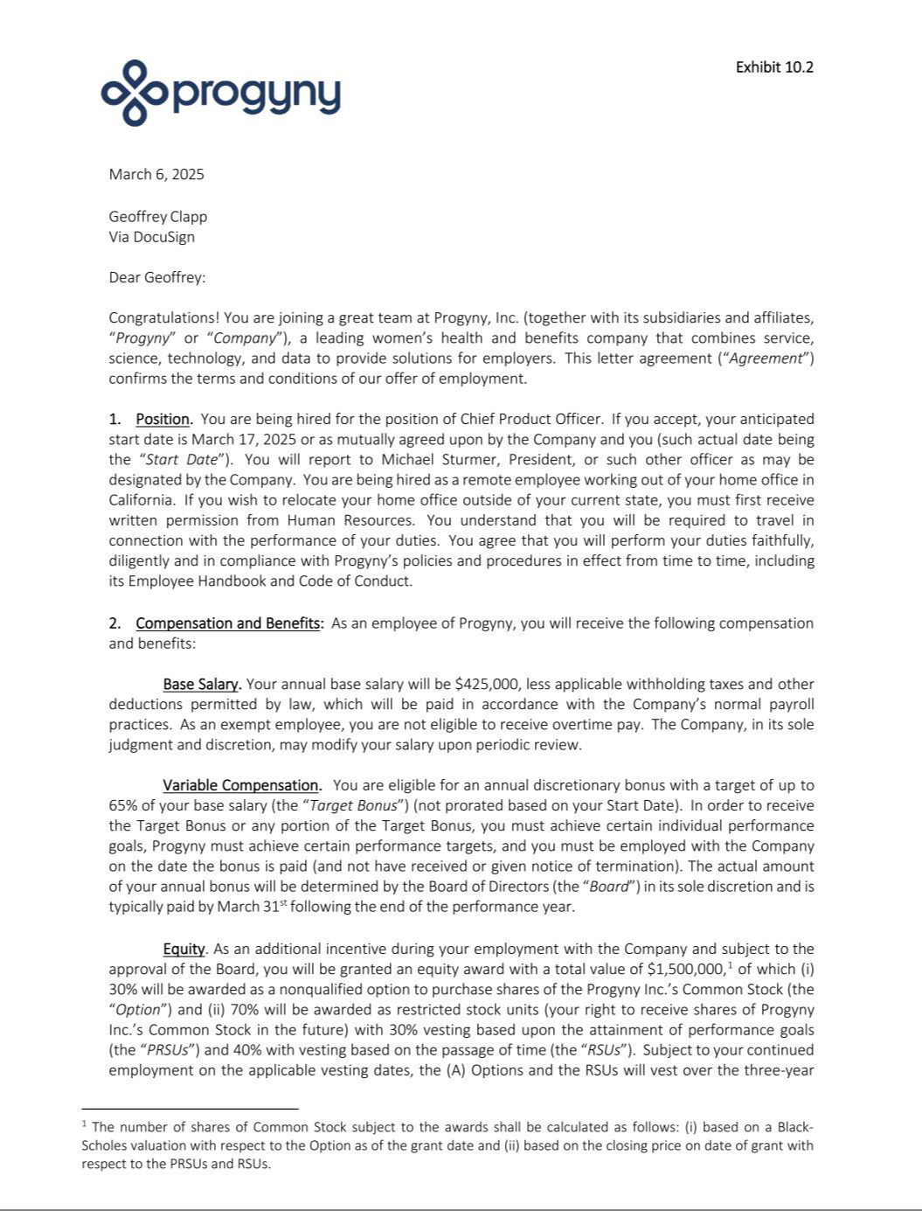

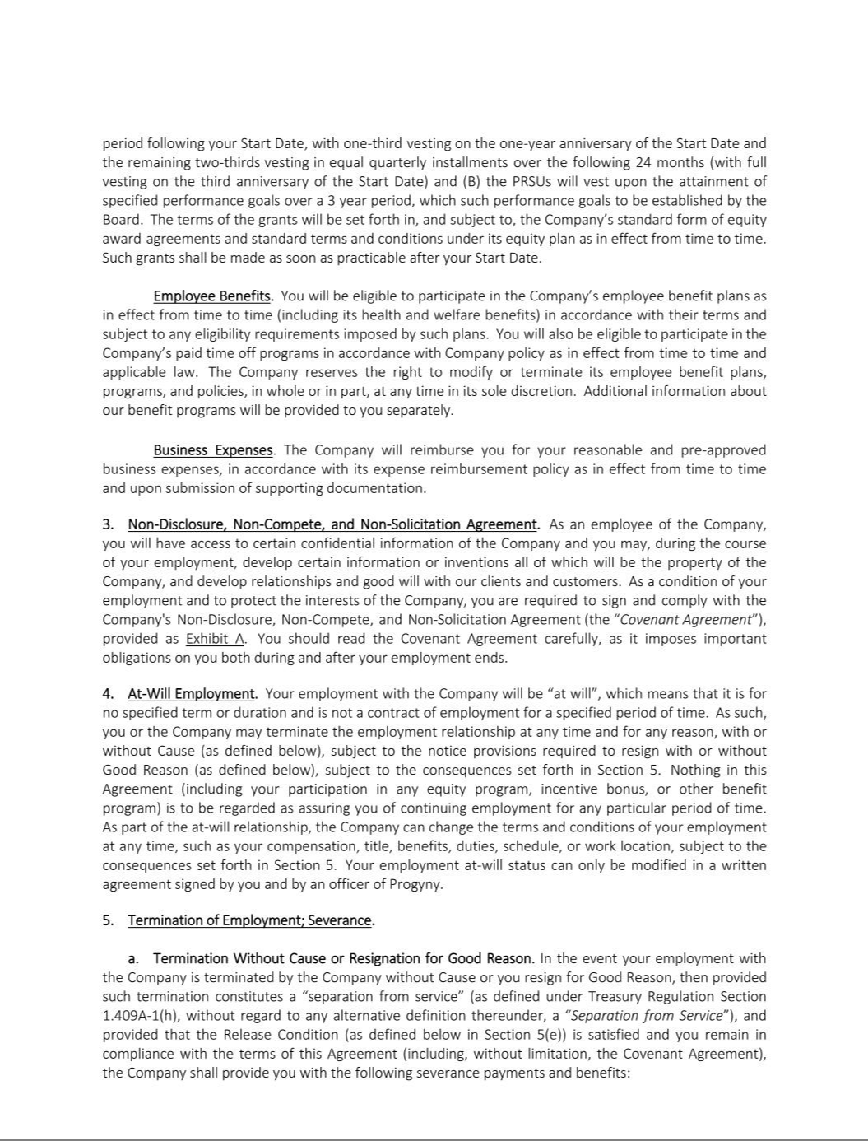

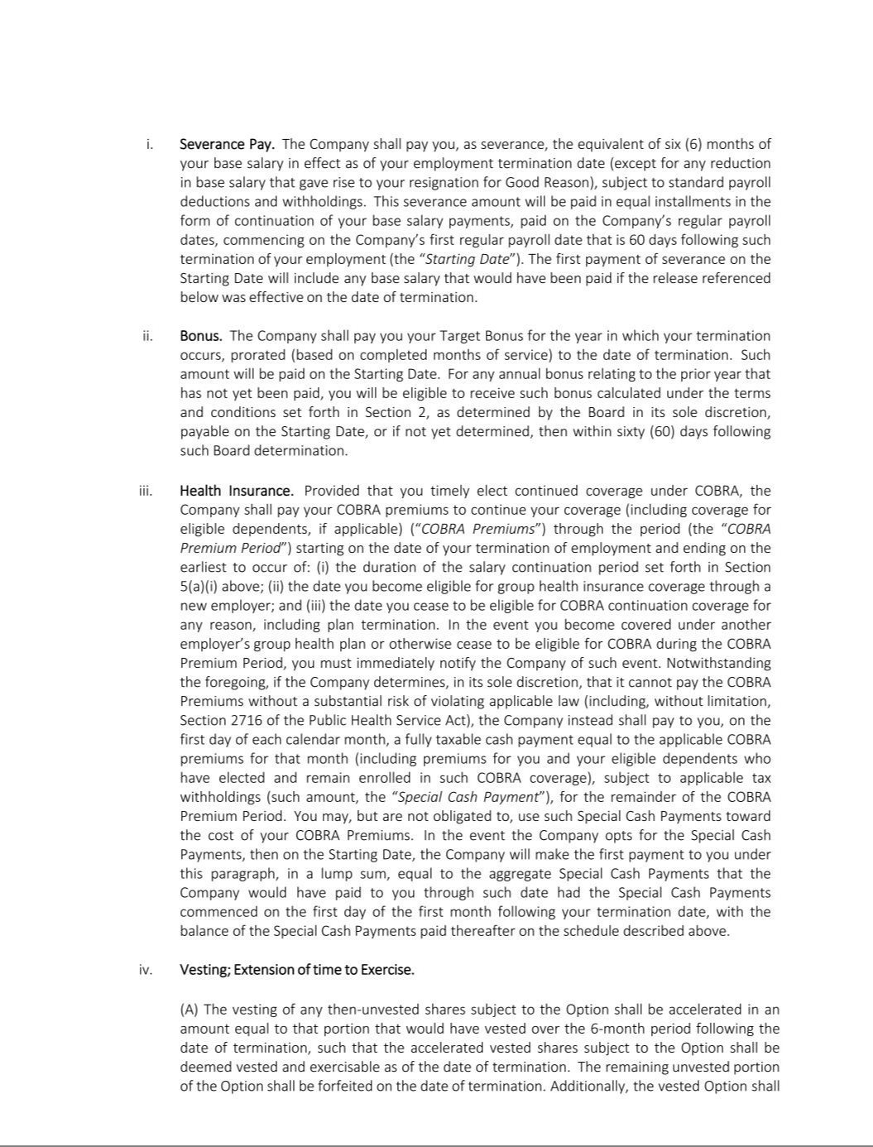

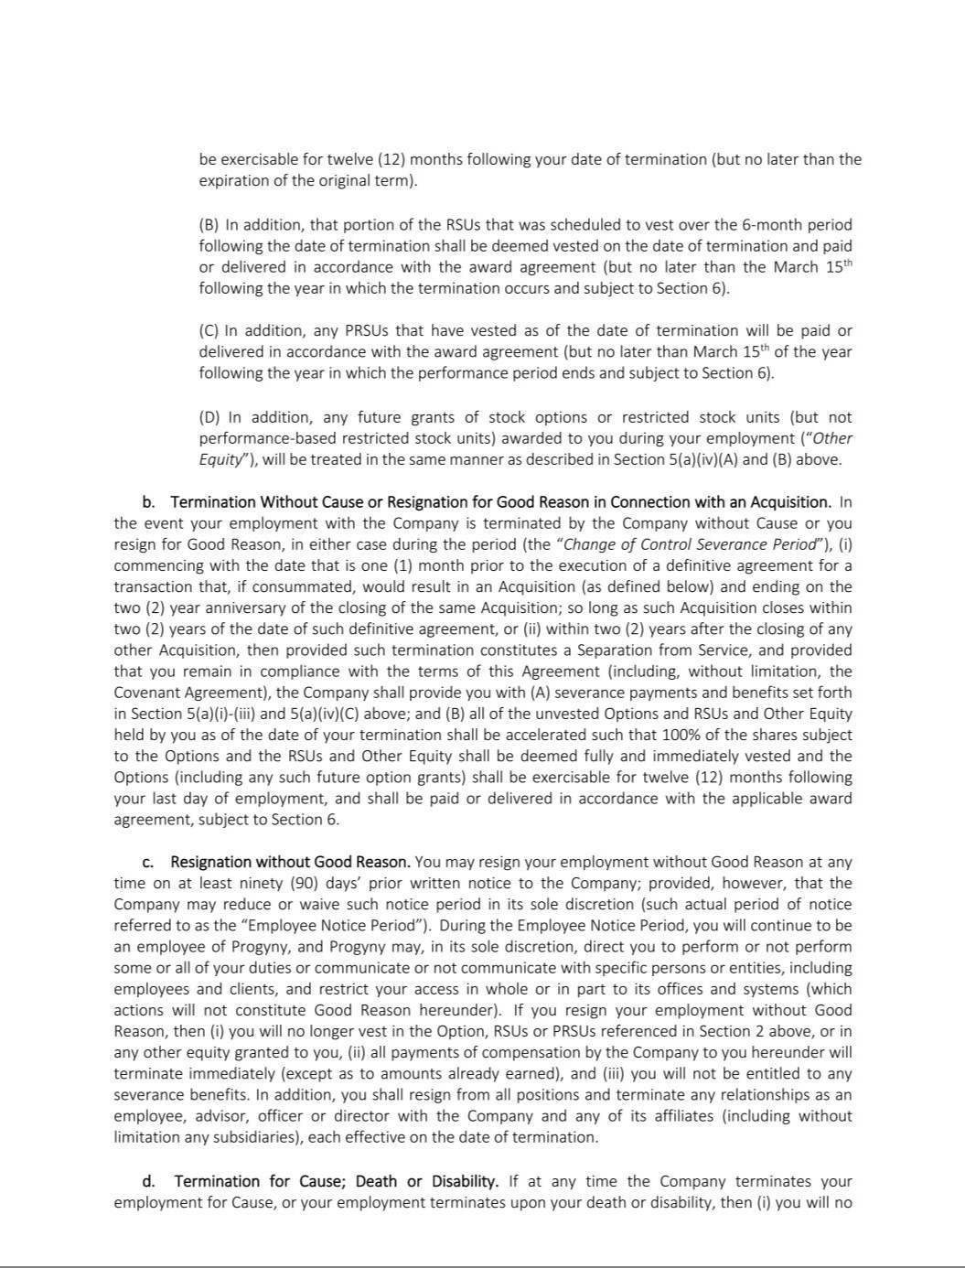

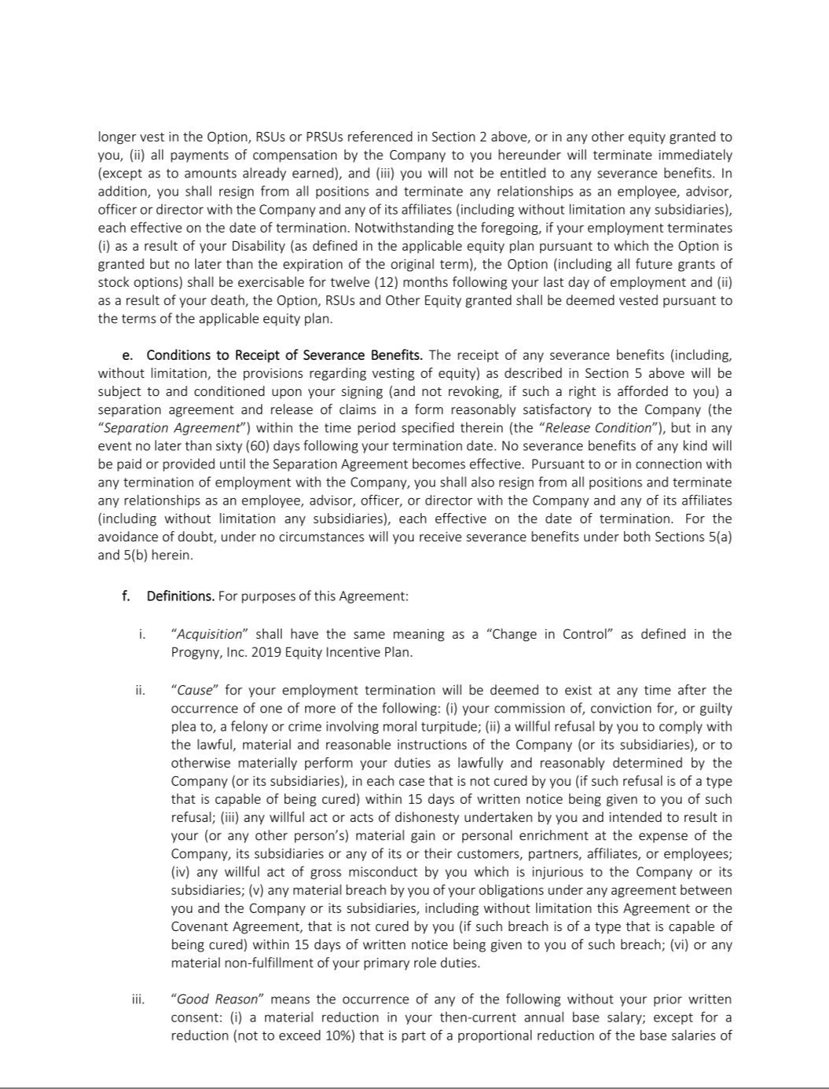

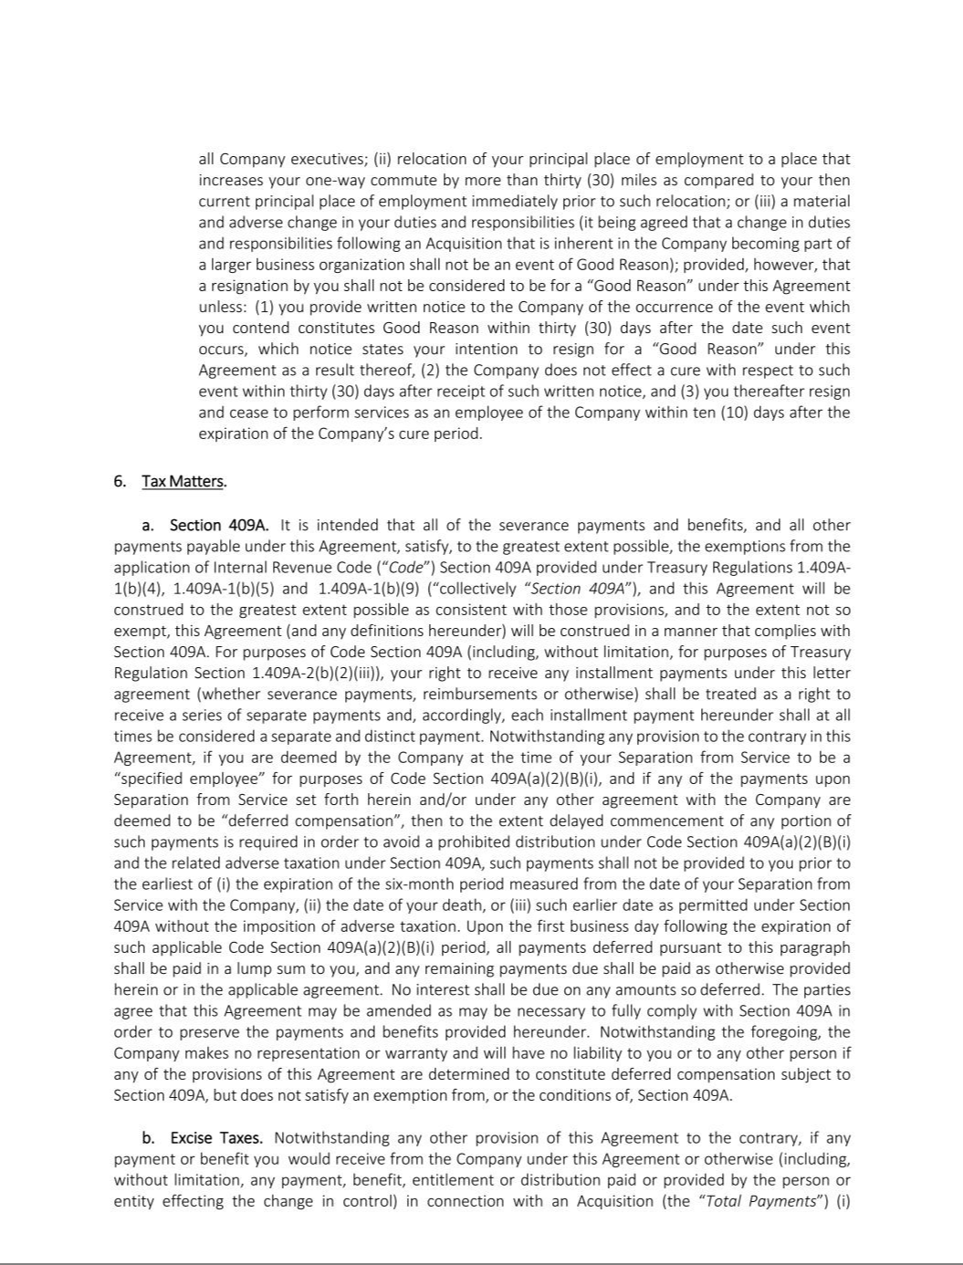

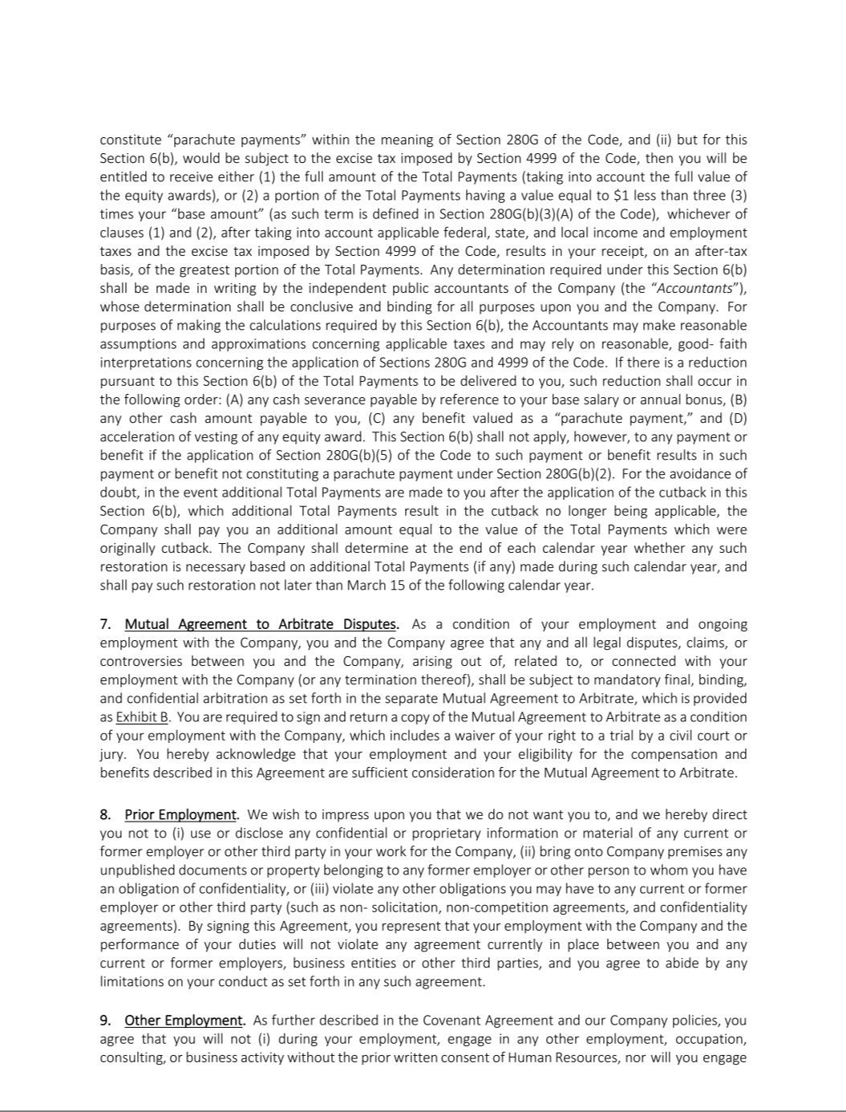

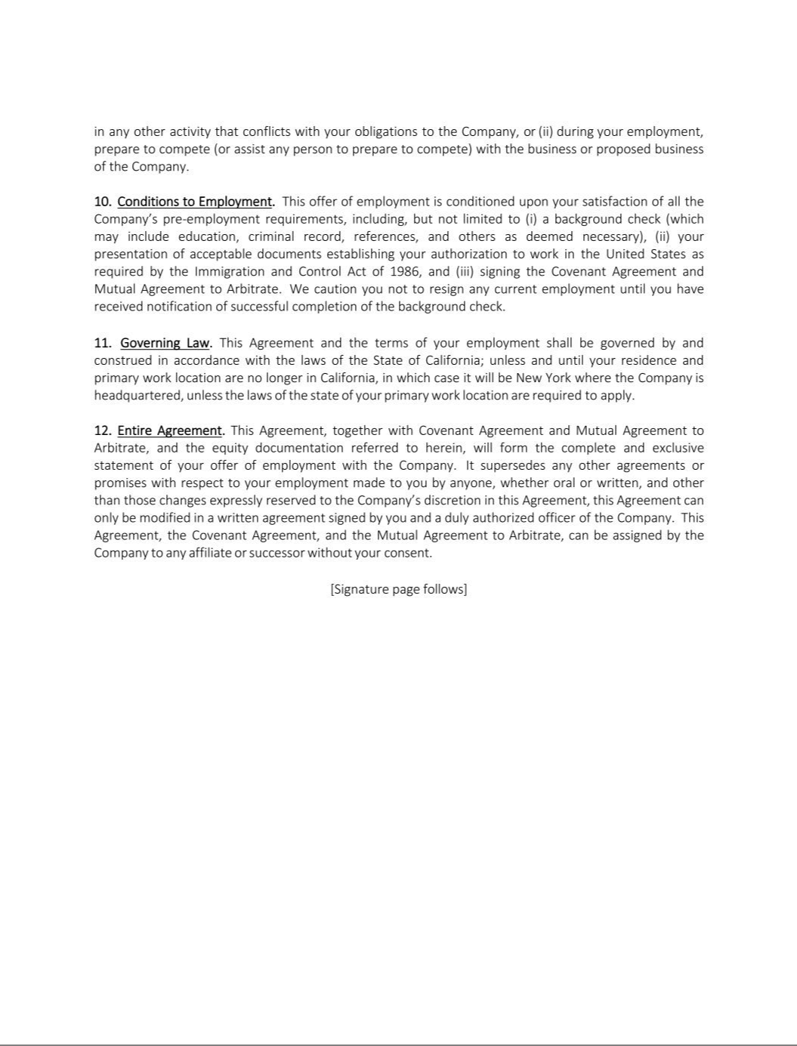

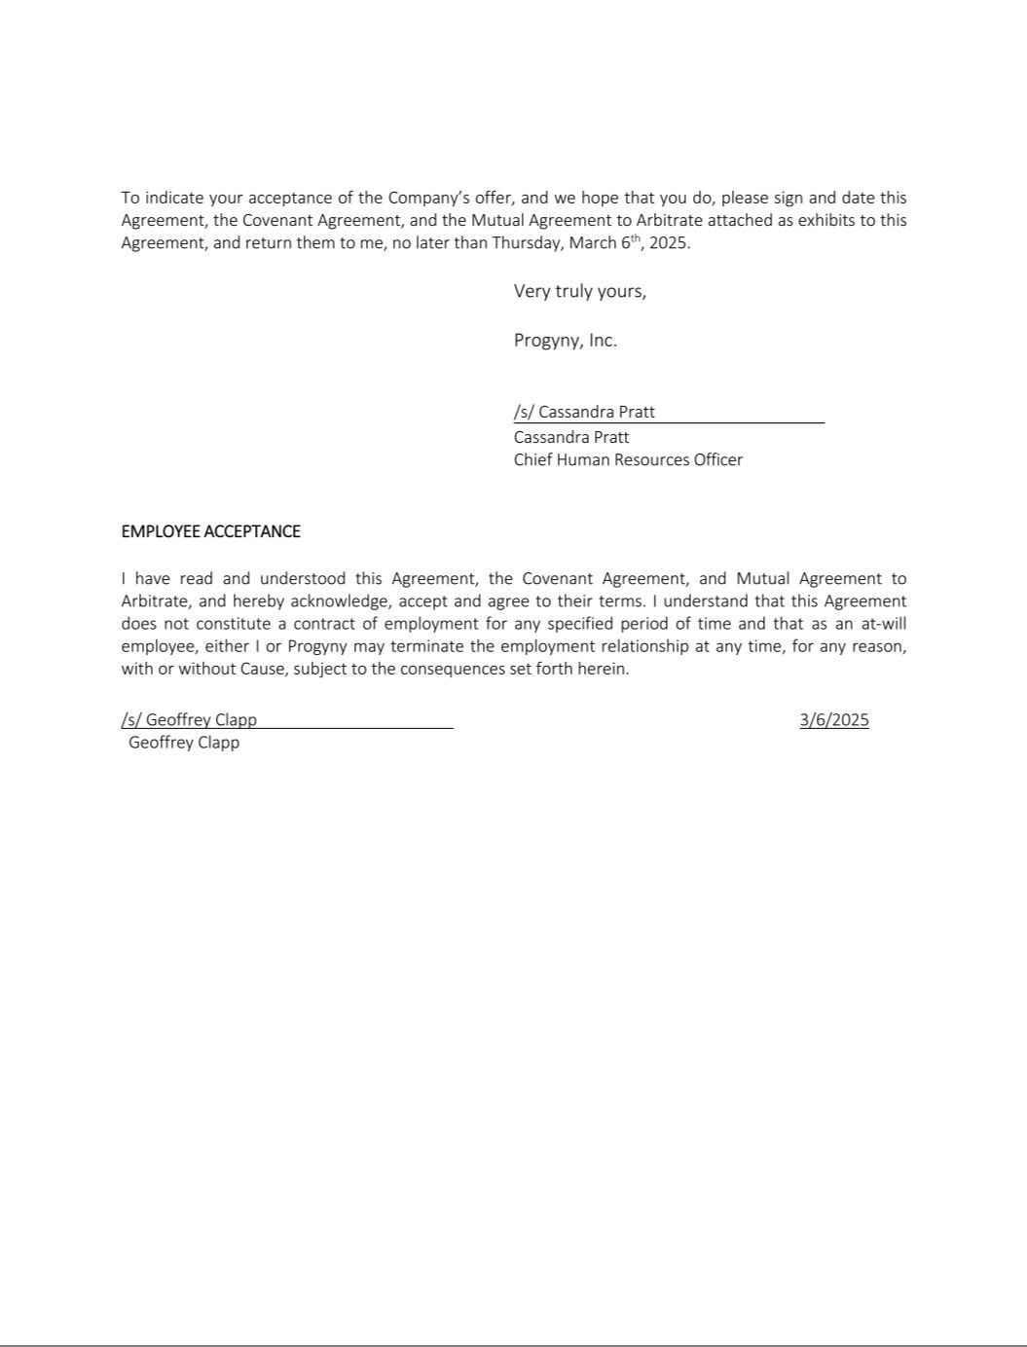

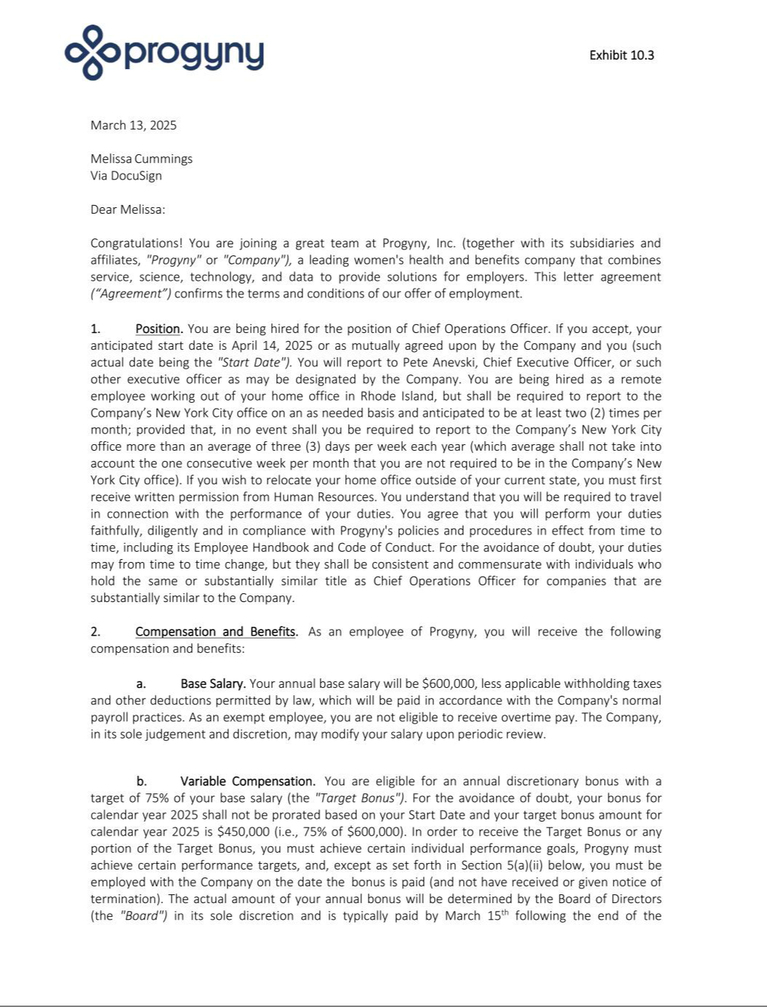

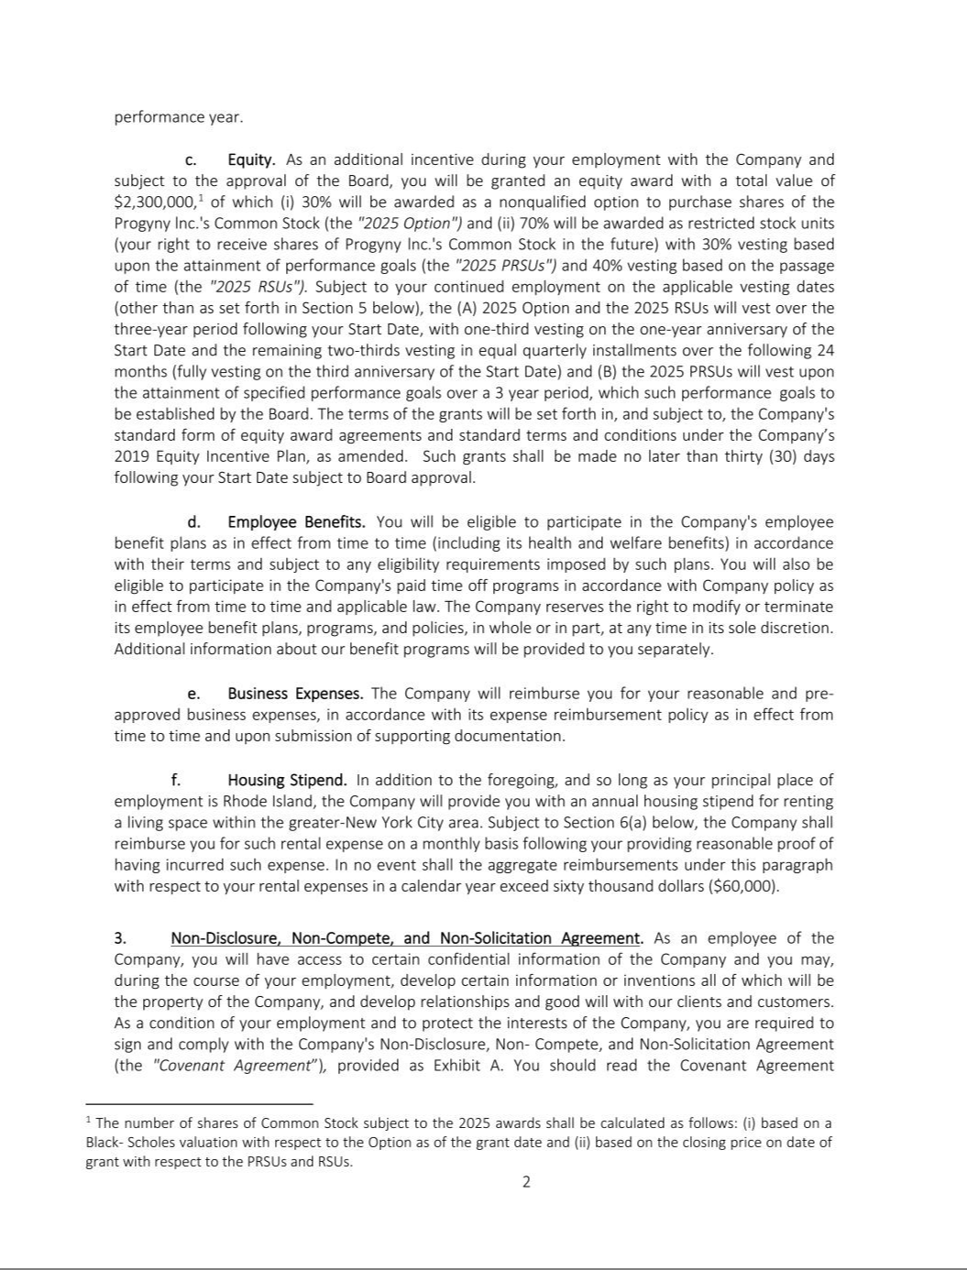

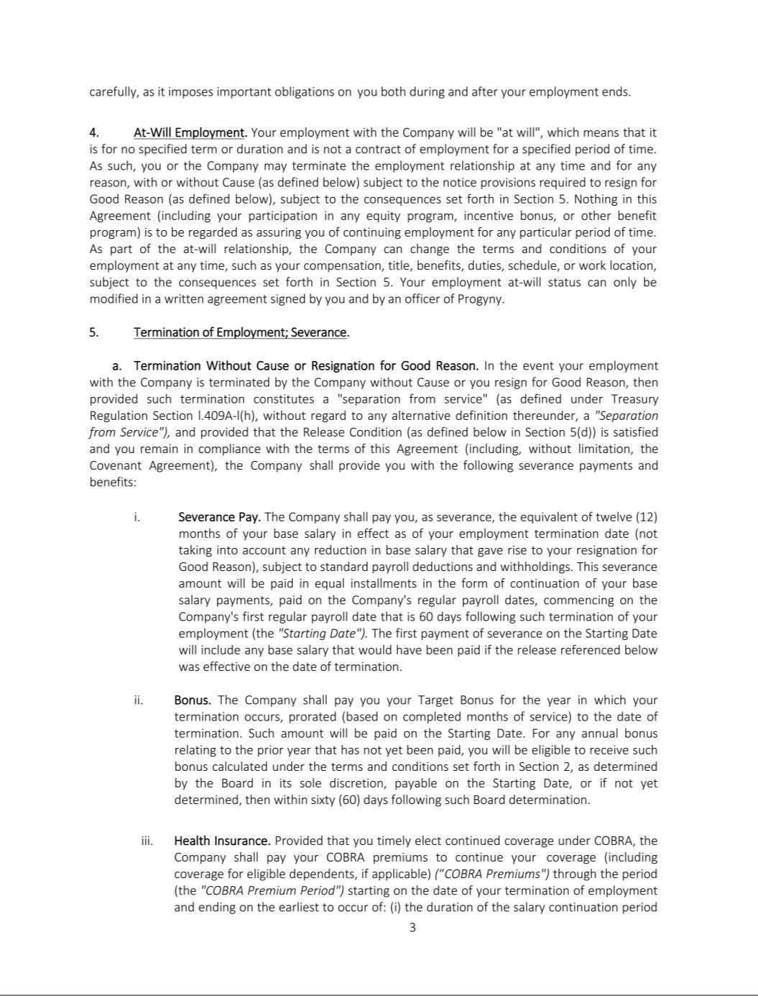

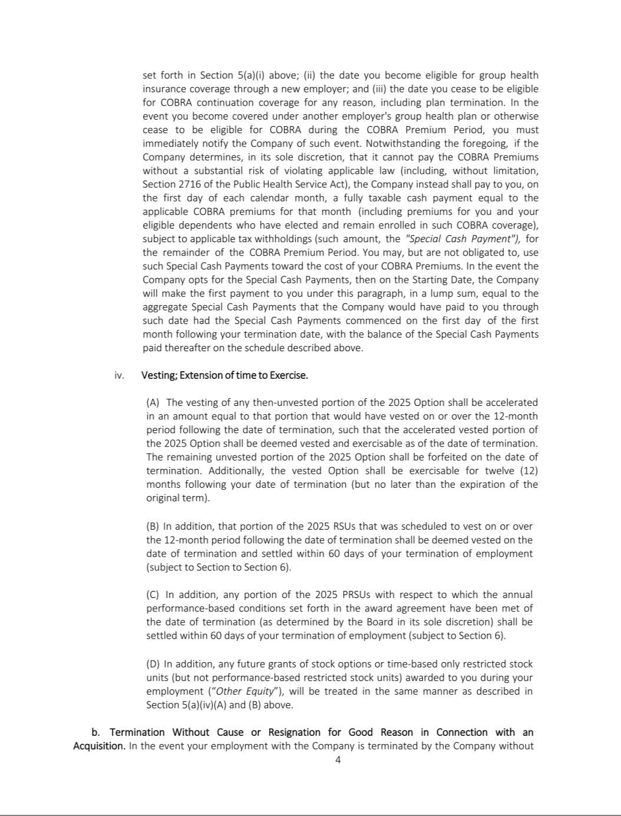

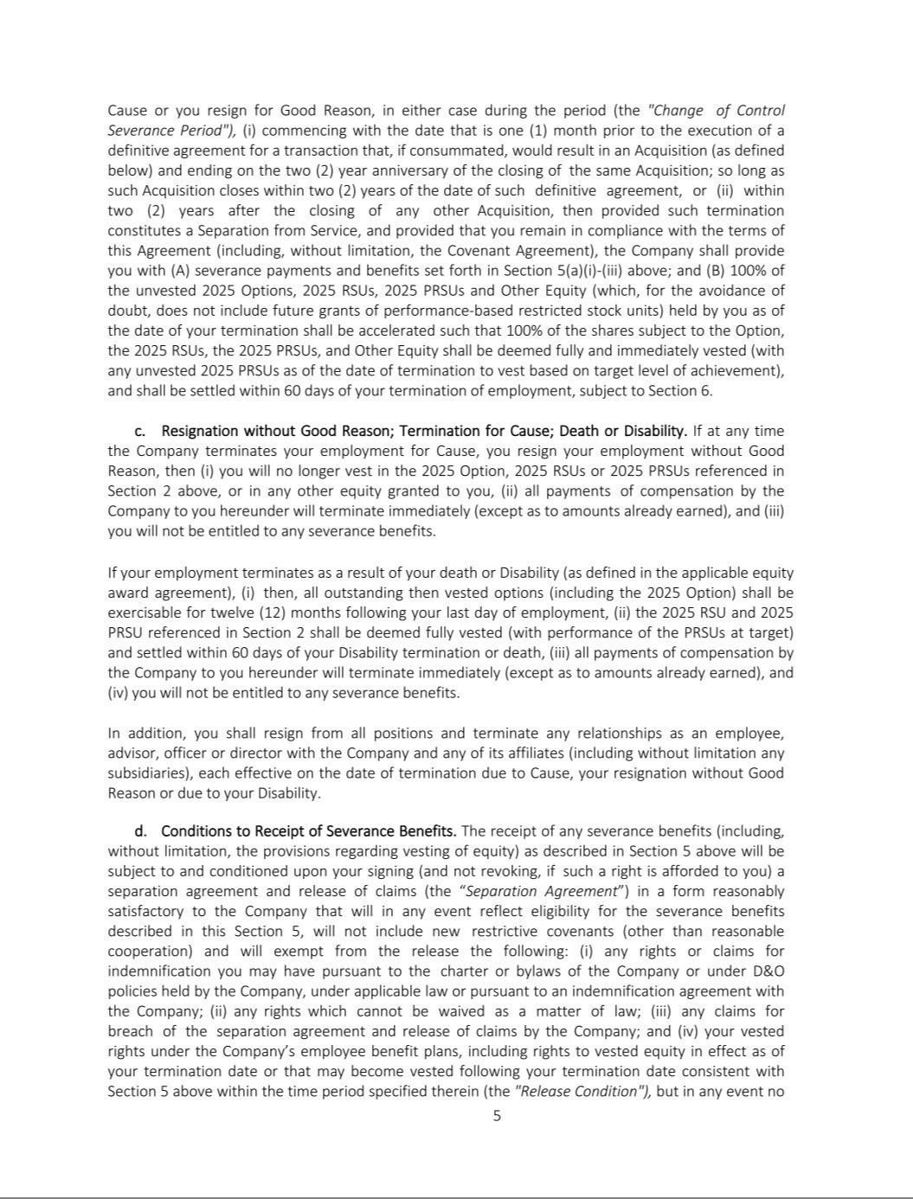

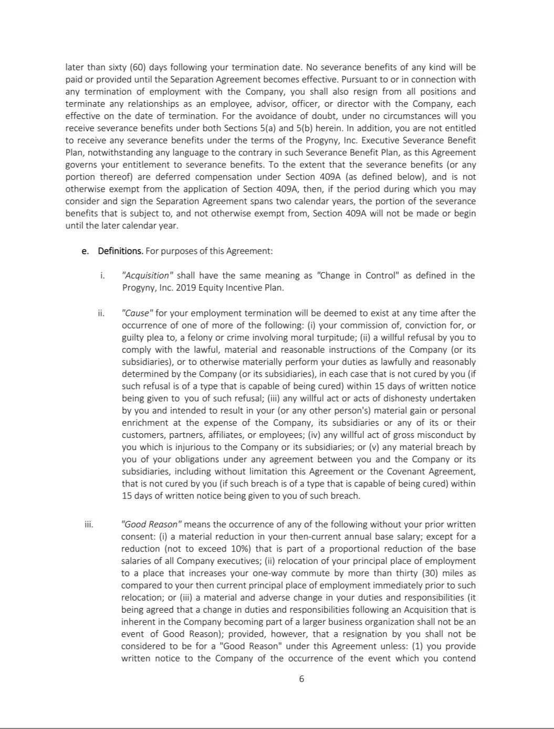

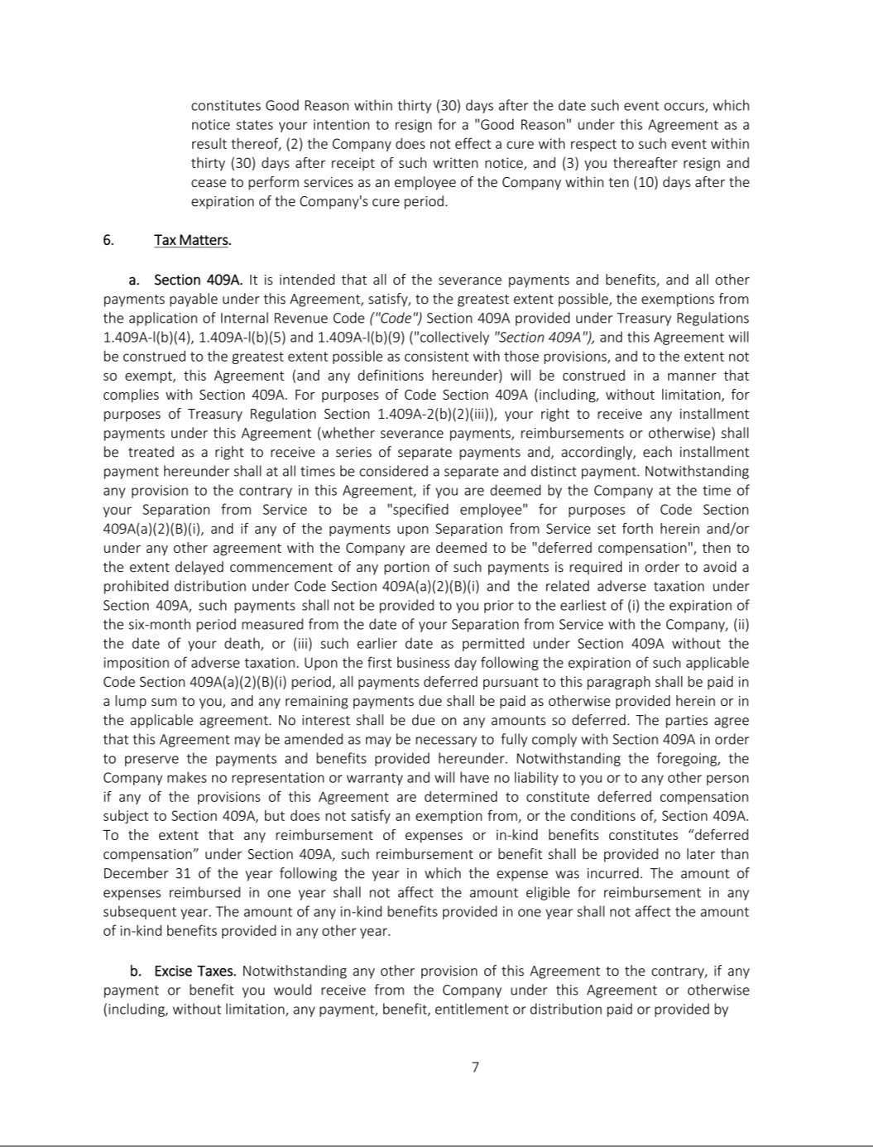

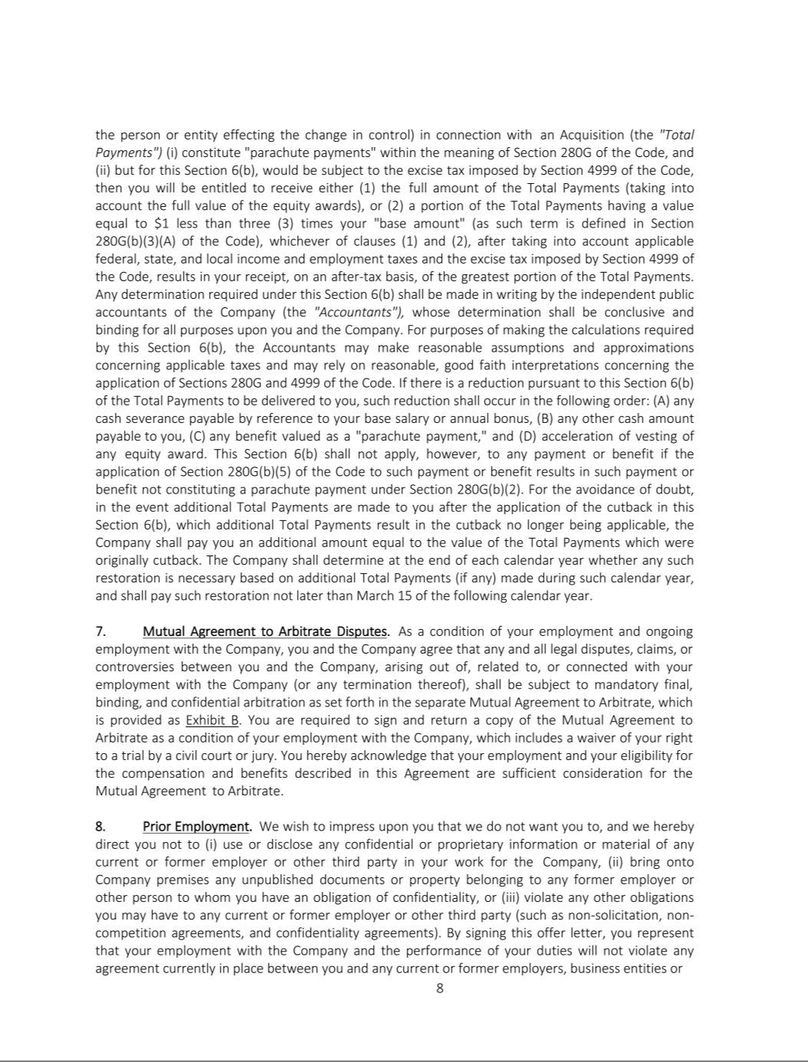

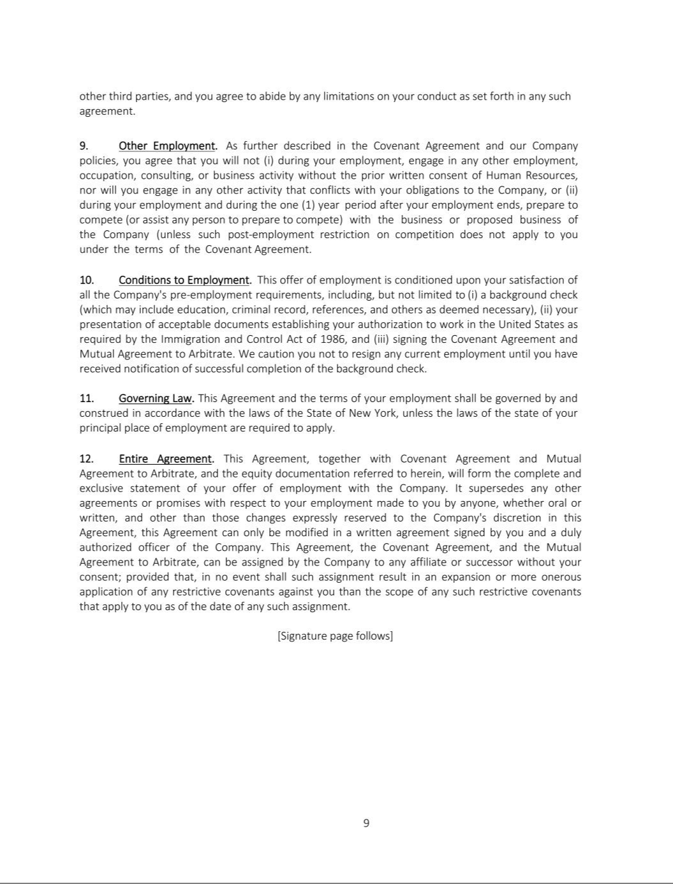



Exhibit 31.1

CERTIFICATION

I, Peter Anevski, certify that:

- I have reviewed this Quarterly Report on Form 10-Q of Progyny, Inc.;

- Based on my knowledge, this report does not contain any untrue statement of a material fact or omit to state a material fact necessary to make the statements made, in light of the circumstances under which such statements were made, not misleading with respect to the period covered by this report;

- Based on my knowledge, the financial statements, and other financial information included in this report, fairly present in all material respects the financial condition, results of operations and cash flows of the registrant as of, and for, the periods presented in this report;

- The registrant’s other certifying officer(s) and I are responsible for establishing and maintaining disclosure controls and procedures (as defined in Exchange Act Rules 13a-15(e) and 15d-15(e)) and internal control over financial reporting (as defined in Exchange Act Rules 13a-15(f) and 15d-15(f)) for the registrant and have:

  - Designed such disclosure controls and procedures, or caused such disclosure controls and procedures to be designed under our supervision, to ensure that material information relating to the registrant, including its consolidated subsidiaries, is made known to us by others within those entities, particularly during the period in which this report is being prepared;

  - Designed such internal control over financial reporting, or caused such internal control over financial reporting to be designed under our supervision, to provide reasonable assurance regarding the reliability of financial reporting and the preparation of financial statements for external purposes in accordance with generally accepted accounting principles;

  - Evaluated the effectiveness of the registrant’s disclosure controls and procedures and presented in this report our conclusions about the effectiveness of the disclosure controls and procedures, as of the end of the period covered by this report based on such evaluation; and

  - Disclosed in this report any change in the registrant’s internal control over financial reporting that occurred during the registrant’s most recent fiscal quarter (the registrant’s fourth fiscal quarter in the case of an annual report) that has materially affected, or is reasonably likely to materially affect, the registrant’s internal control over financial reporting; and

- The registrant’s other certifying officer(s) and I have disclosed, based on our most recent evaluation of internal control over financial reporting, to the registrant’s auditors and the audit committee of the registrant’s board of directors (or persons performing the equivalent functions):

  - All significant deficiencies and material weaknesses in the design or operation of internal control over financial reporting which are reasonably likely to adversely affect the registrant’s ability to record, process, summarize and report financial information; and

  - Any fraud, whether or not material, that involves management or other employees who have a significant role in the registrant’s internal control over financial reporting.

Date: August 8, 2025 By: /s/ Peter Anevski

Peter Anevski

Chief Executive Officer

(principal executive officer)

Exhibit 31.2

CERTIFICATION

I, Mark Livingston, certify that:

- I have reviewed this Quarterly Report on Form 10-Q of Progyny, Inc.;

- Based on my knowledge, this report does not contain any untrue statement of a material fact or omit to state a material fact necessary to make the statements made, in light of the circumstances under which such statements were made, not misleading with respect to the period covered by this report;

- Based on my knowledge, the financial statements, and other financial information included in this report, fairly present in all material respects the financial condition, results of operations and cash flows of the registrant as of, and for, the periods presented in this report;

- The registrant’s other certifying officer(s) and I are responsible for establishing and maintaining disclosure controls and procedures (as defined in Exchange Act Rules 13a-15(e) and 15d-15(e)) and internal control over financial reporting (as defined in Exchange Act Rules 13a-15(f) and 15d-15(f)) for the registrant and have:

  - Designed such disclosure controls and procedures, or caused such disclosure controls and procedures to be designed under our supervision, to ensure that material information relating to the registrant, including its consolidated subsidiaries, is made known to us by others within those entities, particularly during the period in which this report is being prepared;

  - Designed such internal control over financial reporting, or caused such internal control over financial reporting to be designed under our supervision, to provide reasonable assurance regarding the reliability of financial reporting and the preparation of financial statements for external purposes in accordance with generally accepted accounting principles;

  - Evaluated the effectiveness of the registrant’s disclosure controls and procedures and presented in this report our conclusions about the effectiveness of the disclosure controls and procedures, as of the end of the period covered by this report based on such evaluation; and

  - Disclosed in this report any change in the registrant’s internal control over financial reporting that occurred during the registrant’s most recent fiscal quarter (the registrant’s fourth fiscal quarter in the case of an annual report) that has materially affected, or is reasonably likely to materially affect, the registrant’s internal control over financial reporting; and

- The registrant’s other certifying officer(s) and I have disclosed, based on our most recent evaluation of internal control over financial reporting, to the registrant’s auditors and the audit committee of the registrant’s board of directors (or persons performing the equivalent functions):

  - All significant deficiencies and material weaknesses in the design or operation of internal control over financial reporting which are reasonably likely to adversely affect the registrant’s ability to record, process, summarize and report financial information; and

  - Any fraud, whether or not material, that involves management or other employees who have a significant role in the registrant’s internal control over financial reporting.

Date: August 8, 2025 By: /s/ Mark Livingston

Mark Livingston

Chief Financial Officer

(principal financial officer)

Exhibit 32.1

CERTIFICATION PURSUANT TO

18 U.S.C. SECTION 1350, AS ADOPTED PURSUANT TO

SECTION 906 OF THE SARBANES-OXLEY ACT OF 2002

In connection with the Quarterly Report on Form 10-Q of Progyny, Inc. (the “Company”) for the period ended June 30, 2025, as filed with the Securities and Exchange Commission on the date hereof (the “Report”), I certify, pursuant to 18 U.S.C. § 1350, as adopted pursuant to § 906 of the Sarbanes-Oxley Act of 2002, that, to my knowledge:

- The Report fully complies with the requirements of Section 13(a) or 15(d) of the Securities Exchange Act of 1934, as amended; and

- The information contained in the Report fairly presents, in all material respects, the financial condition and results of operations of the Company.

Date: August 8, 2025 By: /s/ Peter Anevski

Peter Anevski

Chief Executive Officer

(principal executive officer)

Exhibit 32.2

CERTIFICATION PURSUANT TO

18 U.S.C. SECTION 1350, AS ADOPTED PURSUANT TO

SECTION 906 OF THE SARBANES-OXLEY ACT OF 2002

In connection with the Quarterly Report on Form 10-Q of Progyny, Inc. (the “Company”) for the period ended June 30, 2025, as filed with the Securities and Exchange Commission on the date hereof (the “Report”), I certify, pursuant to 18 U.S.C. § 1350, as adopted pursuant to § 906 of the Sarbanes-Oxley Act of 2002, that, to my knowledge:

- The Report fully complies with the requirements of Section 13(a) or 15(d) of the Securities Exchange Act of 1934, as amended; and

- The information contained in the Report fairly presents, in all material respects, the financial condition and results of operations of the Company.

Date: August 8, 2025 By: /s/ Mark Livingston

Mark Livingston

Chief Financial Officer

(principal financial officer)

