UNITED STATES
SECURITIES AND EXCHANGE COMMISSION
WASHINGTON, D.C. 20549

FORM 8-K

CURRENT REPORT
Pursuant to Section 13 or 15(d)
of the Securities Exchange Act of 1934
Date of Report (Date of earliest event reported): August 6, 2026

Progyny, Inc.
(Exact Name of Registrant as Specified in Charter)

Delaware |  |  | 001-39100 |  |  | 27-2220139
(State or Other Jurisdiction  of Incorporation) |  |  | (Commission  File Number) |  |  | (IRS Employer  Identification No.)

1359 Broadway  New York, New York |  |  | 10018
(Address of Principal Executive Offices) |  |  | (Zip Code)
(212) 888-3124
(Registrant’s telephone number, including area code)
Not Applicable
(Former Name or Former Address, if Changed Since Last Report)

Check the appropriate box below if the Form 8-K filing is intended to simultaneously satisfy the filing obligation of the registrant under any of the following provisions:
☐ |  |  | Written communications pursuant to Rule 425 under the Securities Act (17 CFR 230.425)
☐ |  |  | Soliciting material pursuant to Rule 14a-12 under the Exchange Act (17 CFR 240.14a-12)
☐ |  |  | Pre-commencement communications pursuant to Rule 14d-2(b) under the Exchange Act (17 CFR 240.14d-2(b))
☐ |  |  | Pre-commencement communications pursuant to Rule 13e-4(c) under the Exchange Act (17 CFR 240.13e-4(c))

Securities registered pursuant to Section 12(b) of the Act:
Title of each class |  |  |  |  |  | Trading Symbol(s) |  |  |  |  |  | Name of each exchange on which registered
Common Stock, $0.0001 par value per share |  |  |  |  |  | PGNY |  |  |  |  |  | The Nasdaq Global Select Market
Indicate by check mark whether the registrant is an emerging growth company as defined in Rule 405 of the Securities Act of 1933 (§230.405 of this chapter) or Rule 12b-2 of the Securities Exchange Act of 1934 (§240.12b-2 of this chapter).
Emerging growth company ☐
If an emerging growth company, indicate by check mark if the registrant has elected not to use the extended transition period for complying with any new or revised financial accounting standards provided pursuant to Section 13(a) of the Exchange Act. ☐

Item 2.02 Results of Operations and Financial Condition and
Item 7.01 Regulation FD Disclosure.

On August 6, 2026, Progyny, Inc. (the “Company”) issued a press release announcing its financial results for the fiscal quarter ended June 30, 2026. A copy of this press release is furnished as Exhibit 99.1 to this Current Report on Form 8-K and is incorporated by reference herein.

In addition to the press release, a supplemental earnings presentation will be made available on the Company’s investor relations page at investors.progyny.com. A copy of this supplemental earnings presentation is furnished as Exhibit 99.2 to this Current Report on Form 8-K and is incorporated by reference herein.

The information furnished under Item 2.02 and Item 7.01, including Exhibit 99.1 and Exhibit 99.2, shall not be deemed “filed” for purposes of Section 18 of the Securities Exchange Act of 1934, as amended, or subject to the liabilities of that section. The information shall not be deemed incorporated by reference into any other filing with the Securities and Exchange Commission made by the Company, regardless of any general incorporation language in such filing.

Item 9.01 Financial Statements and Exhibits.

(d) Exhibits

Exhibit No. |  |  |  |  |  | Description
99.1 |  |  |  |  |  | Press Release of Progyny, Inc. dated August 6, 2026
99.2 |  |  |  |  |  | Second Quarter 2026 Earnings Supplemental Presentation
104 |  |  |  |  |  | Cover Page Interactive Data File (embedded within the Inline XBRL document)

SIGNATURES
Pursuant to the requirements of the Securities Exchange Act of 1934, as amended, the registrant has duly caused this report to be signed on its behalf by the undersigned hereunto duly authorized.
 |  |  | Progyny, Inc.
Date: August 6, 2026
 |  |  | By: |  |  | /s/ Peter Anevski
 |  |  |  |  |  | Peter Anevski
 |  |  |  |  |  | Chief Executive Officer

Progyny, Inc. Announces Second Quarter 2026 Results
Reports Record Quarterly Revenue, Gross Profit and Adjusted EBITDA
Robust Selling Season Activity Continues to Reflect Strong Demand for Women's Health, Family Building Solutions
Value Returned to Shareholders Through the Repurchase of Over 2 Million Shares Under Current Authorization

NEW YORK, August 6, 2026 /GlobeNewswire/ - Progyny, Inc. (Nasdaq: PGNY) (“Progyny” or the “Company”), a global leader in women's health and family building solutions, today announced its financial results for the three-month period ended June 30, 2026 (“the second quarter of 2026”), as compared to the three-month period ended June 30, 2025 (“the second quarter of 2025” or “the prior year period”).

“The strong second quarter results reflect that member engagement trended to the higher end of our expectations, as members continued to pursue the services they need in order to address their family building and overall health and well-being goals,” said Pete Anevski, Chief Executive Officer of Progyny.

“As we enter the heart of the selling season, momentum continues to be favorable and we're extremely pleased with our overall progress,” continued Anevski. “New lives and expected contribution from early commitments are pacing meaningfully ahead of this time last year; regarding renewals, based on commitments received to date, we've removed the vast majority of client retention risk with our largest accounts as well.”

“The second quarter results reflect strong topline growth, gross margin expansion, and the continued high conversion of Adjusted EBITDA to operating cash flow, which has given us the flexibility to continue investing in our platform while also returning value to shareholders through the repurchase of 2 million shares to date under the most recent authorization,” said Mark Livingston, Chief Financial Officer of Progyny.

Second Quarter 2026 Highlights:
(unaudited; in thousands, except per share amounts) |  |  | 2Q 2026 |  |  |  |  |  | 2Q 2025
Revenue |  |  | $350,511 |  |  |  |  |  | $332,874
Gross Profit |  |  | $89,301 |  |  |  |  |  | $78,973
Gross Margin |  |  | 25.5% |  |  |  |  |  | 23.7%
Net Income |  |  | $28,052 |  |  |  |  |  | $17,112
Net Income per Diluted Share1 |  |  | $0.34 |  |  |  |  |  | $0.19
Adjusted Earnings per Diluted Share2 |  |  | $0.55 |  |  |  |  |  | $0.48
Adjusted EBITDA2 |  |  | $62,104 |  |  |  |  |  | $57,946
Adjusted EBITDA Margin2 |  |  | 17.7% |  |  |  |  |  | 17.4%
Trailing Twelve-Month Operating Cash Flow |  |  | $201,248 |  |  |  |  |  | $201,997

1.Net income per diluted share reflects weighted-average shares outstanding as adjusted for potential dilutive securities, including options, restricted stock units, and shares issuable under the employee stock purchase plan.
2.Adjusted Earnings per Diluted Share, Adjusted EBITDA, and Adjusted EBITDA margin are financial measures that are not required by, or presented in accordance with U.S. generally accepted accounting principles ("GAAP"). Please see Annex A of this press release for a reconciliation of Adjusted Earnings per Diluted Share to earnings per share, and Adjusted EBITDA to net income, the most directly comparable financial measures stated in accordance with GAAP for each of the periods presented. We calculate Adjusted Earnings per Diluted Share as net income per diluted share excluding the impact of stock-based compensation, adjusted for the impact of taxes. We calculate Adjusted EBITDA margin as Adjusted EBITDA divided by revenue.

Financial Highlights
Revenue was $350.5 million, a 5.3% increase as compared to the $332.9 million reported in the second quarter of 2025, as the increase in the number of clients and covered lives was partially offset by the impact of the previously disclosed large client who did not renew its services for 2025, though it provided for an extended transition period over the first half of 2025 for members meeting certain criteria. There was no contribution from this client in the second quarter of 2026, and excluding the $17.2 million of revenue from this client in the second quarter of 2025, revenue increased 11.0%.
1

•Fertility benefit services revenue was $230.2 million, a 7.6% increase from the $213.9 million reported in the second quarter of 2025.
•Pharmacy benefit services revenue was $120.3 million, a 1.2% increase as compared to the $118.9 million reported in the second quarter of 2025.

Gross profit was $89.3 million, an increase of 13% from the $79.0 million reported in the second quarter of 2025, reflecting ongoing efficiencies realized in the delivery of our care management services as well as a decrease in stock-based compensation expense. Gross margin was 25.5%, as compared to 23.7% reported in the prior year.

Net income was $28.1 million, or $0.34 income per diluted share, as compared to the $17.1 million, or $0.19 income per diluted share, reported in the second quarter of 2025. The higher net income was due primarily to the higher operating profit and lower stock-based compensation expense, which was partially offset by lower interest and other income, net, and a higher provision for income taxes.

Adjusted EBITDA was $62.1 million, a increase of 7.2% as compared to the $57.9 million reported in the second quarter of 2025, as the higher gross profit was partially offset by planned investments to expand the features and functionality of our platform. Adjusted EBITDA margin was 17.7% as compared to the 17.4% Adjusted EBITDA margin in the second quarter of 2025. Refer to Annex A for a reconciliation of Adjusted EBITDA to net income.

Cash Flow
Net cash provided by operating activities in the second quarter of 2026 was $50.4 million, as compared to $55.5 million provided by operating activities in the prior year period. Cash flow reflects the timing impact of certain working capital items in both periods.

Balance Sheet and Financial Position
As of June 30, 2026, the Company had total working capital of approximately $272.9 million and no debt. This included cash and cash equivalents and marketable securities of $236.9 million, an increase of $11.8 million from the balances as of March 31, 2026 as the operating cash flow generated during the quarter was partially offset by share repurchase activity during the quarter. The Company's $200 million revolving credit facility remains undrawn, and the Company has no planned use for the facility at this time.

Share Repurchase Activity
During the second quarter of 2026, the Company repurchased nearly 1.2 million shares of its common stock for a total cost of $31.5 million through its May 2026 share repurchase program, which provided for a total authorization of up to $200 million. To date, the Company has repurchased a cumulative 2 million shares of its common stock under this most recent program, and approximately $142.5 million remains under the existing authorization. In combination with its predecessor program which began in November 2025 and concluded earlier this year, the Company has now repurchased an aggregate 10.8 million shares under both its May 2026 and November 2025 share repurchase programs.

Key Metrics
The Company had 604 fertility and family building clients as of June 30, 2026, as compared to 542 clients as of June 30, 2025.
 |  |  | Three Months Ended  June 30, |  |  |  |  |  |  |  |  |  |  |  | Six Months Ended  June 30,
 |  |  | 2026 |  |  |  |  |  | 2025 |  |  |  |  |  | 2026 |  |  |  |  |  | 2025
Assisted Reproductive Treatment (ART) Cycles(*) |  |  | 16,998 |  |  |  |  |  | 16,938 |  |  |  |  |  | 32,645 |  |  |  |  |  | 33,098
Utilization - All Members(**) |  |  | 0.56% |  |  |  |  |  | 0.55% |  |  |  |  |  | 0.85% |  |  |  |  |  | 0.82%
Utilization - Female Only(**) |  |  | 0.49% |  |  |  |  |  | 0.48% |  |  |  |  |  | 0.71% |  |  |  |  |  | 0.69%
Average Members(***) |  |  | 7,185,000 |  |  |  |  |  | 6,743,000 |  |  |  |  |  | 7,176,000 |  |  |  |  |  | 6,723,000
* Represents the number of ART cycles performed, including IVF with a fresh embryo transfer, IVF freeze all cycles/embryo banking, frozen embryo transfers, and egg freezing. Includes ART cycles performed in the first half of 2025 under the extended transition of care agreement with the large client who did not renew its service agreement.
2

** Represents the member utilization rate for all fertility and family building services, including, but not limited to, ART cycles, initial consultations, IUIs, and genetic testing. The utilization rate for all members includes all unique members (female and male) who utilize the benefit during that period, while the utilization rate for female only includes only unique females who utilize the benefit during that period. For purposes of calculating utilization rates in any given period, the results reflect the number of unique members utilizing the benefit for that period. Individual periods cannot be combined as member treatments may span multiple periods. Utilization for 2025 excludes activity under the extended transition of care agreement that ended June 30, 2025 with the large client who did not renew its service agreement, as only members meeting certain criteria were eligible to use the benefit.
***Includes approximately 300,000 members from a single client who are not reflected in utilization as a result of the client's chosen benefit design. 2025 excludes the limited number of members who were eligible to use the benefit under the extended transition of care agreement that ended June 30, 2025 with the large client who did not renew its service agreement.

Financial Outlook
Member engagement typically lessens during the peak of the summer months, and the third quarter guidance reflects a slightly more pronounced seasonal impact on member activity. With our present visibility, activity in September is consistent with the engagement seen over the first half of the year, and this is reflected in the assumptions for the remainder of the year.

The Company is providing the following financial guidance for both the three-month and full year periods ending September 30, 2026.

•Full Year 2026 Outlook:
oRevenue is projected to be $1.360 billion to $1.385 billion, reflecting growth of 5.5% to 7.5%; excluding the $48.5 million of revenue in 2025 from the large client who was under a transition agreement in the first half of 2025, revenue is expected to increase by 9.7% to 11.7%
oNet income is projected to be $104.8 million to $109.9 million, or $1.26 to $1.32 per diluted share, on the basis of approximately 83 million assumed weighted-average fully diluted-shares outstanding
oAdjusted EBITDA1 is projected to be $233.0 million to $240.0 million
oAdjusted earnings per diluted share1 is projected to be $2.04 to $2.10

•Third Quarter of 2026 Outlook:
oRevenue is projected to be $335.0 million to $345.0 million, reflecting growth of 6.9% to 10.1%
oNet income is projected to be $24.5 million to $26.7 million, or $0.30 to $0.33 per diluted share, on the basis of approximately 82 million assumed weighted-average fully diluted-shares outstanding
oAdjusted EBITDA1 is projected to be $56.0 million to $59.0 million
oAdjusted earnings per diluted share1 is projected to be $0.50 to $0.52

1.Adjusted EBITDA and Adjusted earnings per diluted share are financial measures that are not required by, or presented in accordance with, GAAP. Please see Annex A of this press release for a reconciliation of forward-looking Adjusted EBITDA to forward-looking net income and Adjusted net income to net income, the most directly comparable financial measures stated in accordance with GAAP, for the period presented.

Conference Call Information
Progyny will host a conference call at 4:45 P.M. Eastern Time (1:45 P.M. Pacific Time) today, August 6, 2026, to discuss its financial results. Interested participants from the United States may join by calling 1.866.825.7331 and using conference ID 265484. Participants from international locations may join by calling 1.973.413.6106 and using the same conference ID. A replay of the call will be available until August 13, 2026 at 5:00 P.M. Eastern Time by dialing 1.800.332.6854 (U.S. participants) or 1.973.528.0005 (international) and entering passcode 265484. A live audio webcast of the call and subsequent replay will also be available through the Events & Presentations section of the Company’s Investor Relations website at investors.progyny.com.

3

About Progyny
Progyny (Nasdaq: PGNY) is a global leader in women's health and family building solutions, trusted by the nation's leading employers, health plans and benefit purchasers. We envision a world where everyone can realize their dreams of family and ideal health. Our outcomes prove that comprehensive, inclusive and intentionally designed solutions simultaneously benefit employers, patients, and physicians.

Our benefits solution empowers patients with concierge support, coaching, education, and digital tools; provides access to a premier network of fertility and women's health specialists who use the latest science and technologies; drives optimal clinical outcomes; and reduces healthcare costs.

Headquartered in New York City, Progyny has been recognized for its leadership and growth as a TIME100 Most Influential Company, CNBC Disruptor 50, Modern Healthcare’s Best Places to Work in Healthcare, Forbes' Best Employers, Financial Times Fastest Growing Companies, INC. 5000, INC. Power Partners and Crain’s Fast 50 for NYC. For more information, visit www.progyny.com.

Safe Harbor Statement Under the Private Securities Litigation Reform Act of 1995
This press release contains forward-looking statements within the meaning of the Private Securities Litigation Reform Act of 1995. We intend such forward-looking statements to be covered by the safe harbor provisions for forward-looking statements contained in Section 27A of the Securities Act of 1933, as amended, and Section 21E of the Securities Exchange Act of 1934, as amended. All statements contained in this press release other than statements of historical fact, including, without limitation, statements regarding our financial outlook for the third quarter and full year 2026, including the impact of our sales season and client launches; our anticipated number of clients and covered lives for 2026; our expected utilization rates and mix; the demand for our solutions; our expectations for our selling season for 2027 launches; our positioning to successfully manage economic uncertainty on our business; the timing of client decisions; our ability to retain existing clients and acquire new clients; and our business strategy, plans, goals and expectations concerning our market position, future operations, and other financial and operating information. The words “anticipates,” “assumes,” “believe,” “contemplate,” “continues, ” “could,” “estimates,” “expects,” “future,” “intends,” “may,” “plans,” “predict,” “potential,” “project,” “seeks,” “should,” “target,” “will,” and the negative of these or similar expressions and phrases are intended to identify forward-looking statements, though not all forward-looking statements use these words or expressions.

Forward-looking statements are neither promises nor guarantees, but involve known and unknown risks, uncertainties and other important factors that may cause our actual results, performance or achievements to be materially different from any future results, performance or achievements expressed or implied by the forward-looking statements. These risks include, without limitation, failure to meet our publicly announced guidance or other expectations about our business; competition in the market in which we operate; our history of operating losses and ability to sustain profitability; unfavorable conditions in our industry or the United States economy; our limited operating history and the difficulty in predicting our future results of operations; our ability to attract and retain clients and increase the adoption of services within our client base; the loss of any of our largest client accounts; changes in the technology industry; changes or developments in the health insurance market; negative publicity in the health benefits industry; lags, failures or security breaches in our computer systems or those of our vendors; a significant change in the utilization of our solutions; our ability to offer high-quality support; positive references from our existing clients; our ability to develop and expand our marketing and sales capabilities; the rate of growth of our future revenue; the accuracy of the estimates and assumptions we use to determine the size of target markets; our ability to successfully manage our growth; reductions in employee benefits spending; seasonal fluctuations in our sales; the adoption of new solutions and services by our clients or members; our ability to innovate and develop new offerings; our ability to adapt and respond to the changing medical landscape, regulations, and client needs, requirements or preferences; our ability to maintain and enhance our brand; our ability to attract and retain members of our management team, key employees, or other qualified personnel; risks related to any litigation against us; our ability to maintain our Center of Excellence network of healthcare providers; our strategic relationships with and monitoring of third parties; our ability to maintain our pharmacy distribution network if there is a disruption to our network or its associated supply chains; our relationship with
4

key pharmacy program partners or any decline in rebates provided by them; our ability to maintain our relationships with benefits consultants; exposure to credit risk from our members; risks related to government regulation; risks related to our business with government entities; our ability to protect our intellectual property rights; risks related to acquisitions, strategic investments, or partnerships; federal tax reform and changes to our effective tax rate; the imposition of state and local state taxes; our ability to utilize a portion of our net operating loss or research tax credit carryforwards; our ability to develop or maintain effective internal control over financial reporting; and our ability to adapt and respond to the changing SEC or stakeholder expectations regarding environmental, social and governance practices. For a detailed discussion of these and other risk factors, please refer to our filings with the Securities and Exchange Commission (the “SEC”), including in the section entitled “Risk Factors” in our Annual Report on Form 10-K for the fiscal year ended December 31, 2025, and subsequent reports that we file with the SEC, which are available at http://investors.progyny.com and on the SEC’s website at https://www.sec.gov.

Forward-looking statements represent our management’s beliefs and assumptions only as of the date of this press release. Our actual future results could differ materially from what we expect. Except as required by law, we assume no obligation to update these forward-looking statements publicly, or to update the reasons.

Non-GAAP Financial Measures
In addition to disclosing financial measures prepared in accordance with U.S. generally accepted accounting principles (“GAAP”), this press release and the accompanying tables include the non-GAAP financial measures Adjusted EBITDA, Adjusted EBITDA margin, and Adjusted earnings per diluted share.

Adjusted EBITDA, Adjusted EBITDA margin, and Adjusted earnings per diluted share are supplemental financial measures that are not required by, or presented in accordance with, GAAP. We believe that these non-GAAP measures, when taken together with our GAAP financial results, provide meaningful supplemental information regarding our operating performance and facilitates internal comparisons of our historical operating performance on a more consistent basis by excluding certain items that may not be indicative of our business, results of operations or outlook. In particular, we believe that the use of Adjusted EBITDA, Adjusted EBITDA margin, and Adjusted earnings per diluted share are helpful to our investors as they are measures used by management in assessing the health of our business, determining incentive compensation, evaluating our operating performance, and for internal planning and forecasting purposes.

Adjusted EBITDA, Adjusted EBITDA margin, and Adjusted earnings per diluted share are presented for supplemental informational purposes only, have limitations as analytical tools and should not be considered in isolation or as a substitute for financial information presented in accordance with GAAP. Some of the limitations of Adjusted EBITDA, Adjusted EBITDA margin, and Adjusted earnings per diluted share include: (1) it does not properly reflect capital commitments to be paid in the future; (2) although depreciation and amortization are non-cash charges, the underlying assets may need to be replaced and Adjusted EBITDA does not reflect these capital expenditures; (3) it does not consider the impact of stock-based compensation expense; (4) it does not reflect other non-operating income and expenses, including interest and other income, net; and (5) it does not reflect tax payments that may represent a reduction in cash available to us. In addition, our non-GAAP measures may not be comparable to similarly titled measures of other companies because they may not calculate such measures in the same manner as we calculate these measures, limiting their usefulness as comparative measures. Because of these limitations, when evaluating our performance, you should consider Adjusted EBITDA, Adjusted EBITDA margin, and Adjusted earnings per diluted share alongside other financial performance measures, including our net income, gross margin, and our other GAAP results.

5

We calculate Adjusted EBITDA as net income, adjusted to exclude depreciation and amortization; stock-based compensation expense; interest and other income, net; and provision for income taxes. We calculate Adjusted EBITDA margin as Adjusted EBITDA divided by revenue. We calculate Adjusted earnings per diluted share as net income per diluted share excluding the impact of stock-based compensation, adjusted for the associated impact of taxes. Please see Annex A: “Reconciliation of GAAP to Non-GAAP Financial Measures” elsewhere in this press release.

For Further Information, Please Contact:
Investors:
James Hart
investors@progyny.com

Media:
Alexis Ford
media@progyny.com

6

PROGYNY, INC.
Consolidated Balance Sheets
(Unaudited)
(in thousands, except share and per share amounts)
 |  |  | June 30, |  |  |  |  |  | December 31,
 |  |  | 2026 |  |  |  |  |  | 2025
ASSETS
Current assets:
Cash and cash equivalents |  |  | $ | 152,632 |  |  |  |  | $ | 112,238
Marketable securities |  |  | 84,293 |  |  |  |  |  | 197,858
Accounts receivable, net of $54,735 and $55,659 of allowances at June 30, 2026 and December 31, 2025, respectively |  |  | 257,476 |  |  |  |  |  | 220,287
Prepaid expenses and other current assets |  |  | 18,617 |  |  |  |  |  | 21,392
Total current assets |  |  | 513,018 |  |  |  |  |  | 551,775
Property and equipment, net |  |  | 41,992 |  |  |  |  |  | 29,927
Operating lease right-of-use assets |  |  | 23,577 |  |  |  |  |  | 24,990
Goodwill |  |  | 19,853 |  |  |  |  |  | 19,978
Intangible assets, net |  |  | 5,748 |  |  |  |  |  | 6,216
Deferred tax assets, net |  |  | 93,077 |  |  |  |  |  | 93,013
Other noncurrent assets |  |  | 18,571 |  |  |  |  |  | 16,536
Total assets |  |  | $ | 715,836 |  |  |  |  | $ | 742,435
LIABILITIES AND STOCKHOLDERS’ EQUITY
Current liabilities:
Accounts payable |  |  | $ | 152,050 |  |  |  |  | $ | 124,071
Accrued expenses and other current liabilities |  |  | 88,034 |  |  |  |  |  | 78,320
Total current liabilities |  |  | 240,084 |  |  |  |  |  | 202,391
Operating lease noncurrent liabilities |  |  | 22,495 |  |  |  |  |  | 24,000
Total liabilities |  |  | 262,579 |  |  |  |  |  | 226,391
Commitments and Contingencies
STOCKHOLDERS' EQUITY
Common stock, $0.0001 par value; 1,000,000,000 shares authorized; at June 30, 2026 and December 31, 2025, respectively; 99,774,414 and 99,049,485 shares issued; 77,390,288 and 83,365,696 outstanding at June 30, 2026 and December 31, 2025, respectively |  |  | 9 |  |  |  |  |  | 9
Additional paid-in capital |  |  | 735,417 |  |  |  |  |  | 700,785
Treasury stock, at cost, $0.0001 par value; 23,000,106 and 16,299,769 shares at June 30, 2026 and December 31, 2025, respectively |  |  | (537,525) |  |  |  |  |  | (388,075)
Accumulated earnings |  |  | 255,111 |  |  |  |  |  | 202,827
Accumulated other comprehensive income |  |  | 245 |  |  |  |  |  | 498
Total stockholders’ equity |  |  | 453,257 |  |  |  |  |  | 516,044
Total liabilities and stockholders’ equity |  |  | $ | 715,836 |  |  |  |  | $ | 742,435

7

PROGYNY, INC.
Consolidated Statements of Operations
(Unaudited)
(in thousands, except share and per share amounts)

 |  |  | Three Months Ended  June 30, |  |  |  |  |  |  |  |  |  |  |  | Six Months Ended  June 30,
 |  |  | 2026 |  |  |  |  |  | 2025 |  |  |  |  |  | 2026 |  |  |  |  |  | 2025
Revenue |  |  | $ | 350,511 |  |  |  |  | $ | 332,874 |  |  |  |  | $ | 679,015 |  |  |  |  | $ | 656,912
Cost of services |  |  | 261,210 |  |  |  |  |  | 253,901 |  |  |  |  |  | 506,643 |  |  |  |  |  | 502,144
Gross profit |  |  | 89,301 |  |  |  |  |  | 78,973 |  |  |  |  |  | 172,372 |  |  |  |  |  | 154,768
Operating expenses:
Sales and marketing |  |  | 18,074 |  |  |  |  |  | 18,405 |  |  |  |  |  | 34,958 |  |  |  |  |  | 36,191
General and administrative |  |  | 31,224 |  |  |  |  |  | 36,210 |  |  |  |  |  | 62,032 |  |  |  |  |  | 70,049
Total operating expenses |  |  | 49,298 |  |  |  |  |  | 54,615 |  |  |  |  |  | 96,990 |  |  |  |  |  | 106,240
Income from operations |  |  | 40,003 |  |  |  |  |  | 24,358 |  |  |  |  |  | 75,382 |  |  |  |  |  | 48,528
Interest and other income, net |  |  | 1,134 |  |  |  |  |  | 2,719 |  |  |  |  |  | 2,638 |  |  |  |  |  | 5,086
Income before income taxes |  |  | 41,137 |  |  |  |  |  | 27,077 |  |  |  |  |  | 78,020 |  |  |  |  |  | 53,614
Provision for income taxes |  |  | 13,085 |  |  |  |  |  | 9,965 |  |  |  |  |  | 25,736 |  |  |  |  |  | 21,443
Net income |  |  | $ | 28,052 |  |  |  |  | $ | 17,112 |  |  |  |  | $ | 52,284 |  |  |  |  | $ | 32,171
Net income per share:
Basic |  |  | $ | 0.36 |  |  |  |  | $ | 0.20 |  |  |  |  | $ | 0.66 |  |  |  |  | $ | 0.38
Diluted |  |  | $ | 0.34 |  |  |  |  | $ | 0.19 |  |  |  |  | $ | 0.63 |  |  |  |  | $ | 0.36
Weighted-average shares used in computing net income per share:
Basic |  |  | 78,165,235 |  |  |  |  |  | 85,766,254 |  |  |  |  |  | 79,528,569 |  |  |  |  |  | 85,644,091
Diluted |  |  | 82,141,428 |  |  |  |  |  | 89,638,677 |  |  |  |  |  | 83,476,446 |  |  |  |  |  | 89,507,906

8

PROGYNY, INC.
Consolidated Statements of Cash Flows
(Unaudited)
(in thousands)
Six Months Ended
June 30,
 |  |  |  |  |  | 2026 |  |  |  |  |  | 2025
OPERATING ACTIVITIES
Net income |  |  |  |  |  | $ | 52,284 |  |  |  |  | $ | 32,171
Adjustments to reconcile net income to net cash provided by operating activities:
Deferred tax expense |  |  |  |  |  | 20 |  |  |  |  |  | 23
Non-cash interest expense |  |  |  |  |  | 437 |  |  |  |  |  | —
Depreciation and amortization |  |  |  |  |  | 3,106 |  |  |  |  |  | 2,313
Loss on disposal of property and equipment |  |  |  |  |  | 580 |  |  |  |  |  | 79
Stock-based compensation expense |  |  |  |  |  | 40,199 |  |  |  |  |  | 64,895
Bad debt expense |  |  |  |  |  | 10,176 |  |  |  |  |  | 11,017
Net accretion of discounts on marketable securities |  |  |  |  |  | 566 |  |  |  |  |  | 27
Changes in operating assets and liabilities:
Accounts receivable, net |  |  |  |  |  | (47,388) |  |  |  |  |  | (47,166)
Prepaid expenses and other current assets |  |  |  |  |  | 3,808 |  |  |  |  |  | (7,946)
Accounts payable |  |  |  |  |  | 27,843 |  |  |  |  |  | 45,207
Accrued expenses and other current liabilities |  |  |  |  |  | 7,979 |  |  |  |  |  | 5,852
Other noncurrent assets and liabilities |  |  |  |  |  | (3,236) |  |  |  |  |  | (1,154)
Net cash provided by operating activities |  |  |  |  |  | 96,374 |  |  |  |  |  | 105,318
INVESTING ACTIVITIES
Purchase of property and equipment, net |  |  |  |  |  | (12,566) |  |  |  |  |  | (8,112)
Purchase of marketable securities |  |  |  |  |  | — |  |  |  |  |  | (200,088)
Sale of marketable securities |  |  |  |  |  | 112,712 |  |  |  |  |  | 93,015
Acquisition of business, net of cash acquired |  |  |  |  |  | — |  |  |  |  |  | (9,340)
Net cash provided by (used in) investing activities |  |  |  |  |  | 100,146 |  |  |  |  |  | (124,525)
FINANCING ACTIVITIES
Repurchase of common stock |  |  |  |  |  | (148,630) |  |  |  |  |  | —
Payment of excise tax from repurchase of common stock |  |  |  |  |  | (528) |  |  |  |  |  | —
Proceeds from exercise of stock options |  |  |  |  |  | 31 |  |  |  |  |  | 18
Payment of employee taxes related to equity awards |  |  |  |  |  | (7,547) |  |  |  |  |  | (6,195)
Proceeds from contributions to employee stock purchase plan |  |  |  |  |  | 666 |  |  |  |  |  | 560
Net cash used in financing activities |  |  |  |  |  | (156,008) |  |  |  |  |  | (5,617)
Effect of exchange rate changes on cash, cash equivalents, and restricted cash |  |  |  |  |  | (102) |  |  |  |  |  | 52
Net increase (decrease) in cash, cash equivalents, and restricted cash |  |  |  |  |  | 40,410 |  |  |  |  |  | (24,772)
Cash, cash equivalents, and restricted cash, beginning of period |  |  |  |  |  | 114,193 |  |  |  |  |  | 162,314
Cash, cash equivalents, and restricted cash, end of period |  |  |  |  |  | $ | 154,603 |  |  |  |  | $ | 137,542
Cash and cash equivalents |  |  |  |  |  | $ | 152,632 |  |  |  |  | $ | 132,506
Restricted cash included within prepaid expenses and other current assets |  |  |  |  |  | 1,046 |  |  |  |  |  | —
Restricted cash included within other noncurrent assets |  |  |  |  |  | 925 |  |  |  |  |  | 5,036
Total cash, cash equivalents, and restricted cash |  |  |  |  |  | $ | 154,603 |  |  |  |  | $ | 137,542
SUPPLEMENTAL DISCLOSURE OF CASH FLOW INFORMATION
Cash paid for income taxes, net of refunds received |  |  |  |  |  | $ | 18,981 |  |  |  |  | $ | 24,342
SUPPLEMENTAL DISCLOSURE OF NON-CASH INVESTING AND FINANCING ACTIVITIES
Additions of property and equipment, net included in accounts payable and accrued expenses |  |  |  |  |  | $ | 2,116 |  |  |  |  | $ | 468
Repurchases of common stock recorded in accrued expenses and other current liabilities |  |  |  |  |  | $ | 1,501 |  |  |  |  | $ | —
Excise tax payable on common stock included in accrued expenses and other current liabilities |  |  |  |  |  | $ | 1,321 |  |  |  |  | $ | —
Payment of employee taxes related to equity awards included in accrued expenses and other current liabilities |  |  |  |  |  | $ | 971 |  |  |  |  | $ | 22

9

ANNEX A

PROGYNY, INC.
Reconciliation of GAAP to Non-GAAP Financial Measures
(Unaudited)
(in thousands, except share and per share amounts)

Costs of Services, Gross Margin and Operating Expenses Excluding Stock-Based Compensation Calculation
The following table provides a reconciliation of cost of services, gross profit, sales and marketing and general and administrative expenses to each of these measures excluding the impact of stock-based compensation expense for each of the periods presented:

 |  |  |  |  |  | Three Months Ended |  |  |  |  |  |  |  |  |  |  |  |  |  |  |  |  |  | Three Months Ended
 |  |  |  |  |  | June 30, 2026 |  |  |  |  |  |  |  |  |  |  |  |  |  |  |  |  |  | June 30, 2025
 |  |  |  |  |  | GAAP |  |  |  |  |  | Stock-Based  Compensation  Expense |  |  |  |  |  | Non-GAAP |  |  |  |  |  | GAAP |  |  |  |  |  | Stock-Based  Compensation  Expense |  |  |  |  |  | Non-GAAP
Cost of services |  |  |  |  |  | $ | 261,210 |  |  |  |  | $ | (6,133) |  |  |  |  | $ | 255,077 |  |  |  |  | $ | 253,901 |  |  |  |  | $ | (9,542) |  |  |  |  | $ | 244,359
Gross profit |  |  |  |  |  | $ | 89,301 |  |  |  |  | $ | 6,133 |  |  |  |  | $ | 95,434 |  |  |  |  | $ | 78,973 |  |  |  |  | $ | 9,542 |  |  |  |  | $ | 88,515
Sales and marketing |  |  |  |  |  | $ | 18,074 |  |  |  |  | $ | (5,570) |  |  |  |  | $ | 12,504 |  |  |  |  | $ | 18,405 |  |  |  |  | $ | (8,184) |  |  |  |  | $ | 10,221
General and administrative |  |  |  |  |  | $ | 31,224 |  |  |  |  | $ | (8,775) |  |  |  |  | $ | 22,449 |  |  |  |  | $ | 36,210 |  |  |  |  | $ | (14,657) |  |  |  |  | $ | 21,553
Expressed as a Percentage of Revenue
Gross margin |  |  |  |  |  | 25.5 |  | % |  |  |  | 1.7 |  | % |  |  |  | 27.2 |  | % |  |  |  | 23.7 |  | % |  |  |  | 2.9 |  | % |  |  |  | 26.6 |  | %
Sales and marketing |  |  |  |  |  | 5.2 |  | % |  |  |  | (1.6) |  | % |  |  |  | 3.6 |  | % |  |  |  | 5.5 |  | % |  |  |  | (2.5) |  | % |  |  |  | 3.1 |  | %
General and administrative |  |  |  |  |  | 8.9 |  | % |  |  |  | (2.5) |  | % |  |  |  | 6.4 |  | % |  |  |  | 10.9 |  | % |  |  |  | (4.4) |  | % |  |  |  | 6.5 |  | %
 |  |  |  |  |  | Six Months Ended |  |  |  |  |  |  |  |  |  |  |  |  |  |  |  |  |  | Six Months Ended
 |  |  |  |  |  | June 30, 2026 |  |  |  |  |  |  |  |  |  |  |  |  |  |  |  |  |  | June 30, 2025
 |  |  |  |  |  | GAAP |  |  |  |  |  | Stock-Based  Compensation  Expense |  |  |  |  |  | Non-GAAP |  |  |  |  |  | GAAP |  |  |  |  |  | Stock-Based  Compensation  Expense |  |  |  |  |  | Non-GAAP
Cost of services |  |  |  |  |  | $ | 506,643 |  |  |  |  | $ | (12,403) |  |  |  |  | $ | 494,240 |  |  |  |  | $ | 502,144 |  |  |  |  | $ | (18,940) |  |  |  |  | $ | 483,204
Gross profit |  |  |  |  |  | $ | 172,372 |  |  |  |  | $ | 12,403 |  |  |  |  | $ | 184,775 |  |  |  |  | $ | 154,768 |  |  |  |  | $ | 18,940 |  |  |  |  | $ | 173,708
Sales and marketing |  |  |  |  |  | $ | 34,958 |  |  |  |  | $ | (11,125) |  |  |  |  | $ | 23,833 |  |  |  |  | $ | 36,191 |  |  |  |  | $ | (16,059) |  |  |  |  | $ | 20,132
General and administrative |  |  |  |  |  | $ | 62,032 |  |  |  |  | $ | (16,671) |  |  |  |  | $ | 45,361 |  |  |  |  | $ | 70,049 |  |  |  |  | $ | (29,896) |  |  |  |  | $ | 40,153
Expressed as a Percentage of Revenue
Gross margin |  |  |  |  |  | 25.4 |  | % |  |  |  | 1.8 |  | % |  |  |  | 27.2 |  | % |  |  |  | 23.6 |  | % |  |  |  | 2.9 |  | % |  |  |  | 26.4 |  | %
Sales and marketing |  |  |  |  |  | 5.1 |  | % |  |  |  | (1.6) |  | % |  |  |  | 3.5 |  | % |  |  |  | 5.5 |  | % |  |  |  | (2.4) |  | % |  |  |  | 3.1 |  | %
General and administrative |  |  |  |  |  | 9.1 |  | % |  |  |  | (2.5) |  | % |  |  |  | 6.7 |  | % |  |  |  | 10.7 |  | % |  |  |  | (4.6) |  | % |  |  |  | 6.1 |  | %
Note: percentages shown in the table may not cross foot due to rounding.

10

Adjusted Earnings Per Diluted Share Calculation
The following table provides a reconciliation of net income to Adjusted Earnings Per Diluted Share for each of the periods presented:
 |  |  |  |  |  | Three months ended |  |  |  |  |  |  |  |  |  |  |  | Six Months Ended
 |  |  |  |  |  | June 30, |  |  |  |  |  |  |  |  |  |  |  | June 30,
 |  |  |  |  |  | 2026 |  |  |  |  |  | 2025 |  |  |  |  |  | 2026 |  |  |  |  |  | 2025
Net Income |  |  |  |  |  | $ | 28,052 |  |  |  |  | $ | 17,112 |  |  |  |  | $ | 52,284 |  |  |  |  | $ | 32,171
Add:
Stock-based compensation expense |  |  |  |  |  | 20,478 |  |  |  |  |  | 32,383 |  |  |  |  |  | 40,199 |  |  |  |  |  | 64,895
Income tax effect of non-GAAP adjustment |  |  |  |  |  | (3,316) |  |  |  |  |  | (6,090) |  |  |  |  |  | (5,256) |  |  |  |  |  | (10,613)
Adjusted Net income |  |  |  |  |  | $ | 45,214 |  |  |  |  | $ | 43,405 |  |  |  |  | $ | 87,227 |  |  |  |  | $ | 86,453
Diluted Shares |  |  |  |  |  | 82,141,428 |  |  |  |  |  | 89,638,677 |  |  |  |  |  | 83,476,446 |  |  |  |  |  | 89,507,906
Adjusted Earnings Per Diluted Share |  |  |  |  |  | $ | 0.55 |  |  |  |  | $ | 0.48 |  |  |  |  | $ | 1.04 |  |  |  |  | $ | 0.97

Adjusted EBITDA Calculation
The following table provides a reconciliation of net income to Adjusted EBITDA for each of the periods presented:

 |  |  |  |  |  | Three months ended |  |  |  |  |  |  |  |  |  |  |  | Six Months Ended
 |  |  |  |  |  | June 30, |  |  |  |  |  |  |  |  |  |  |  | June 30,
 |  |  |  |  |  | 2026 |  |  |  |  |  | 2025 |  |  |  |  |  | 2026 |  |  |  |  |  | 2025
Net income |  |  |  |  |  | $ | 28,052 |  |  |  |  | $ | 17,112 |  |  |  |  | $ | 52,284 |  |  |  |  | $ | 32,171
Add:
Depreciation and amortization |  |  |  |  |  | 1,623 |  |  |  |  |  | 1,205 |  |  |  |  |  | 3,106 |  |  |  |  |  | 2,313
Stock-based compensation expense |  |  |  |  |  | 20,478 |  |  |  |  |  | 32,383 |  |  |  |  |  | 40,199 |  |  |  |  |  | 64,895
Interest and other income, net |  |  |  |  |  | (1,134) |  |  |  |  |  | (2,719) |  |  |  |  |  | (2,638) |  |  |  |  |  | (5,086)
Provision for income taxes |  |  |  |  |  | 13,085 |  |  |  |  |  | 9,965 |  |  |  |  |  | 25,736 |  |  |  |  |  | 21,443
Adjusted EBITDA |  |  |  |  |  | $ | 62,104 |  |  |  |  | $ | 57,946 |  |  |  |  | $ | 118,687 |  |  |  |  | $ | 115,736
Revenue |  |  |  |  |  | $ | 350,511 |  |  |  |  | $ | 332,874 |  |  |  |  | $ | 679,015 |  |  |  |  | $ | 656,912

11

Reconciliation of Non-GAAP Financial Guidance for the Three Months Ending September 30, 2026 and Year Ending December 31, 2026

 |  |  |  |  |  | Three Months Ending  September 30, 2026 |  |  |  |  |  |  |  |  |  |  |  | Year Ending  December 31, 2026
 |  |  |  |  |  | Low |  |  |  |  |  | High |  |  |  |  |  | Low |  |  |  |  |  | High
Revenue |  |  |  |  |  | $ | 335,000 |  |  |  |  | $ | 345,000 |  |  |  |  | $ | 1,360,000 |  |  |  |  | $ | 1,385,000
Net Income |  |  |  |  |  | $ | 24,500 |  |  |  |  | $ | 26,700 |  |  |  |  | $ | 104,800 |  |  |  |  | $ | 109,900
Add:
Depreciation and amortization |  |  |  |  |  | 2,300 |  |  |  |  |  | 2,300 |  |  |  |  |  | 8,800 |  |  |  |  |  | 8,800
Stock-based compensation expense |  |  |  |  |  | 21,500 |  |  |  |  |  | 21,500 |  |  |  |  |  | 80,000 |  |  |  |  |  | 80,000
Interest and other income, net |  |  |  |  |  | (2,000) |  |  |  |  |  | (2,000) |  |  |  |  |  | (7,000) |  |  |  |  |  | (7,000)
Provision for income taxes |  |  |  |  |  | 9,700 |  |  |  |  |  | 10,500 |  |  |  |  |  | 46,400 |  |  |  |  |  | 48,300
Adjusted EBITDA* |  |  |  |  |  | $ | 56,000 |  |  |  |  | $ | 59,000 |  |  |  |  | $ | 233,000 |  |  |  |  | $ | 240,000

 |  |  |  |  |  | Three Months Ending  September 30, 2026 |  |  |  |  |  |  |  |  |  |  |  | Year Ending  December 31, 2026
 |  |  |  |  |  | Low |  |  |  |  |  | High |  |  |  |  |  | Low |  |  |  |  |  | High
Net Income |  |  |  |  |  | $ | 24,500 |  |  |  |  | $ | 26,700 |  |  |  |  | $ | 104,800 |  |  |  |  | $ | 109,900
Add:
Stock-based compensation |  |  |  |  |  | 21,500 |  |  |  |  |  | 21,500 |  |  |  |  |  | 80,000 |  |  |  |  |  | 80,000
Income tax effect of non-GAAP adjustment |  |  |  |  |  | (5,400) |  |  |  |  |  | (5,400) |  |  |  |  |  | (15,200) |  |  |  |  |  | (15,200)
Adjusted Net income* |  |  |  |  |  | $ | 40,600 |  |  |  |  | $ | 42,800 |  |  |  |  | $ | 169,600 |  |  |  |  | $ | 174,700
Diluted Shares |  |  |  |  |  | 82,000,000 |  |  |  |  |  | 82,000,000 |  |  |  |  |  | 83,000,000 |  |  |  |  |  | 83,000,000
Adjusted Earnings Per Diluted Share |  |  |  |  |  | $ | 0.50 |  |  |  |  | $ | 0.52 |  |  |  |  | $ | 2.04 |  |  |  |  | $ | 2.10

* All of the numbers in the tables above reflect our future outlook as of the date hereof. Net income, Adjusted Net Income and Adjusted EBITDA ranges do not reflect any estimate for other potential activities and transactions, nor do they contemplate any discrete income tax items, including the income tax impact related to equity compensation activity.

12

Assisted Reproductive Technology (ART) Cycles per Unique Female Utilizer

The following tables provide historical trend and guidance assumptions for average members, female utilization rate, and ART Cycles per Unique Female Utilizer for the full year and quarterly periods presented:

 |  |  |  |  |  |  |  |  |  |  |  |  |  |  |  |  |  |  |  |  |  |  |  |  |  |  |  |  |  |  |  |  |  |  |  | Guidance Assumptions For:
 |  |  |  |  |  |  |  |  |  |  |  |  |  |  |  |  |  |  |  |  |  |  |  |  |  |  |  |  |  |  |  |  |  |  |  | Year Ending December 31, 2026
 |  |  |  |  |  | Year Ending December 31, |  |  |  |  |  |  |  |  |  |  |  |  |  |  |  |  |  |  |  |  |  |  |  |  |  |  |  |  |  | Low End as of |  |  |  |  |  | High End as of
 |  |  |  |  |  | 2021 |  |  |  |  |  | 2022 |  |  |  |  |  | 2023 |  |  |  |  |  | 2024 1 |  |  |  |  |  | 2025 1 |  |  |  |  |  | August 6, 20261 |  |  |  |  |  | August 6, 20261
Average Members |  |  |  |  |  | 2,812,000 |  |  |  |  |  | 4,349,000 |  |  |  |  |  | 5,383,000 |  |  |  |  |  | 6,104,0001 |  |  |  |  |  | 6,419,0001 |  |  |  |  |  | 6,900,000 |  |  |  |  |  | 6,900,000
Female Utilization Rate |  |  |  |  |  | 1.07 |  | % |  |  |  | 1.03 |  | % |  |  |  | 1.09 |  | % |  |  |  | 1.07 |  | % |  |  |  | 1.04%2 |  |  |  |  |  | 1.04 |  | % |  |  |  | 1.05 |  | %
Female Unique Utilizers |  |  |  |  |  | 30,053 |  |  |  |  |  | 44,600 |  |  |  |  |  | 58,596 |  |  |  |  |  | 65,077 |  |  |  |  |  | 66,7732 |  |  |  |  |  | 72,000 |  |  |  |  |  | 72,500
ART Cycles |  |  |  |  |  | 28,413 |  |  |  |  |  | 42,598 |  |  |  |  |  | 58,013 |  |  |  |  |  | 61,114 |  |  |  |  |  | 65,006 |  |  |  |  |  | 66,700 |  |  |  |  |  | 68,000
ART Cycles per Unique Female Utilizer |  |  |  |  |  | 0.95 |  |  |  |  |  | 0.96 |  |  |  |  |  | 0.99 |  |  |  |  |  | 0.94 |  |  |  |  |  | 0.93 |  |  |  |  |  | 0.93 |  |  |  |  |  | 0.94
Revenue ($ in millions) |  |  |  |  |  | $500.6 |  |  |  |  |  | $786.9 |  |  |  |  |  | $1,088.6 |  |  |  |  |  | $1,167.2 |  |  |  |  |  | $1,288.7 |  |  |  |  |  | $1,360.0 |  |  |  |  |  | $1,385.0

1 Calculations for 2024, 2025, and 2026 exclude approximately 300,000 members from a single client not reflected in female utilizers as a result of the client's chosen benefit design.
2 Calculations exclude activity from a large client whose program discontinued for 2025, but who allowed for an extended period of transition of care for certain members during the first half of 2025.

Quarterly ART Cycles per Unique Female Utilizer

 |  |  |  |  |  | Three Months Ending |  |  |  |  |  |  |  |  |  |  |  |  |  |  |  |  |  |  |  |  |  |  |  | Year Ending
 |  |  |  |  |  | March 31, |  |  |  |  |  | June 30, |  |  |  |  |  | September 30, |  |  |  |  |  | December 31, |  |  |  |  |  | December 31,
2022 |  |  |  |  |  | 0.50 |  |  |  |  |  | 0.55 |  |  |  |  |  | 0.56 |  |  |  |  |  | 0.58 |  |  |  |  |  | 0.96
2023 |  |  |  |  |  | 0.51 |  |  |  |  |  | 0.55 |  |  |  |  |  | 0.56 |  |  |  |  |  | 0.58 |  |  |  |  |  | 0.99
2024* |  |  |  |  |  | 0.53 |  |  |  |  |  | 0.54 |  |  |  |  |  | 0.52 |  |  |  |  |  | 0.54 |  |  |  |  |  | 0.94
2025* |  |  |  |  |  | 0.51 |  |  |  |  |  | 0.52 |  |  |  |  |  | 0.52 |  |  |  |  |  | 0.52 |  |  |  |  |  | 0.93
2026: Low End of Guidance Range* |  |  |  |  |  | 0.48 |  |  |  |  |  | 0.51 |  |  |  |  |  | 0.51E |  |  |  |  |  |  |  |  |  |  |  | 0.93E
2026: High End of Guidance Range* |  |  |  |  |  | 0.48 |  |  |  |  |  | 0.51 |  |  |  |  |  | 0.52E |  |  |  |  |  |  |  |  |  |  |  | 0.94E
*Calculations for 2024, 2025, and 2026 exclude approximately 300,000 members from a single client not reflected in female utilizers as a result of the client's chosen benefit design.
E indicates the estimated value assumed.

13

P L E A S E R E F E R T O S L I D E 2 F O R T H E S A F E H A R B O R L A N G U A G E R E G A R D I N G T H I S P R E S E N T A T I O N1 2nd Quarter 2026 Earnings Supplement August 2026

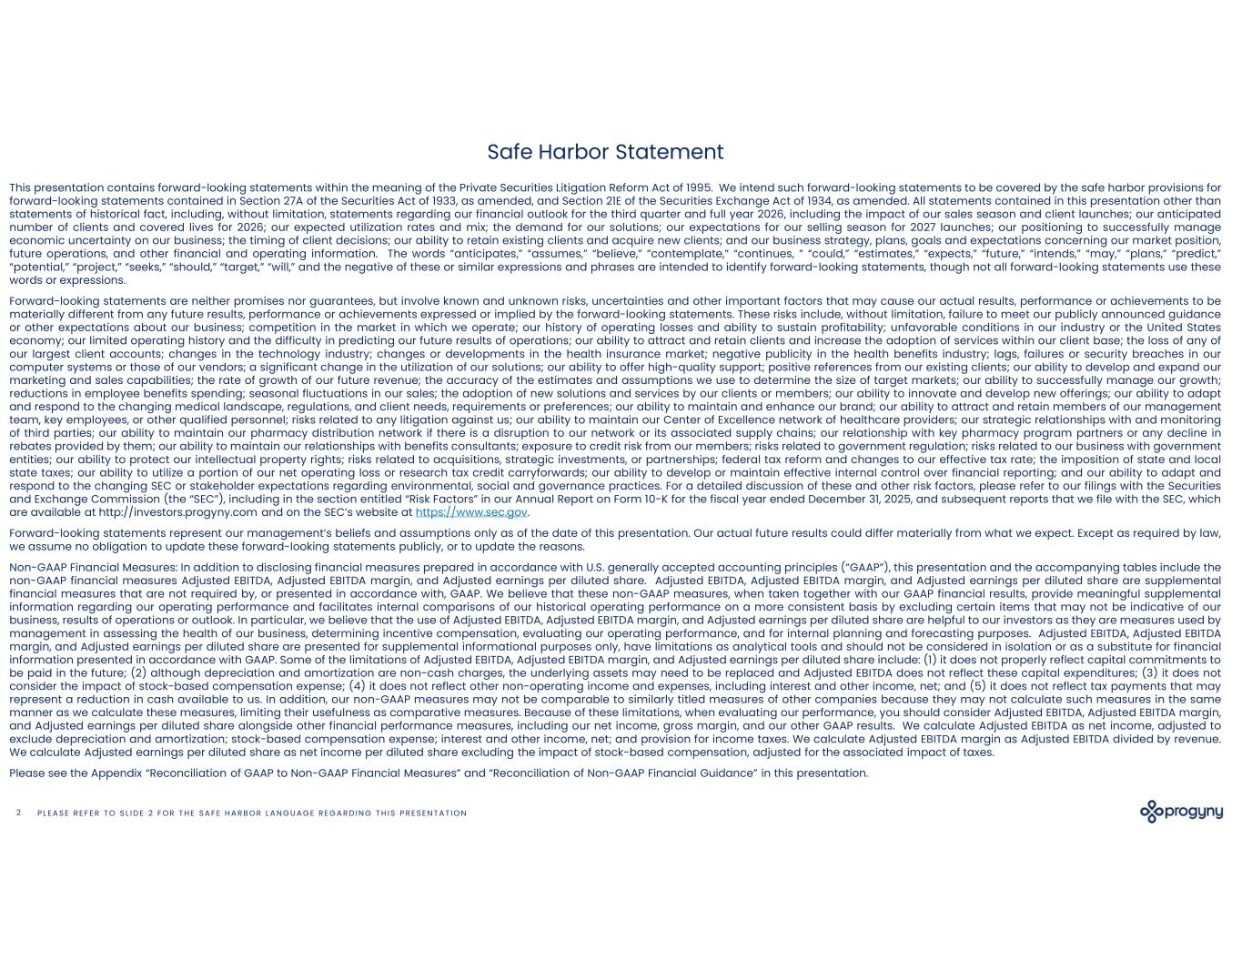
P L E A S E R E F E R T O S L I D E 2 F O R T H E S A F E H A R B O R L A N G U A G E R E G A R D I N G T H I S P R E S E N T A T I O N2 Safe Harbor Statement This presentation contains forward-looking statements within the meaning of the Private Securities Litigation Reform Act of 1995. We intend such forward-looking statements to be covered by the safe harbor provisions for forward-looking statements contained in Section 27A of the Securities Act of 1933, as amended, and Section 21E of the Securities Exchange Act of 1934, as amended. All statements contained in this presentation other than statements of historical fact, including, without limitation, statements regarding our financial outlook for the third quarter and full year 2026, including the impact of our sales season and client launches; our anticipated number of clients and covered lives for 2026; our expected utilization rates and mix; the demand for our solutions; our expectations for our selling season for 2027 launches; our positioning to successfully manage economic uncertainty on our business; the timing of client decisions; our ability to retain existing clients and acquire new clients; and our business strategy, plans, goals and expectations concerning our market position, future operations, and other financial and operating information. The words “anticipates,” “assumes,” “believe,” “contemplate,” “continues, ” “could,” “estimates,” “expects,” “future,” “intends,” “may,” “plans,” “predict,” “potential,” “project,” “seeks,” “should,” “target,” “will,” and the negative of these or similar expressions and phrases are intended to identify forward-looking statements, though not all forward-looking statements use these words or expressions. Forward-looking statements are neither promises nor guarantees, but involve known and unknown risks, uncertainties and other important factors that may cause our actual results, performance or achievements to be materially different from any future results, performance or achievements expressed or implied by the forward-looking statements. These risks include, without limitation, failure to meet our publicly announced guidance or other expectations about our business; competition in the market in which we operate; our history of operating losses and ability to sustain profitability; unfavorable conditions in our industry or the United States economy; our limited operating history and the difficulty in predicting our future results of operations; our ability to attract and retain clients and increase the adoption of services within our client base; the loss of any of our largest client accounts; changes in the technology industry; changes or developments in the health insurance market; negative publicity in the health benefits industry; lags, failures or security breaches in our computer systems or those of our vendors; a significant change in the utilization of our solutions; our ability to offer high-quality support; positive references from our existing clients; our ability to develop and expand our marketing and sales capabilities; the rate of growth of our future revenue; the accuracy of the estimates and assumptions we use to determine the size of target markets; our ability to successfully manage our growth; reductions in employee benefits spending; seasonal fluctuations in our sales; the adoption of new solutions and services by our clients or members; our ability to innovate and develop new offerings; our ability to adapt and respond to the changing medical landscape, regulations, and client needs, requirements or preferences; our ability to maintain and enhance our brand; our ability to attract and retain members of our management team, key employees, or other qualified personnel; risks related to any litigation against us; our ability to maintain our Center of Excellence network of healthcare providers; our strategic relationships with and monitoring of third parties; our ability to maintain our pharmacy distribution network if there is a disruption to our network or its associated supply chains; our relationship with key pharmacy program partners or any decline in rebates provided by them; our ability to maintain our relationships with benefits consultants; exposure to credit risk from our members; risks related to government regulation; risks related to our business with government entities; our ability to protect our intellectual property rights; risks related to acquisitions, strategic investments, or partnerships; federal tax reform and changes to our effective tax rate; the imposition of state and local state taxes; our ability to utilize a portion of our net operating loss or research tax credit carryforwards; our ability to develop or maintain effective internal control over financial reporting; and our ability to adapt and respond to the changing SEC or stakeholder expectations regarding environmental, social and governance practices. For a detailed discussion of these and other risk factors, please refer to our filings with the Securities and Exchange Commission (the “SEC”), including in the section entitled “Risk Factors” in our Annual Report on Form 10-K for the fiscal year ended December 31, 2025, and subsequent reports that we file with the SEC, which are available at http://investors.progyny.com and on the SEC’s website at https://www.sec.gov. Forward-looking statements represent our management’s beliefs and assumptions only as of the date of this presentation. Our actual future results could differ materially from what we expect. Except as required by law, we assume no obligation to update these forward-looking statements publicly, or to update the reasons. Non-GAAP Financial Measures: In addition to disclosing financial measures prepared in accordance with U.S. generally accepted accounting principles (“GAAP”), this presentation and the accompanying tables include the non-GAAP financial measures Adjusted EBITDA, Adjusted EBITDA margin, and Adjusted earnings per diluted share. Adjusted EBITDA, Adjusted EBITDA margin, and Adjusted earnings per diluted share are supplemental financial measures that are not required by, or presented in accordance with, GAAP. We believe that these non-GAAP measures, when taken together with our GAAP financial results, provide meaningful supplemental information regarding our operating performance and facilitates internal comparisons of our historical operating performance on a more consistent basis by excluding certain items that may not be indicative of our business, results of operations or outlook. In particular, we believe that the use of Adjusted EBITDA, Adjusted EBITDA margin, and Adjusted earnings per diluted share are helpful to our investors as they are measures used by management in assessing the health of our business, determining incentive compensation, evaluating our operating performance, and for internal planning and forecasting purposes. Adjusted EBITDA, Adjusted EBITDA margin, and Adjusted earnings per diluted share are presented for supplemental informational purposes only, have limitations as analytical tools and should not be considered in isolation or as a substitute for financial information presented in accordance with GAAP. Some of the limitations of Adjusted EBITDA, Adjusted EBITDA margin, and Adjusted earnings per diluted share include: (1) it does not properly reflect capital commitments to be paid in the future; (2) although depreciation and amortization are non-cash charges, the underlying assets may need to be replaced and Adjusted EBITDA does not reflect these capital expenditures; (3) it does not consider the impact of stock-based compensation expense; (4) it does not reflect other non-operating income and expenses, including interest and other income, net; and (5) it does not reflect tax payments that may represent a reduction in cash available to us. In addition, our non-GAAP measures may not be comparable to similarly titled measures of other companies because they may not calculate such measures in the same manner as we calculate these measures, limiting their usefulness as comparative measures. Because of these limitations, when evaluating our performance, you should consider Adjusted EBITDA, Adjusted EBITDA margin, and Adjusted earnings per diluted share alongside other financial performance measures, including our net income, gross margin, and our other GAAP results. We calculate Adjusted EBITDA as net income, adjusted to exclude depreciation and amortization; stock-based compensation expense; interest and other income, net; and provision for income taxes. We calculate Adjusted EBITDA margin as Adjusted EBITDA divided by revenue. We calculate Adjusted earnings per diluted share as net income per diluted share excluding the impact of stock-based compensation, adjusted for the associated impact of taxes. Please see the Appendix “Reconciliation of GAAP to Non-GAAP Financial Measures” and “Reconciliation of Non-GAAP Financial Guidance” in this presentation.

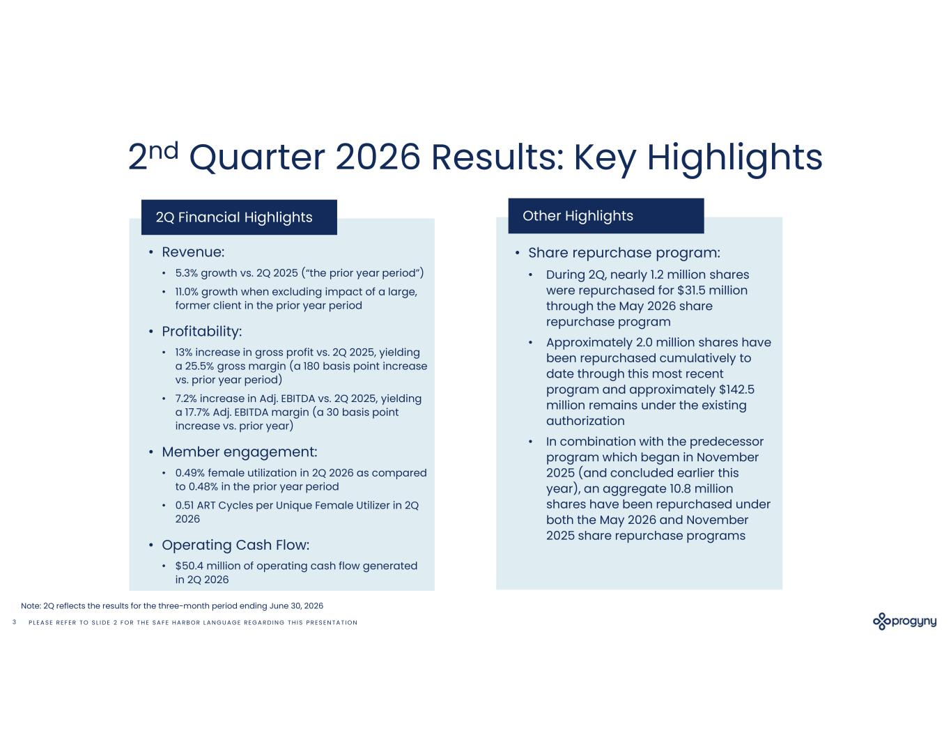
P L E A S E R E F E R T O S L I D E 2 F O R T H E S A F E H A R B O R L A N G U A G E R E G A R D I N G T H I S P R E S E N T A T I O N3 2nd Quarter 2026 Results: Key Highlights 2Q Financial Highlights • Revenue: • 5.3% growth vs. 2Q 2025 (“the prior year period”) • 11.0% growth when excluding impact of a large, former client in the prior year period • Profitability: • 13% increase in gross profit vs. 2Q 2025, yielding a 25.5% gross margin (a 180 basis point increase vs. prior year period) • 7.2% increase in Adj. EBITDA vs. 2Q 2025, yielding a 17.7% Adj. EBITDA margin (a 30 basis point increase vs. prior year) • Member engagement: • 0.49% female utilization in 2Q 2026 as compared to 0.48% in the prior year period • 0.51 ART Cycles per Unique Female Utilizer in 2Q 2026 • Operating Cash Flow: • $50.4 million of operating cash flow generated in 2Q 2026 Other Highlights • Share repurchase program: • During 2Q, nearly 1.2 million shares were repurchased for $31.5 million through the May 2026 share repurchase program • Approximately 2.0 million shares have been repurchased cumulatively to date through this most recent program and approximately $142.5 million remains under the existing authorization • In combination with the predecessor program which began in November 2025 (and concluded earlier this year), an aggregate 10.8 million shares have been repurchased under both the May 2026 and November 2025 share repurchase programs Note: 2Q reflects the results for the three-month period ending June 30, 2026

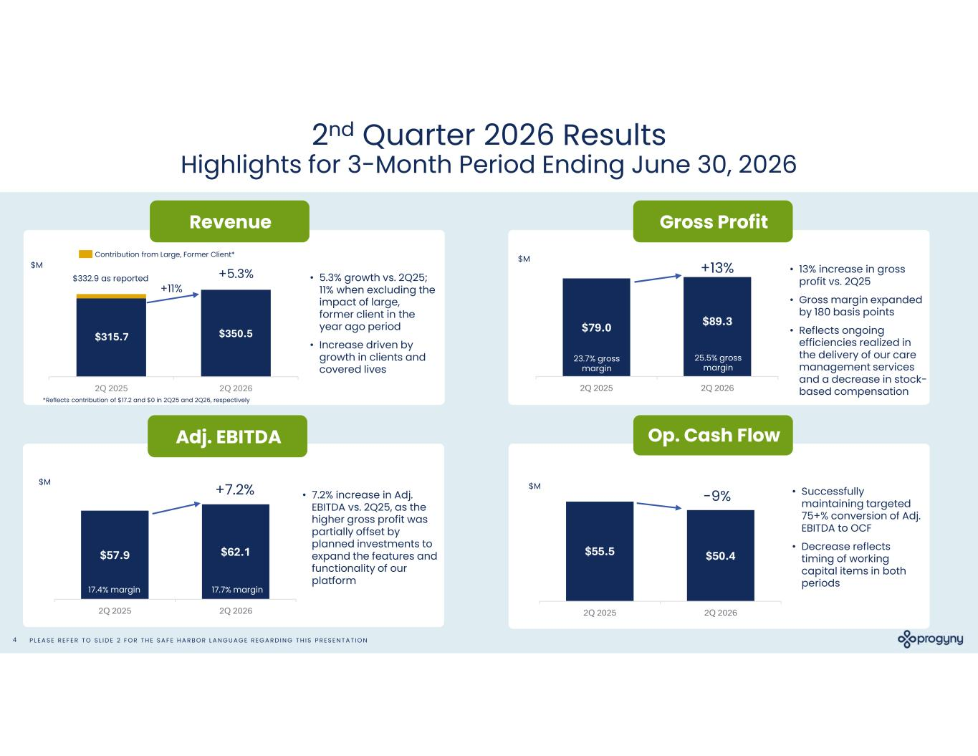
P L E A S E R E F E R T O S L I D E 2 F O R T H E S A F E H A R B O R L A N G U A G E R E G A R D I N G T H I S P R E S E N T A T I O N4 2nd Quarter 2026 Results Highlights for 3-Month Period Ending June 30, 2026 Revenue Op. Cash Flow $350.5 2Q 2025 2Q 2026 • 5.3% growth vs. 2Q25; 11% when excluding the impact of large, former client in the year ago period • Increase driven by growth in clients and covered lives Contribution from Large, Former Client* $M Adj. EBITDA • 7.2% increase in Adj. EBITDA vs. 2Q25, as the higher gross profit was partially offset by planned investments to expand the features and functionality of our platform $57.9 $62.1 2Q 2025 2Q 2026 $M 17.4% margin 17.7% margin $315.7 $55.5 $50.4 2Q 2025 2Q 2026 $M • Successfully maintaining targeted 75+% conversion of Adj. EBITDA to OCF • Decrease reflects timing of working capital items in both periods Gross Profit • 13% increase in gross profit vs. 2Q25 • Gross margin expanded by 180 basis points • Reflects ongoing efficiencies realized in the delivery of our care management services and a decrease in stock- based compensation $79.0 $89.3 2Q 2025 2Q 2026 $M 23.7% gross margin 25.5% gross margin $332.9 as reported +11% *Reflects contribution of $17.2 and $0 in 2Q25 and 2Q26, respectively +7.2% +5.3% +13% -9%

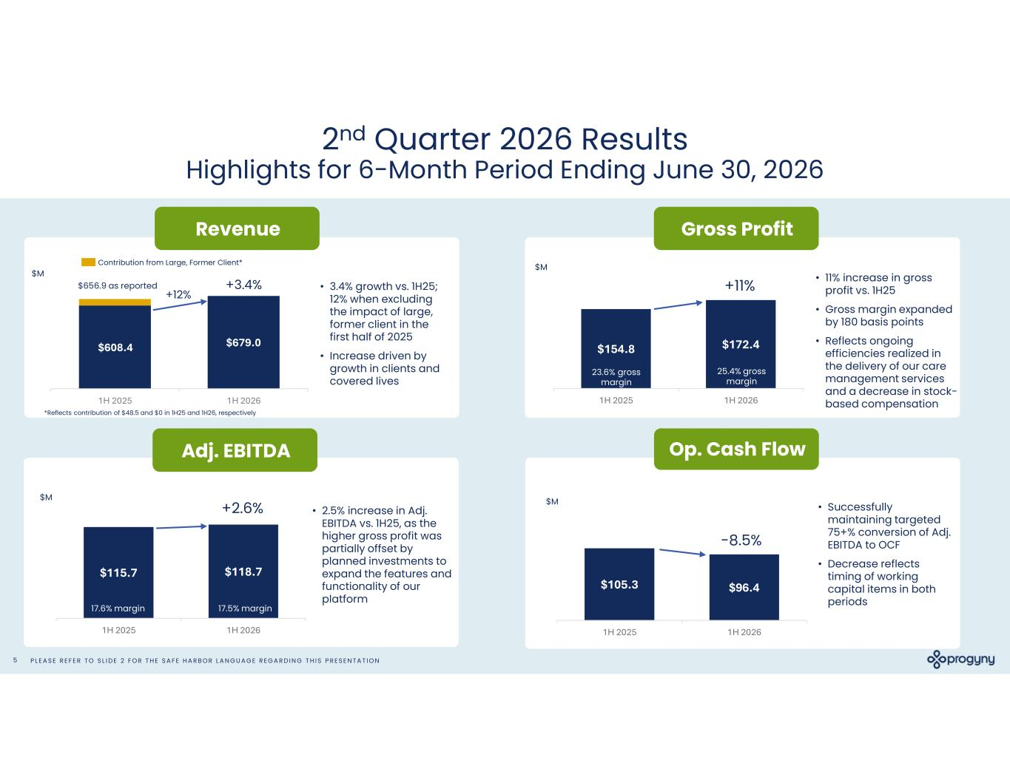
P L E A S E R E F E R T O S L I D E 2 F O R T H E S A F E H A R B O R L A N G U A G E R E G A R D I N G T H I S P R E S E N T A T I O N5 2nd Quarter 2026 Results Highlights for 6-Month Period Ending June 30, 2026 Revenue Op. Cash Flow $679.0 1H 2025 1H 2026 • 3.4% growth vs. 1H25; 12% when excluding the impact of large, former client in the first half of 2025 • Increase driven by growth in clients and covered lives Contribution from Large, Former Client* $M Adj. EBITDA • 2.5% increase in Adj. EBITDA vs. 1H25, as the higher gross profit was partially offset by planned investments to expand the features and functionality of our platform $115.7 $118.7 1H 2025 1H 2026 $M 17.6% margin 17.5% margin $608.4 $105.3 $96.4 1H 2025 1H 2026 $M • Successfully maintaining targeted 75+% conversion of Adj. EBITDA to OCF • Decrease reflects timing of working capital items in both periods Gross Profit • 11% increase in gross profit vs. 1H25 • Gross margin expanded by 180 basis points • Reflects ongoing efficiencies realized in the delivery of our care management services and a decrease in stock- based compensation $154.8 $172.4 1H 2025 1H 2026 $M 23.6% gross margin 25.4% gross margin $656.9 as reported +12% *Reflects contribution of $48.5 and $0 in 1H25 and 1H26, respectively +2.6% +3.4% +11% -8.5%

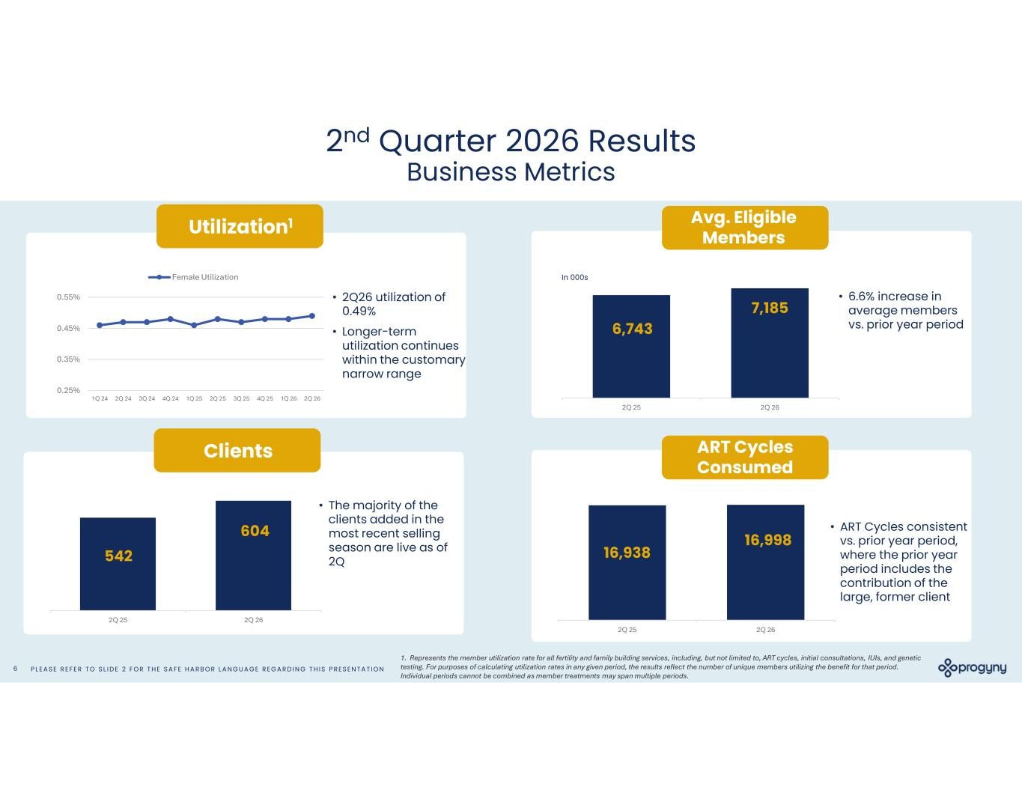
P L E A S E R E F E R T O S L I D E 2 F O R T H E S A F E H A R B O R L A N G U A G E R E G A R D I N G T H I S P R E S E N T A T I O N6 2nd Quarter 2026 Results Business Metrics ART Cycles Consumed Clients 2Q 25 2Q 26 2Q 25 2Q 26 Utilization1 • 2Q26 utilization of 0.49% • Longer-term utilization continues within the customary narrow range 0.25% 0.35% 0.45% 0.55% 1Q 24 2Q 24 3Q 24 4Q 24 1Q 25 2Q 25 3Q 25 4Q 25 1Q 26 2Q 26 Female Utilization 16,998604 542 16,938 • The majority of the clients added in the most recent selling season are live as of 2Q • ART Cycles consistent vs. prior year period, where the prior year period includes the contribution of the large, former client In 000s 2Q 25 2Q 26 7,185 6,743 • 6.6% increase in average members vs. prior year period 1. Represents the member utilization rate for all fertility and family building services, including, but not limited to, ART cycles, initial consultations, IUIs, and genetic testing. For purposes of calculating utilization rates in any given period, the results reflect the number of unique members utilizing the benefit for that period. Individual periods cannot be combined as member treatments may span multiple periods. Avg. Eligible Members

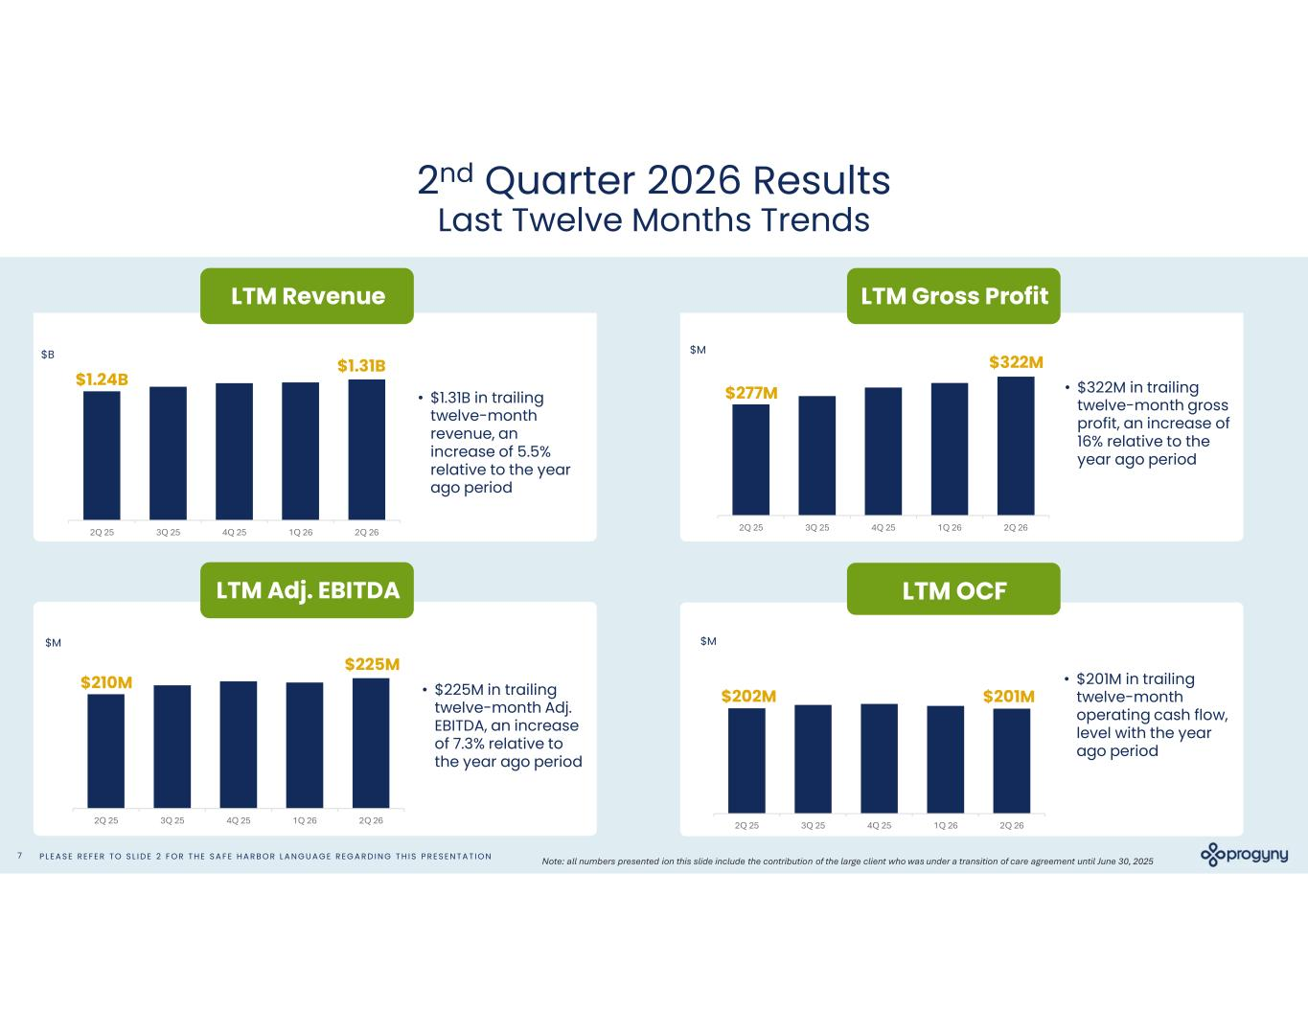
P L E A S E R E F E R T O S L I D E 2 F O R T H E S A F E H A R B O R L A N G U A G E R E G A R D I N G T H I S P R E S E N T A T I O N7 2nd Quarter 2026 Results Last Twelve Months Trends LTM Gross Profit LTM Adj. EBITDA LTM OCF • $1.31B in trailing twelve-month revenue, an increase of 5.5% relative to the year ago period LTM Revenue 2Q 25 3Q 25 4Q 25 1Q 26 2Q 26 $B 2Q 25 3Q 25 4Q 25 1Q 26 2Q 26 • $201M in trailing twelve-month operating cash flow, level with the year ago period $M • $322M in trailing twelve-month gross profit, an increase of 16% relative to the year ago period 2Q 25 3Q 25 4Q 25 1Q 26 2Q 26 $M • $225M in trailing twelve-month Adj. EBITDA, an increase of 7.3% relative to the year ago period 2Q 25 3Q 25 4Q 25 1Q 26 2Q 26 $M $1.31B $225M $322M $201M $1.24B $210M $277M $202M Note: all numbers presented ion this slide include the contribution of the large client who was under a transition of care agreement until June 30, 2025

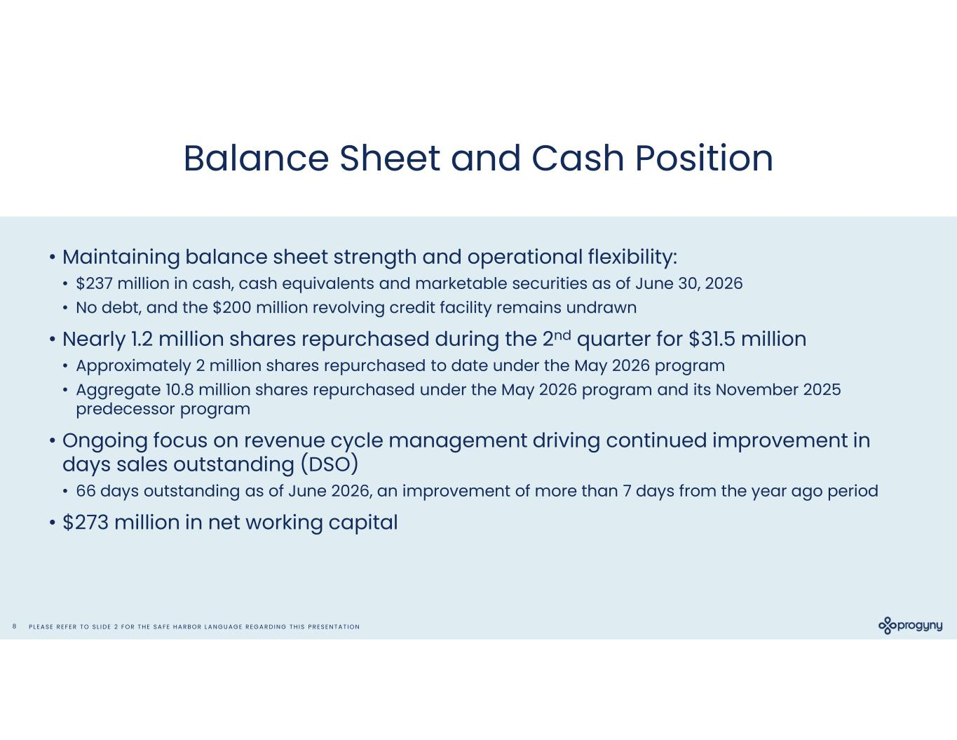
P L E A S E R E F E R T O S L I D E 2 F O R T H E S A F E H A R B O R L A N G U A G E R E G A R D I N G T H I S P R E S E N T A T I O N8 Balance Sheet and Cash Position • Maintaining balance sheet strength and operational flexibility: • $237 million in cash, cash equivalents and marketable securities as of June 30, 2026 • No debt, and the $200 million revolving credit facility remains undrawn • Nearly 1.2 million shares repurchased during the 2nd quarter for $31.5 million • Approximately 2 million shares repurchased to date under the May 2026 program • Aggregate 10.8 million shares repurchased under the May 2026 program and its November 2025 predecessor program • Ongoing focus on revenue cycle management driving continued improvement in days sales outstanding (DSO) • 66 days outstanding as of June 2026, an improvement of more than 7 days from the year ago period • $273 million in net working capital

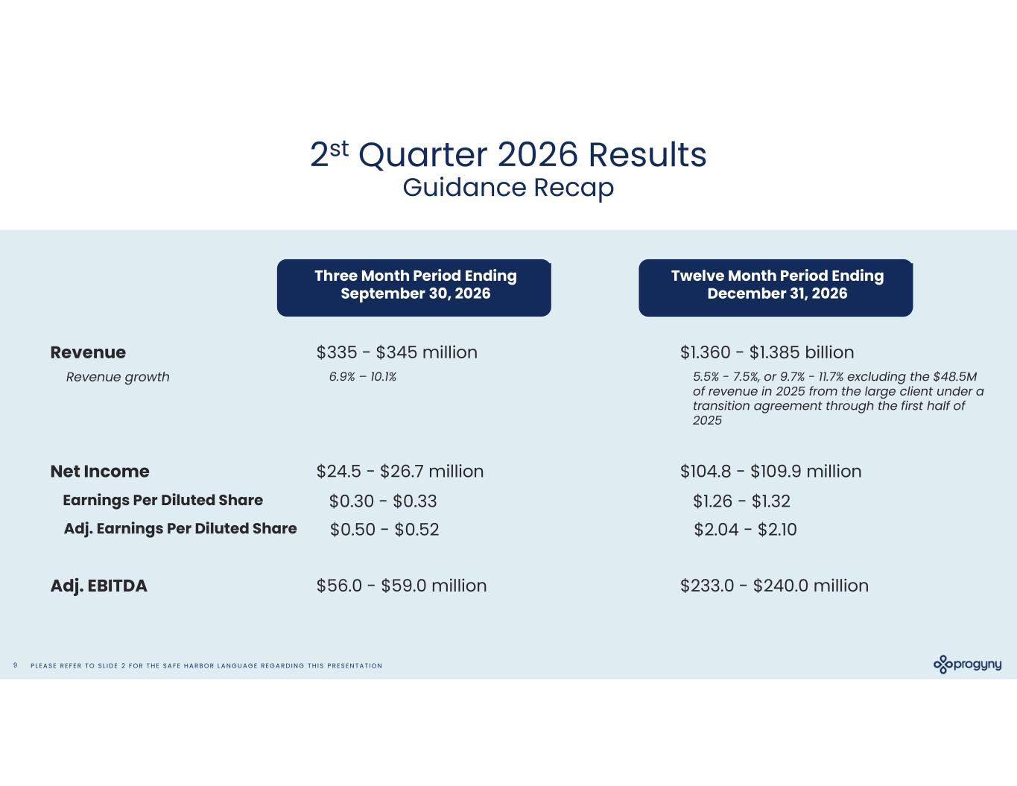
P L E A S E R E F E R T O S L I D E 2 F O R T H E S A F E H A R B O R L A N G U A G E R E G A R D I N G T H I S P R E S E N T A T I O N9 2st Quarter 2026 Results Guidance Recap Three Month Period Ending September 30, 2026 Twelve Month Period Ending December 31, 2026 Revenue Net Income Adj. EBITDA $335 - $345 million $24.5 - $26.7 million $56.0 - $59.0 million $1.360 - $1.385 billion $104.8 - $109.9 million $233.0 - $240.0 million Revenue growth 6.9% – 10.1% 5.5% - 7.5%, or 9.7% - 11.7% excluding the $48.5M of revenue in 2025 from the large client under a transition agreement through the first half of 2025 Earnings Per Diluted Share $0.30 - $0.33 $1.26 - $1.32 Adj. Earnings Per Diluted Share $0.50 - $0.52 $2.04 - $2.10


P L E A S E R E F E R T O S L I D E 2 F O R T H E S A F E H A R B O R L A N G U A G E R E G A R D I N G T H I S P R E S E N T A T I O N10 Appendix

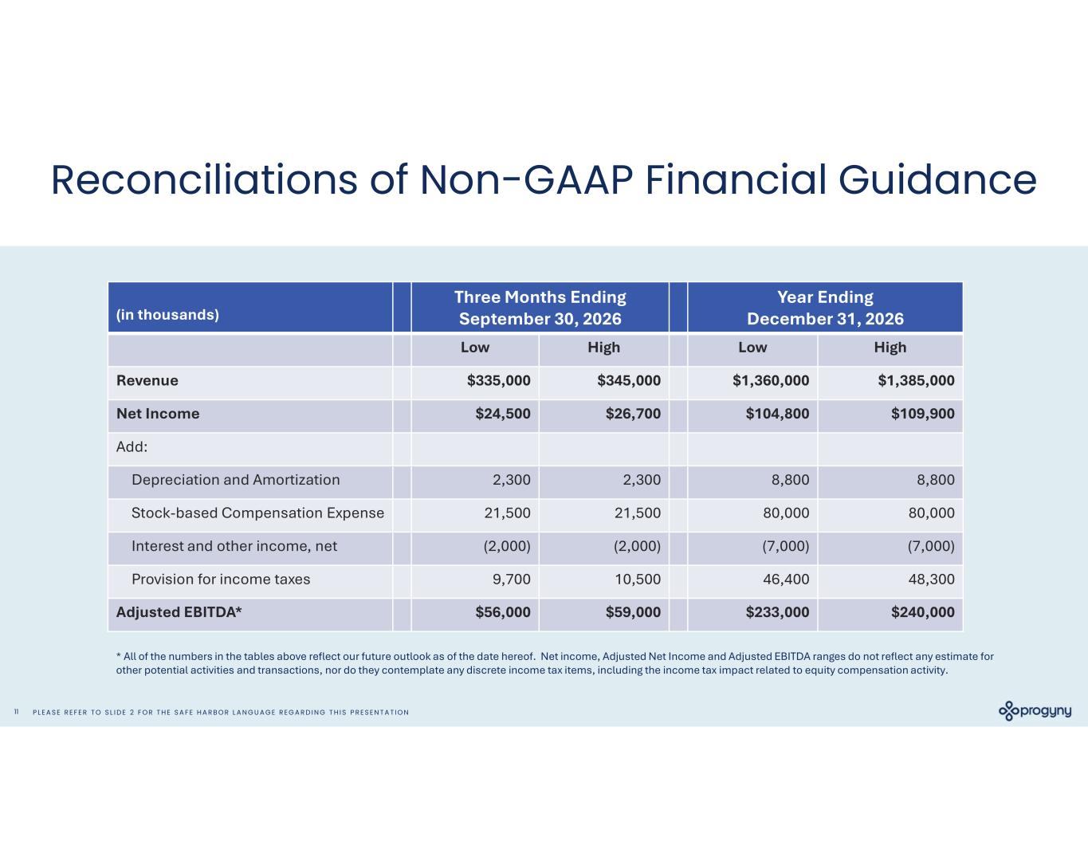
P L E A S E R E F E R T O S L I D E 2 F O R T H E S A F E H A R B O R L A N G U A G E R E G A R D I N G T H I S P R E S E N T A T I O N11 Reconciliations of Non-GAAP Financial Guidance Year Ending December 31, 2026 Three Months Ending September 30, 2026(in thousands) HighLowHighLow $1,385,000$1,360,000$345,000$335,000Revenue $109,900$104,800$26,700$24,500Net Income Add: 8,8008,8002,3002,300Depreciation and Amortization 80,00080,00021,50021,500Stock-based Compensation Expense (7,000)(7,000)(2,000)(2,000)Interest and other income, net 48,30046,40010,5009,700Provision for income taxes $240,000$233,000$59,000$56,000Adjusted EBITDA* * All of the numbers in the tables above reflect our future outlook as of the date hereof. Net income, Adjusted Net Income and Adjusted EBITDA ranges do not reflect any estimate for other potential activities and transactions, nor do they contemplate any discrete income tax items, including the income tax impact related to equity compensation activity.

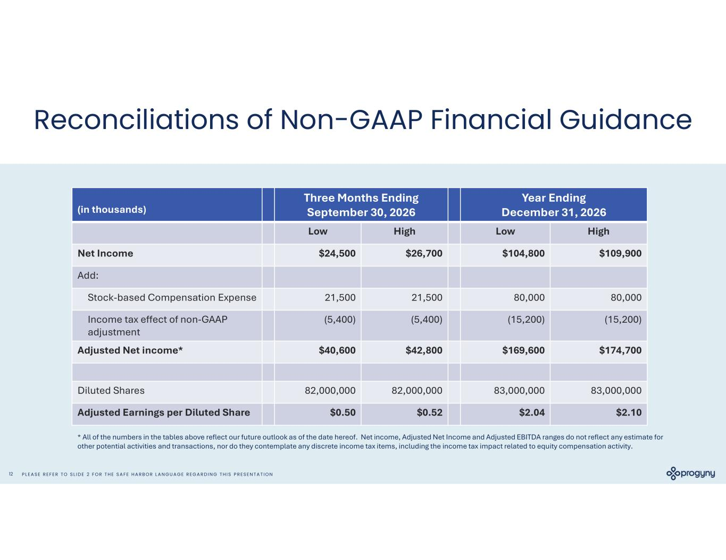
P L E A S E R E F E R T O S L I D E 2 F O R T H E S A F E H A R B O R L A N G U A G E R E G A R D I N G T H I S P R E S E N T A T I O N12 Reconciliations of Non-GAAP Financial Guidance Year Ending December 31, 2026 Three Months Ending September 30, 2026(in thousands) HighLowHighLow $109,900$104,800$26,700$24,500Net Income Add: 80,00080,00021,50021,500Stock-based Compensation Expense (15,200)(15,200)(5,400)(5,400)Income tax effect of non-GAAP adjustment $174,700$169,600$42,800$40,600Adjusted Net income* 83,000,00083,000,00082,000,00082,000,000Diluted Shares $2.10$2.04$0.52$0.50Adjusted Earnings per Diluted Share * All of the numbers in the tables above reflect our future outlook as of the date hereof. Net income, Adjusted Net Income and Adjusted EBITDA ranges do not reflect any estimate for other potential activities and transactions, nor do they contemplate any discrete income tax items, including the income tax impact related to equity compensation activity.

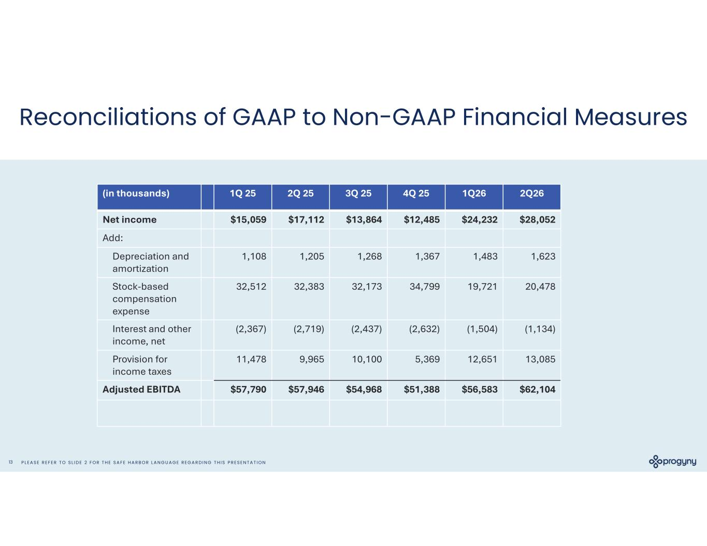
P L E A S E R E F E R T O S L I D E 2 F O R T H E S A F E H A R B O R L A N G U A G E R E G A R D I N G T H I S P R E S E N T A T I O N13 Reconciliations of GAAP to Non-GAAP Financial Measures 2Q261Q264Q 253Q 252Q 251Q 25(in thousands) $28,052$24,232$12,485$13,864$17,112$15,059Net income Add: 1,6231,4831,3671,2681,2051,108Depreciation and amortization 20,47819,72134,79932,17332,38332,512Stock-based compensation expense (1,134)(1,504)(2,632)(2,437)(2,719)(2,367)Interest and other income, net 13,08512,6515,36910,1009,96511,478Provision for income taxes $62,104$56,583$51,388$54,968$57,946$57,790Adjusted EBITDA

